Additional file 1
Journal: BMC Microbiology
Differential gene content and gene expression for bacterial evolution and speciation of Shewanella in terms of biosynthesis of heme and heme-requiring proteins
Jingcheng Dai¹, Yaqi Liu¹, Shuangyuan Liu¹,Shuyang Li¹, Na Gao¹, Jing Wang¹, Jizhong Zhou^{2,3}, Dongru Qiu^{1*}

¹ Institute of Hydrobiology, Chinese Academy of Sciences, Wuhan 430072, China and University of Chinese Academy of Sciences, Beijing 100049, China
² Institute for Environmental Genomics, and Department of Microbiology and Plant Biology, University of Oklahoma, Norman, OK 73019, USA
³ Earth Science Division, Lawrence Berkeley National Laboratory, Berkeley, CA 94270, USA
*Correspondence to: Dongru Qiu, PhD
Institute of Hydrobiology, Chinese Academy of Sciences
Wuhan 430072, Hubei Province, China
Phone: 0086-27-68780215; Fax: 0086-27-68780123
E-mail: qiu@ihb.ac.cn

Table S1 The heme proteins of S. oneidensis MR-1.

ID | Gene | Protein | Biological process | Prostetic group
SO_1070 | katB | Catalase B | H₂O₂ scavenging | Protoheme IX, heme D?
SO_4405 | katG1 | Catalase G |  | Protoheme IX, heme B
SO_0725 | katG2 | Catalase G |  | Protoheme IX, heme B
SO_1776-SO_1778 | mtrABC | Extracellular iron oxide respiratory  protein | Electron transfer | Protoheme IX, heme B
SO_1779 | omcA |  |  | Protoheme IX, heme B
SO_1780-SO_1782 | mtrDEF | Extracellular respiratory  protein |  | Protoheme IX, heme B
SO_3285-SO_3286 | cydAB | Cytochrome bd oxidase-II |  | Protoheme IX, (heme D?)
SO_1427-SO_1428 | dmsEF | Periplasmic decaheme cytochrome c |  | Protoheme IX, heme B
SO_4606-SO_4607 | coxBA | Cytochrome C oxidase |  | Protoheme IX, heme A
SO_4609 | coxC | Cytochrome C oxidase |  | Protoheme IX, heme A
SO_4613-SO_4614 | ctaA-ctaB | Cytochrome C oxidase |  | Protoheme IX, heme A
SO_0790 | fccA | Fumarate reductase flavoprotein |  | Protoheme IX, heme B?
SO_2361-SO_2364 | ccoPQON | Cytochrome C oxidase |  | Protoheme IX, heme A
SO_0101-SO_0103 | fdnGHI | Formate dehydrogenase-O |  | Protoheme IX, heme B/D
SO_1233 | torC | Trimethylamine-N-oxide reductase |  | Protoheme IX, heme B
SO_4591 | cymA | Tetraheme cytochrome c |  | Protoheme IX, heme B
SO_1927-SO_1930 | sdhCDAB | Succinate dehydrogenase | Electron transfer, TCA cycle | Protoheme IX, heme B
SO_1111-SO_1112 | bfr | Bacterioferritin | Iron storage | Protoheme IX, heme B
SO_2178 | ccpA | Cytochrome C peroxidase | Unknow | Protoheme IX, heme B
SO_0740 | unknow | Dyp-type heme-dependent peroxidase | Unknow | Protoheme IX, heme B
SO_3980 | nrfA | Nitrite reductase | Anaerobic respiration | *Siroheme
SO_4568 | nrfD
SO_0845-SO_0849 | napBHGAD | Periplasmic nitrate reductase | Anaerobic respiration | Protoheme IX, heme B
SO_1783-SO_1784 | feoAB | Ferrous iron transporter | Uptake of ferrous iron under conditions of iron limitation and low pH | Protoheme IX, heme B
SO_3737-SO_3738 | cysIJ | Sulfite reductase | Sulfate assimilation | *Siroheme
*Siroheme synthesis departs from the pathway of heme synthesis after the HemD step and does not involve coproporphyrinogen III oxidase (HemN/HemF) or ferrochelatase (HemH).

Table S2 Iron acquisition and metabolism function between PV-4 and MR-1.

Strains | Function | Expressed protein
MR-1 | Siderophore assembly kit | Siderophore biosynthesis protein, monooxygenase
MR-1 | Siderophore assembly kit | Siderophore synthetase component, ligase
MR-1 | Siderophore assembly kit | Siderophore synthetase small component, acetyltransferase
MR-1 | Heme, hemin uptake and utilization systems in Gram-Negatives | ABC-type hemin transport system, ATPase component
MR-1 | Heme, hemin uptake and utilization systems in Gram-Negatives | Biopolymer transport protein ExbD1
MR-1 | Heme, hemin uptake and utilization systems in Gram-Negatives | Hemin ABC transporter, permease protein
MR-1 | Heme, hemin uptake and utilization systems in Gram-Negatives | Periplasmic hemin-binding protein
MR-1 | Heme, hemin uptake and utilization systems in Gram-Negatives | Putative heme iron utilization protein
MR-1 | Heme, hemin uptake and utilization systems in Gram-Negatives | phosphate oxidase-related putative heme iron utilization protein
MR-1 | Heme, hemin uptake and utilization systems in Gram-Negatives | TonB-dependent hemin , ferrichrome receptor
MR-1 | Heme, hemin uptake and utilization systems in Gram-Negatives | Transcriptional regulator LuxT
MR-1 | Transport of Iron | Iron-uptake factor PiuC
PV-4 | Siderophore Aerobactin | Aerobactin siderophore receptor IutA
PV-4 | ABC transporter [iron.B12.siderophore.hemin] | ABC transporter (iron.B12.siderophore.hemin) , ATP-binding component
PV-4 | Transport of Iron | Iron-regulated protein A precursor
PV-4 | Transport of Iron | Iron-uptake factor PiuB
PV-4 and MR-1 | Encapsulating protein for DyP-type peroxidase and ferritin-like protein oligomers | Predicted dye-decolorizing peroxidase (DyP), YfeX-like subgroup
PV-4 and MR-1 | Hemin transport system | Ferric siderophore transport system, periplasmic binding protein TonB
PV-4 and MR-1 | Hemin transport system | Outer membrane receptor proteins, mostly Fe transport
PV-4 and MR-1 | Iron acquisition in Streptococcus | Ferric iron ABC transporter, ATP-binding protein
PV-4 and MR-1 | Iron acquisition in Streptococcus | Ferric iron ABC transporter, iron-binding protein
PV-4 and MR-1 | Iron acquisition in Streptococcus | Ferric iron ABC transporter, permease protein
PV-4 and MR-1 | Transport of Iron | Ferric iron ABC transporter, ATP-binding protein
PV-4 and MR-1 | Transport of Iron | Ferric iron ABC transporter, iron-binding protein
PV-4 and MR-1 | Transport of Iron | Ferric iron ABC transporter, permease protein
PV-4 and MR-1 | Transport of Iron | Ferric uptake regulation protein FUR
PV-4 and MR-1 | Transport of Iron | Ferrichrome-iron receptor
PV-4 and MR-1 | Transport of Iron | Ferrous iron transport protein A
PV-4 and MR-1 | Transport of Iron | Ferrous iron transport protein B

Figure S1 the double deletion of hemH1 and hemH2 in MR-1 strain

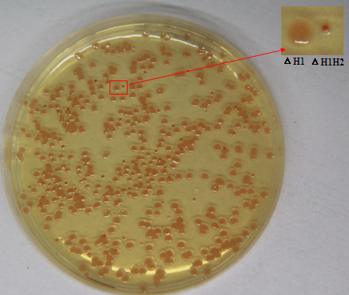
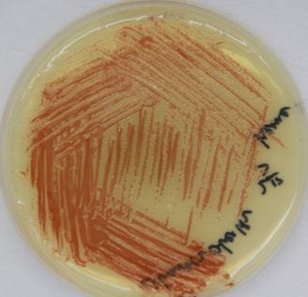

Figure S2 Ultraviolet-visible spectrograms of the bacterial extract (the wildtype and the hemH1 mutant). Absorbance was measured at every 5 or 10 nanometers (nm).

Figure S3 Alignment of promoter sequences upstream of loci SO_3349-SO_3348 (pgpD-hemH2) of S. oneidensis MR-1 and Shew_1140 (hemH2) in S. loihica PV-4. The putative RpoE2 recognizing motifs (-35 motif TGATCC/T and -10 motif CGTAA/CT) are highlighted in yellow.

CLUSTAL 2.1 multiple sequence alignment

SO_3349 TCCTATTTTGTCATATGTTAAAGCAGCTTTTTGAAGCTGCTTTTTATCGCTTAGGGTAAT 60
SHEW_1140 -CC--TCTTATTGCACTTTGAAAAAACC--------------------------GATAAT 31
** * ** * * ** ** * * * ****

SO_3349 AGATAACTCCTTGTAGCTTTTATTTTTTTATT-CAATATGATCCCTATCGTAGCAAGTTA 119
SHEW_1140 ------CCCTTTATCGGTTTT-TTTATGTGTGGCGAT-TGATCTCTAAGGGGCCGAACCG 83
* * ** * * **** *** * * * * ** ***** *** * * *

SO_3349 CGTAATAAGAATAAGTTCGCCTATCTTGGATCATTGAA-TGAGAAGGACATT--- 170
SHEW_1140 CGTACTGA---------TGCCCA---TGCATCATTAGCCTCGGCCAGGTGCCCAG 126
**** * * *** * ** ****** * * *

Figure S4 Distance tree of hemH paralogues in Shewanella based on DNA sequence similarity. E.coli hemH used as reference. Clearly, the two hemH paralogues fall into two cluster, hemH1 sequences form the upper gene cluster, while hemH2 sequences form the lower cluster.
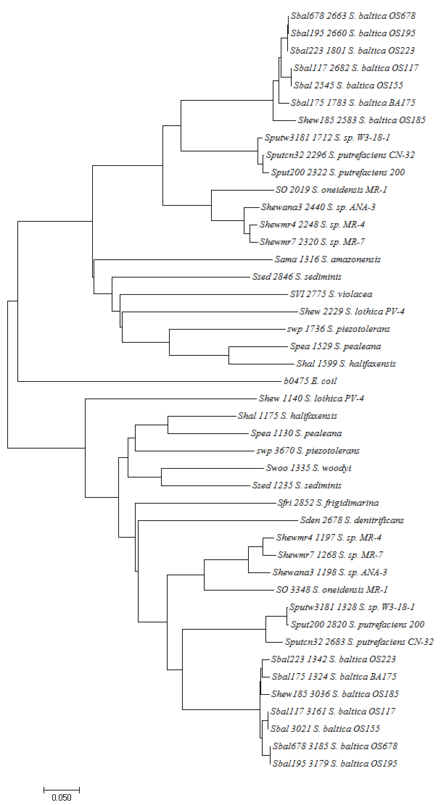
hemH1
hemH2

