Supplementary Materials

S1 Fig. Fungal structure comparison by PCOA among healthy controls, reticular OLP and erosive OLP. PCoA plot based on Bray-Curtis distances indicated no obvious separation.
H: healthy subjects; R: reticular OLP; E: erosive OLP.
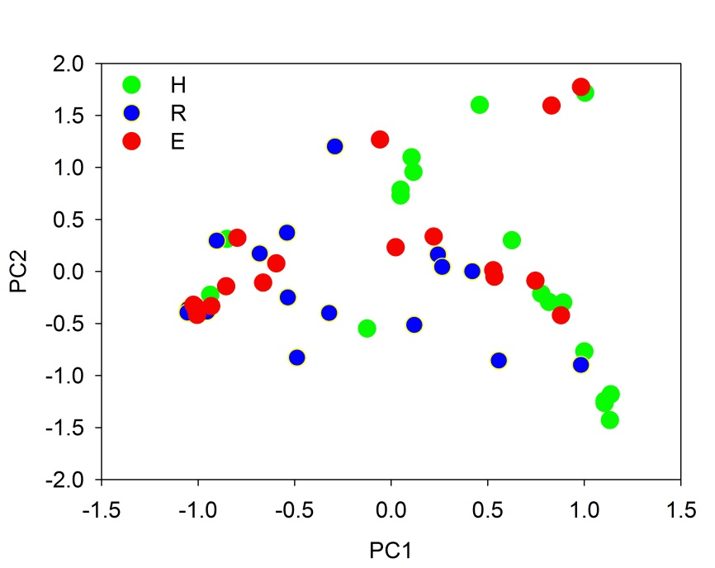

S2 Fig. The core mycobiota of saliva samples among healthy controls, reticular OLP and erosive OLP. The model included the genera (above 1% of relative abundance) and OTUs (above 0.3% of relative abundance) in healthy controls (green), reticular OLP (blue) and erosive OLP (red), which were found in at least 50% of subjects.(a): genus level; (b): OTU level.
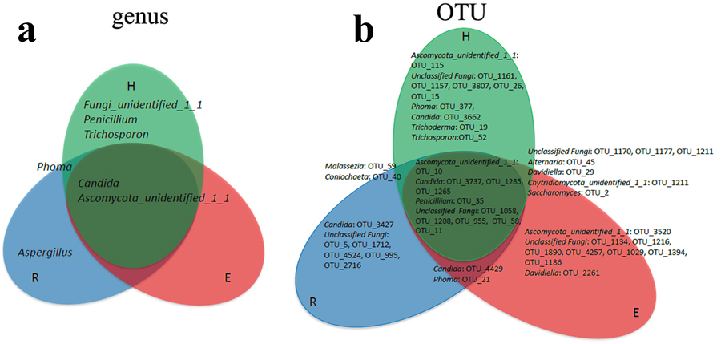

S3 Fig. Network inferences for the complex fungal- bacterial relationships in OLP and healthy subjects. Each node represents an OTU colored by the phylum-level phylotypes, and each edge represents a significant pairwise association. 9 bacterial phylum and 2 fungal (Ascomycota, Basidiomycota) were included. H: healthy subjects; R: reticular OLP; E: erosive OLP.
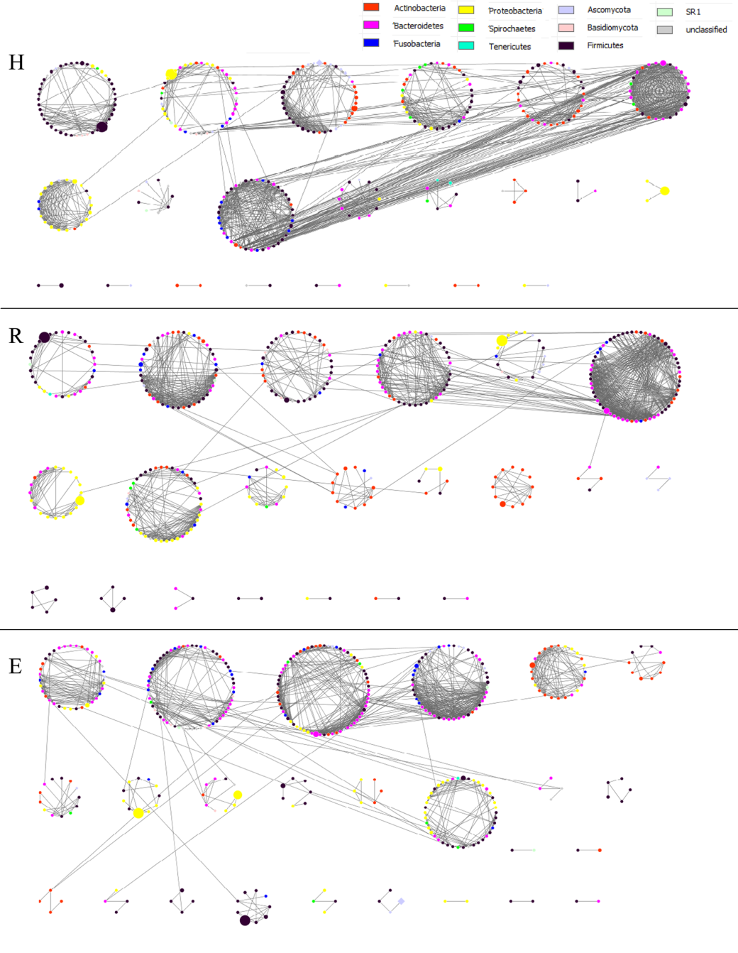

S1 Table. Summary of mycobiome-bacteriome sequencing data among healthy and OLP patients
 | Groups | #samples | #sequences per sample | #resampling efforts | #observed OTUs | Chao1 richness | Shannon index | Good’s coverage
Fungi | H | 18 | 25948±10182 | 2227 | 163±111 | 293±52 | 2.97±1.01 | 99.49±0.32
 | R | 17 | 15636±6365 | 2227 | 117±63 | 180±26 | 2.42±0.97 | 99.69±0.27
 | E | 18 | 13833±9742 | 2227 | 98±31 | 174±15 | 2.06±0.55 | 99.66±0.31
Bacteria | H | 18 | 27094±20420 | 12997 | 459±112 | 748±247 | 3.60±0.45 | 99.86±0.3
 | R | 18 | 62279±12523 | 12997 | 522±102 | 834±185 | 3.81±0.46 | 99.91±0.03
 | E | 19 | 57528±16692 | 12997 | 585±160 | 944±259 | 3.86±0.48 | 99.74±0.6
Note: # means “numbers of”.

S2 Table. Significant correlations between Candida and bacterial genera
Candida | H | R | E
Abiotrophia | -0.26178 | 0.170875 | -0.42148
Actinobacillus | -0.08572 | 0.358064 | -0.12996
Aggregatibacter | -0.2843 | 0.362404 | -0.14373
Bacteroides |  |  | 0.112023
Brachymonas | -0.07633 | -0.11342 | 0.328384
Bulleidia |  | 0.038076
Capnocytophaga | -0.37796 | -0.23747 | 0.37918
Catonella | 0.02771 | 0.019852 | -0.35428
Cellulosimicrobium | -0.33608 | -0.39456 | 0.271504
Dialister | 0.031807 | 0.245904 | -0.63862
Eubacterium | 0.250867 | -0.00878 | -0.06123
Gemella | -0.23454 | -0.26895 | -0.05825
Haemophilus | 0.235308 | 0.014587 | 0.277878
Johnsonella | 0.40808 |  | -0.23228
Leptotrichia | 0.154656 | -0.16702 | -0.36946
Moryella | 0.280209 | 0.086017 | -0.03862
Peptococcus | -0.13469 | 0.05674 | -0.56953
Peptostreptococcaceae_incertae_sedis | -0.16565 | -0.08852 | -0.37154
Peptostreptococcus | 0.053578 | -0.10123 | 0.000134
Planobacterium | -0.25358 | -0.00821 | 0.282025
Porphyromonas | -0.34648 | -0.06732 | -0.2592
Prevotella | -0.18069 | -0.05006 | 0.026872
Rhizobium | -0.39029
Schwartzia |  |  | -0.30522
Solobacterium | -0.06093 | -0.28639 | 0.007523
SR1_genera_incertae_sedis | -0.20953 | 0.308775 | -0.593
Syntrophococcus | -0.02797 | -0.04873 | -0.17608
Treponema | -0.08413 | 0.111953 | -0.16836
Veillonella | -0.02887 | 0.087615 | 0.262253
Note: Inversion of myco-bacteriome co-occurrence patterns from antagonization to co-prosperity in R group (green) and E group (red).

S3 Table. Topological properties of co-occurrence networks of fungal communities in healthy subjects (H), reticular OLP (R) and erosive OLP (E)
 | Total nodes | Total links | Average connectivity | Average path | Modularity | Centralization of degree
H | 336 | 1175 | 6.99 | 5.51 | 0.76 | 0.07
R | 366 | 1241 | 6.78 | 6.05 | 0.77 | 0.06
E | 383 | 1175 | 6.14 | 7.22 | 0.78 | 0.05

