Divergent taxonomic and functional responses of microbial communities to field simulation of aeolian soil erosion and deposition

Xingyu Ma¹, Cancan Zhao², Ying Gao¹, Bin Liu², Tengxu Wang¹, Tong Yuan³, Lauren Hale³, Joy D. Van Nostrand³, Shiqiang Wan², Jizhong Zhou^{1,3,4} and Yunfeng Yang^{1,*}

¹State Key Joint Laboratory of Environment Simulation and Pollution Control, School of Environment, Tsinghua University, Beijing 100084, China
²State Key laboratory of Cotton Biology, Key Laboratory of Plant Stress Biology, College of Life Sciences, Henan University, Kaifeng, Henan 475004, China
³Institute for Environmental Genomics and Department of Microbiology and Plant Biology, University of Oklahoma, Norman, OK 73019, USA
⁴Earth Sciences Division, Lawrence Berkeley National Laboratory, Berkeley, CA 94720, USA
Supplementary materials
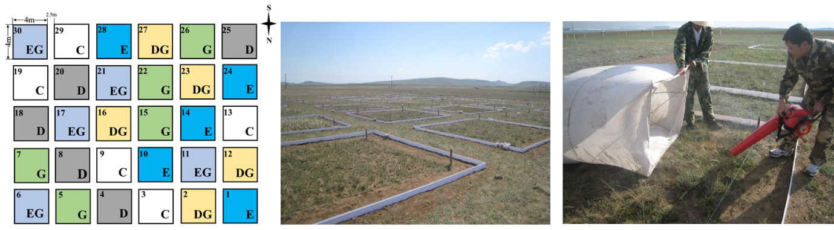
Figure S1. Site sketch and pictures of experimental sites. C, control；E, soil erosion; D, soil deposition; G, sheep grazing; EG, soil erosion plus sheep grazing; DG, soil deposition plus sheep grazing.

Figure S2. Rarefaction curves of control, erosion and deposition samples. E: erosion samples; C; controls; D: deposition samples.
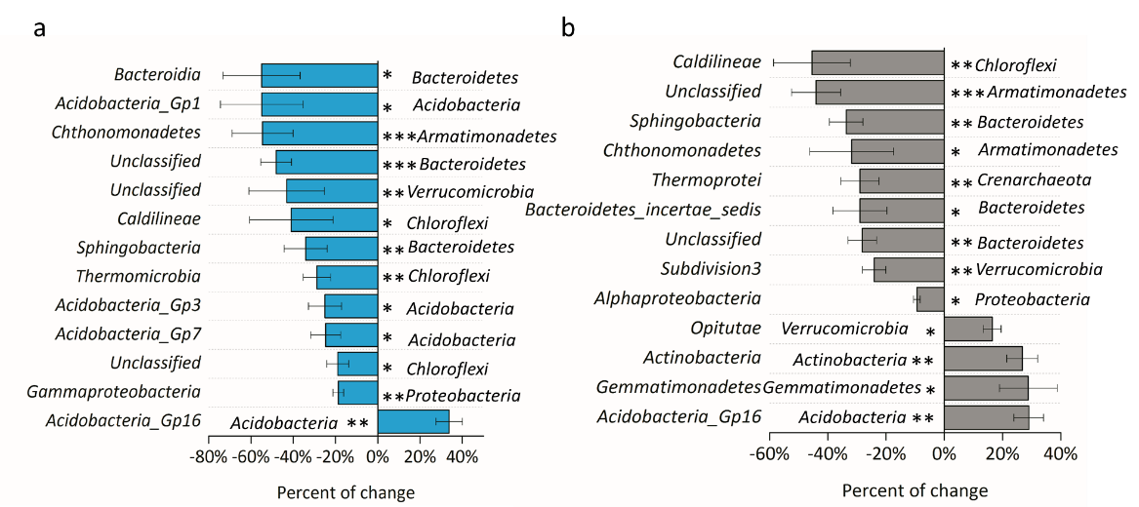
Figure S3. Percentage changes in relative abundances at the class level by (a) soil erosion and (b) soil deposition. Asterisk indicates significant differences. *P<0.10; **P< 0.05; ***P<0.01.

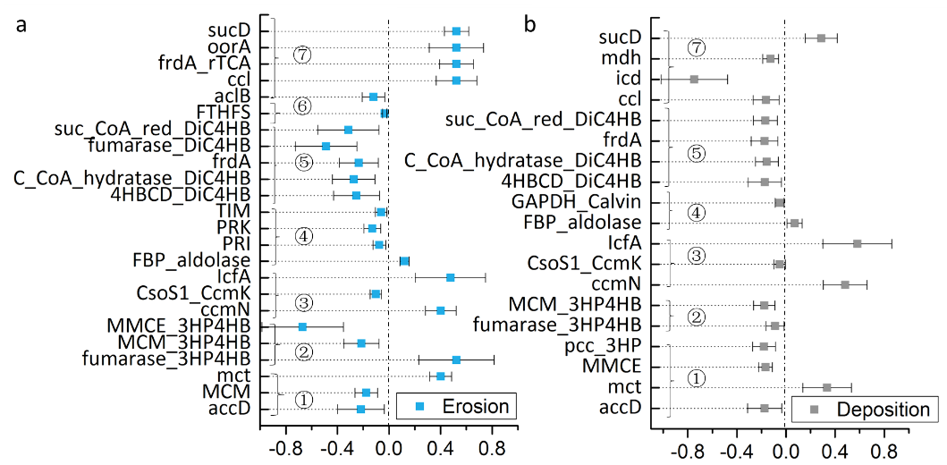
Figure S4. Significantly changed microbial carbon fixation genes by (a) soil erosion and (b) soil deposition. ①3-hydroxypropionate cycle; ②3-hydroxypropionate/4-hydroxybutyrate cycle; ③carboxysome; ④calvin cycle; ⑤dicarboxylate/4-hydroxybutyrate cycle; ⑥reductive acetyl–CoA pathway; and ⑦reductivesuc tricarboxylic acid cycle. The confidence interval is 0.90. Abbreviations of gene names: accD, acetyl-CoA carboxylase beta subunit; MCM, methylmalonyl-CoA mutase; ccmN, carbon dioxide concentrating mechanism protein; lcfA, long-chain fatty acid content; PRI, plasmid IncL/M family conjugative primase; TIM, triosephosphate isomerase; frdA, anaerobic fumarate reductase catalytic and NAD/flavoprotein subunit; FTHFS, fomate-tetrahydrofolate ligase; aclB, ATP-citrate lyase beta subunit; ccl, citrulline cluster-linked gene; oorA, 2-oxoglutarate-acceptor oxidoreductase subunit OorA; sucD, succinyl-CoA synthetase subunit alpha; icd, isocitrate dehydrogenase; mdh, malate dehydrogenase.

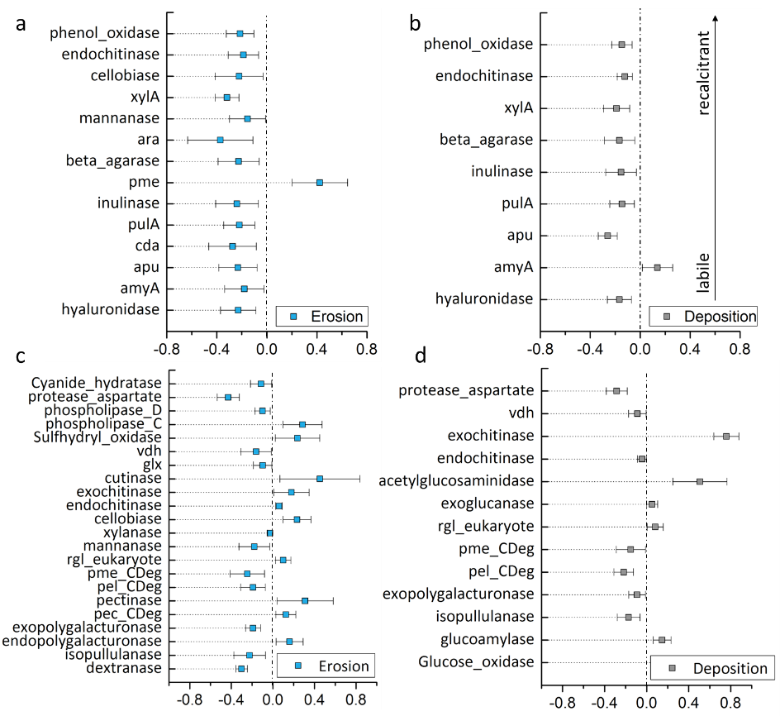
Figure S5. The response ratio results showing significantly changed (a) archaeal carbon degradation genes at the eroded site; (b) archaeal carbon degradation genes at the deposited site; (c) fungal carbon degradation genes at the eroded site; and (d) fungal carbon degradation genes at the deposited site. The confidence interval is 0.90. Abbreviations of gene names: amyA, alpha-amylase; apu, amylopullulanase; cda, cytidine deaminase; pulA, glycogen debranching enzyme; pme, Pectinesterase; ara, alpha-N-arabinofuranosidase; xylA, xylose isomerase; glx, glyoxalase; vdh, vanillin dehydrogenase.

Figure S6. Relative abundances of phosphorus cycling genes. Asterisk indicates significant differences analyzed by two-tailed t-tests. **P<0.01. Abbreviations of gene names: ppk, polyphosphate kinase; ppx, exopolyphosphatase.
Figure S7. Relative abundances of potassium cycling genes. Asterisk indicates significant differences analyzed by two-tailed t-tests. **P<0.01; *P<0.05. Abbreviations of gene names: kdpA, potassium-transporting ATPase subunit A; kefBC, glutathione-regulated potassium-efflux system protein (K(+)/H(+) antiporter); ktrBD, ktr system potassium uptake protein B; kup, potassium transporter; trkA, potassium transporter membrane protein; trkGH, potassium uptake transporter.

Figure S8. The Pearson correlation between soil pH and microbial taxonomic α-diversity measured by the Simpson index.

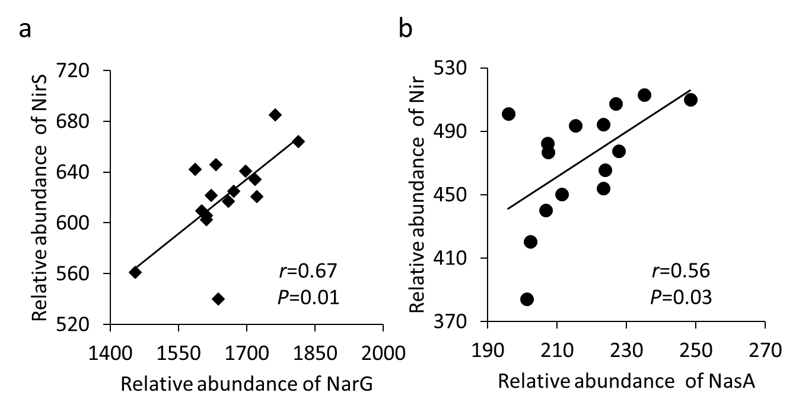
Figure S9. Pearson correlations between (a) relative abundance of narG and nirS; and (b) relative abundance of nasA and nir.

Figure S10 Percent change of significantly changed stress genes (a) at eroded sites (b) at deposited sites. Asterisk indicates significant differences analyzed by T-test. ***P<0.01; **P<0.05; *P<0.10.

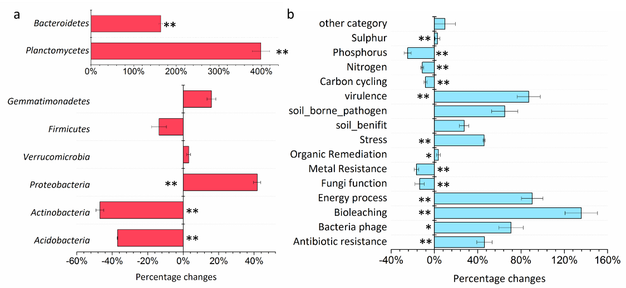
Figure S11. Percentage changes in relative abundance between universal section (ECD overlap) and representative section (CD-E) (a) at the phylum level and (b) at the gene category level. E: erosion; C: control; D: deposition. Asterisk indicates significant differences analyzed by ANOVA. **P<0.01; *P<0.05.

Table S1. Summary of environmental variable measurements
 | Eroded sites | Control | Deposited sites
Soil Tª (ºC) | 19.74±0.21^{b}* | 18.94±0.39 | 18.38±0.20
Water content(% w/w) | 5.00±0.00 | 5.00±0.00 | 5.00±0.00
pH | 7.13±0.05 | 7.10±0.10 | 7.10±0.08
TOC (%) | 1.41±0.03* | 1.58±0.09 | 1.52±0.08
DOC (mg/kg) | 65.48±6.41 | 74.13±3.43 | 123.46±20.59**
NO₃⁻ (mg/kg) | 4.34±0.16 | 4.13±0.63 | 5.90±1.04
TN (%) | 0.16±0.00 | 0.17±0.01 | 0.17±0.01
NH₄⁺ (mg/kg) | 5.39±0.68 | 6.00±0.73 | 7.89±1.20
Dv | 2.67±0.01 | 2.68±0.01 | 2.67±0.02
Sand(%) | 72.48±1.10 | 71.18±1.50 | 71.98±2.82
Silt(%) | 15.18±0.60 | 16.02±0.76 | 15.52±1.42
Clay(%) | 12.34±0.53 | 12.80±0.75 | 12.50±1.41
MBC (mg/kg) | 288.80±49.70 | 226.84±45.36 | 263.45±51.48
MBN (mg/kg) | 35.87±8.14 | 24.27±6.80 | 28.80±9.23
Plant species richness | 177.20±19.19 | 159.80±37.13 | 129.40±14.60
Plant coverage (%) | 36.38±2.95* | 53.29±8.27 | 57.54±8.05
Soil respiration (μmol/m²/s) | 1.06±0.06* | 1.15±0.06 | 1.30±0.05**
ªAbbreviations: T – temperature; TOC – total organic carbon; DOC – dissolved organic carbon; TN – total nitrogen; Dv – volume fractal dimension of soil particles; MBC – microbial biomass carbon; MBN – microbial biomass nitrogen.
^{b}All data are presented as mean ± s.e. calculated from five replicates. The significantly changed mean values as compared to the control sites were indicated by asterisks. **P<0.05; *P<0.10.

Table S2. Three nonparametric dissimilarity tests to compare treatments with their controls
Taxonomic composition |  |  |  |  | Functional gene composition
Level |  | MRPP | Anosim | Adonis | Level |  | MRPP | Anosim | Adonis
Phylum | Eª vs C | 0.211 | 0.277 | 0.158 | Category | E vs C | 0.0733 | 0.048^{b} | 0.068
 | D vs C | 0.062 | 0.061 | 0.038 |  | D vs C | 0.027 | 0.019 | 0.023
Class | E vs C | 0.173 | 0.163 | 0.101 | Sub1 | E vs C | 0.055 | 0.089 | 0.060
 | D vs C | 0.045 | 0.056 | 0.045 |  | D vs C | 0.011 | 0.018 | 0.013
Order | E vs C | 0.141 | 0.257 | 0.104 | Sub2 | E vs C | 0.054 | 0.035 | 0.044
 | D vs C | 0.056 | 0.097 | 0.042 |  | D vs C | 0.008 | 0.007 | 0.001
Family | E vs C | 0.140 | 0.249 | 0.140 | Family | E vs C | 0.018 | 0.022 | 0.021
 | D vs C | 0.061 | 0.074 | 0.044 |  | D vs C | 0.009 | 0.007 | 0.001
Genus | E vs C | 0.146 | 0.188 | 0.106 | Probe | E vs C | 0.027 | 0.039 | 0.016
 | D vs C | 0.062 | 0.077 | 0.038 |  | D vs C | 0.013 | 0.036 | 0.016
Specie | E vs C | 0.007 | 0.009 | 0.001
 | D vs C | 0.009 | 0.003 | 0.001
ªE: the eroded site; C: the control site; and D: the deposited site.
^{b}Values of significance at P<0.05 are shown in bold.

Table S3. Diversity indices of sequencing and GeoChip data
 | Phylogenetic diversity | Microbial species richness | Sequencing -  the Shannon index | Sequencing -  the inverse Simpson index | GeoChip -  the Shannon index | GeoChip -  The inverse Simpson index
Erosion | 193±4bª | 5515±200a | 7.316±0.069a | 650±97a | 9.956±0.157a | 21261±3223a
Control | 200±4a | 5686±195a | 7.352±0.091a | 657±148a | 9.713±0.103b | 16569±1631b
Deposition | 195±5ab | 5509±141a | 7.351±0.032a | 683±69a | 9.882±0.090a | 19611±1746ab
ªAll data are presented as mean ± s.e. calculated from five replicates. Significant (P<0.05) differences among samples are indicated by alphabetic letters.

Table S4. Weighted and unweighted net relatedness indices (NRI) values calculated based on phylogenetic distance matrices.
 | Erosion | Control | Deposition
Weight | 3.57±0.91ª* | 1.65±0.47 | 4.34±0.50***
Unweighted | 4.06±0.96*** | 0.31±0.45 | 3.95±0.46***
ªAll data are presented as mean ± s.e. calculated from five replicates. Asterisk indicates significant differences. *P<0.10; **P< 0.05; ***P<0.01.

Table S5. Percentage changes of nitrogen cycling genes in bacteria, archaea and fungi
Gene category | Name | Bacteria |  | Archaea |  | Fungi
 |  | ªE vs C | D vs C | E vs C | D vs C | E vs C | D vs C
Ammonification | gdh | -0.04% | -6.30% | -15.11% | -0.12% | -- | --
 | ureC | -4.62% | ^{b}-4.47% | -16.43% | -19.62% | -27.93% | -10.24%
Anammox | hzo | 36.30% | 22.61% | -- | -- | -- | --
Assimilatory N reduction | nasA | -1.18% | -11.60% | 23.83% | 31.08% | -- | --
 | nir | -5.09% | -8.78% | 5.88% | 11.22% | -- | --
Denitrification | narG | 1.28% | 4.20% | -20.14% | -8.47% | -- | --
 | nirK | 4.28% | -2.76% | -11.55% | -6.86% | -- | --
 | nirS | -1.44% | -1.42% | -- | -- | -- | --
 | norB | -1.36% | -4.94% | 17.44% | -16.56% | -- | --
 | nosZ | 2.73% | -3.41% | 2.82% | -5.69% | -- | --
Dissimilatory N reduction | napA | -11.37% | -1.82% | -20.50% | -16.44% | -- | --
 | nrfA | 2.93% | -0.85% | -- | -- | -- | --
Nitrification | amoA | -7.56% | -2.39% | -12.76% | 0.10% | -- | --
 | hao | -14.53% | -29.61% | -- | -- | -- | --
Nitrogen fixation | nifH | -8.04% | 0.62% | -14.14% | -3.44% | -- | --
ªE: the eroded site; C: the control site; and D: the deposited site.
^{b}The significant (P<0.05) percentages of changes are shown in bold.

Table S6. Correlations between carbon degradation genes and amoA & ureC
C degradation genes | amoA | ureC | C degradation genes |  | amoA | ureC
Glucose_oxidase_fungi | -0.28 | -0.24 | xylanase |  | -0.14 | 0.04
dextranase_fungi | 0.96 | 0.81 | CDH_2_carveol_dehydrogenase |  | -0.44 | 0.05
invertase_fungi | 0.02 | 0.18 | cellobiase |  | 0.02 | 0.47
lactase_fungi | -0.15 | -0.08 | endoglucanase |  | 0.50 | -0.09
hyaluronidase | ª0.70 | 0.33 | exoglucanase |  | -0.19 | -0.48
amyA | 0.21 | -0.17 | camDCBA |  | 0.30 | 0.51
amyX | 0.02 | -0.47 | acetylglucosaminidase |  | 0.21 | 0.43
apu | 0.13 | 0.48 | chitin_deacetylase_fungi |  | -0.12 | 0.14
cda | 0.69 | 0.39 | chitinase |  | 0.10 | 0.25
glucoamylase | 0.25 | 0.64 | endochitinase |  | 0.11 | 0.25
isopullulanase | 0.09 | 0.60 | exochitinase |  | -0.05 | 0.31
nplT | 0.41 | 0.37 | cutinase |  | 0.16 | 0.19
pulA | 0.67 | 0.26 | glx |  | 0.43 | 0.07
inulinase | 0.89 | 0.43 | Ligninase |  | -0.28 | -0.08
endopolygalacturonase_fungi | -0.21 | -0.27 | mnp |  | 0.09 | 0.03
exopolygalacturonase_fungi | 0.80 | 0.33 | phenol_oxidase |  | -0.12 | 0.03
pec_CDeg | -0.46 | -0.20 | vanA |  | 0.11 | 0.06
pectate_lyase | 0.61 | 0.25 | vdh |  | 0.12 | 0.45
pectin_lyase_Oomycetes | 0.17 | 0.34 | CDH |  | -0.28 | -0.31
pectinase | -0.41 | -0.30 | limEH |  | -0.06 | -0.15
pel_CDeg | 0.30 | 0.80 | LMO |  | -0.39 | -0.31
Pg_Oomycetes | -0.50 | -0.39 | alpha_galactosidase_fungi |  | -0.02 | -0.14
pme | 0.51 | 0.49 | Sulfhydryl_oxidase |  | -0.45 | -0.16
pme_CDeg | 0.62 | 0.57 | phospholipase_A2_fungi |  | 0.07 | -0.47
rgaE | 0.33 | 0.48 | phospholipase_C_fungi |  | -0.64 | -0.42
rgh | 0.55 | 0.12 | phospholipase_D_fungi |  | 0.51 | -0.15
rgl | 0.54 | 0.56 | metalloprotease_fungi |  | 0.21 | 0.16
alginase | -0.17 | 0.28 | protease_aspartate_fungi |  | 0.76 | 0.45
beta_agarase | 0.35 | 0.12 | protease_cysteine_fungi |  | 0.93 | 0.45
ara | 0.15 | -0.12 | protease_serine_fungi |  | 0.11 | 0.17
mannanase | 0.74 | 0.57 | Cyanide_hydratase_Fungi |  | 0.51 | 0.51
xylA | -0.30 | -0.55
ªThe significant (P<0.05) Pearson correlations are shown in bold.

