Supplementary Materials

Table 1. Glucose and cellulose δ13C values (‰) by pulse and round. These δ13Csubstrate values were used as end-members in the isotopic mass balance equation to calculate priming (Equation 1).

|  |  |  |  |  |  |  |
| --- | --- | --- | --- | --- | --- | --- |
|  | **Pulse 1** | | **Pulse 2** | | **Pulse 3** | |
|  | **Round 1** | **Round 2** | **Round 1** | **Round 2** | **Round 1** | **Round 2** |
| **Glucose** | 73.4 | 68.9 | 115.2 | 98.6 | 92.0 | 113.5 |
| **Cellulose** | 8.8 | -21.2 | 76.4 | 234.1 | 494.9 | 494.9 |



Figure 1. Total respired C (μg CO2-C g-1 soil C) in unamended and glucose treatments in surface, transition, and permafrost layers over time (in days) after glucose pulse (DAP) (primary x-axis). The secondary x-axis indicates day since the start of incubation (DOI). The x-axis was square-root transformed to make it easier to see values in the first 15 DAP. Bars are one standard error from the mean. Note that the scale for the y-axis is different for each layer.



Figure 2. Total respired δ13CO2 (‰) in unamended and glucose treatments in surface, transition, and permafrost layers over time (in days) after each glucose pulse (DAP) (primary x-axis). The secondary x-axis indicates day since the start of incubation (DOI). The x-axis was square-root transformed to make it easier to see values in the first 15 DAP. Bars are one standard error from the mean. Note that the scale for the y-axis is different for each layer.

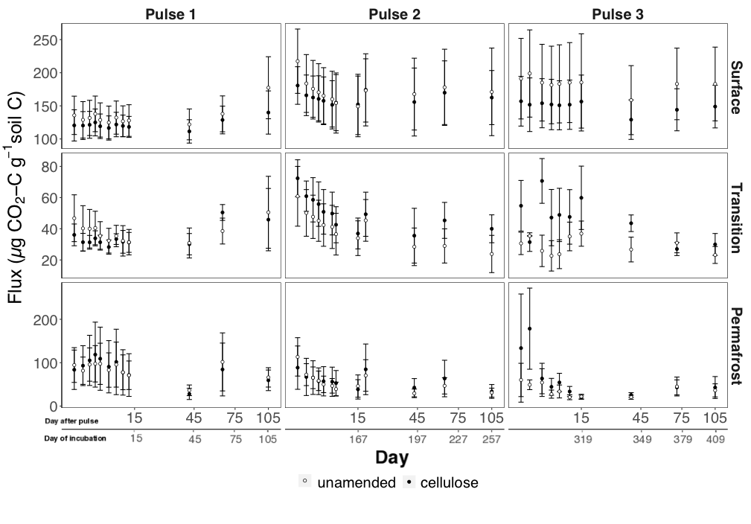

Figure 3. Total respired C (μg CO2-C g-1 soil C) in unamended and cellulose treatments in surface, transition, and permafrost layers over time (in days) after each cellulose pulse (DAP) (primary x-axis). The secondary x-axis indicates day since the start of incubation (DOI). The x-axis was square-root transformed to make it easier to see values in the first 15 DAP. Bars are one standard error from the mean. Note that the scale for the y-axis is different for each layer.



Figure 4. Total respired δ13CO2 (‰) in unamended and cellulose treatments in surface, transition, and permafrost layers over time (in days) after each cellulose pulse (DAP) (primary x-axis). The secondary x-axis indicates day since the start of incubation (DOI). The x-axis was square-root transformed to make it easier to see values in the first 15 DAP. Bars are one standard error from the mean. Note that the scale for the y-axis is different for each layer.

Table 2. Mixed linear effects model parameters for glucose and cellulose priming effects following each amendment pulse. Coefficients represent daily priming values (μg CO2-C g-1 soil C), calculated from the effect size on the intercept. The intercept for the glucose model is: unamended surface soil, at 1 DAP, Pulse 1. The intercept for the cellulose is: unamended surface soil, at 1 DAP, Pulse 2. If the Min and Max CI do not overlap zero, it indicated a significant priming response (bolded).

|  |  |  |  |  |  |  |
| --- | --- | --- | --- | --- | --- | --- |
| Response variable | Full model | Final Model | Variable | Coefficient | Min CI | Max CI |
| ***Glucose priming*** | Pulse x DAP x Layer | Pulse | Intercept (Surface, 1 DAP, Pulse 1) | 5.72 | -22.81 | 35.11 |
| (μg CO2-C g-1 soil C) | | DAP | **Surface x 2 DAP** | **-42.55** | **-77.36** | **-9.09** |
|  |  | Layer | Surface x 3 DAP | -17.06 | -52.17 | 17.95 |
|  |  | Layer x DAP | Surface x 4 DAP | 14.65 | -19.95 | 49.98 |
|  |  | DAP x Pulse | Surface x 5 DAP | 13.08 | -21.63 | 46.59 |
|  |  |  | Surface x 7 DAP | 1.43 | -35.14 | 37.75 |
|  |  |  | Surface x 9 DAP | -2.47 | -36.48 | 31.33 |
|  |  |  | Surface x 11 DAP | -1.58 | -37.7 | 34.03 |
|  |  |  | Surface x 13 DAP | -1.38 | -37.29 | 33.13 |
|  |  |  | Surface x 43 DAP | 7.04 | -27.38 | 40.73 |
|  |  |  | Surface x 65 DAP | 5.73 | -29.03 | 41.46 |
|  |  |  | Surface x 105 DAP | -5.28 | -40.28 | 29.68 |
|  |  |  | Transition x 1 DAP | 21.97 | -19.71 | 63.46 |
|  |  |  | Transition x 2 DAP | -9.57 | -55.91 | 37.76 |
|  |  |  | Transition x 3 DAP | 16.71 | -30.07 | 63.26 |
|  |  |  | Transition x 4 DAP | 36.23 | -8.14 | 81.07 |
|  |  |  | Transition x 5 DAP | 29.37 | -14.72 | 73.26 |
|  |  |  | Transition x 7 DAP | 19.01 | -25.73 | 64.79 |
|  |  |  | Transition x 9 DAP | 11.7 | -32.26 | 55.02 |
|  |  |  | Transition x 11 DAP | 9.54 | -34.46 | 52.97 |
|  |  |  | Transition x 13 DAP | 10 | -33.56 | 56.6 |
|  |  |  | Transition x 43 DAP | 14.03 | -30.81 | 59.23 |
|  |  |  | Transition x 65 DAP | 10.11 | -34.3 | 54.93 |
|  |  |  | Transition x 105 DAP | -1.91 | -44.87 | 43.74 |
|  |  |  | **Permafrost x 1 DAP** | **91.32** | **58.46** | **123.17** |
|  |  |  | **Permafrost x 2 DAP** | **86.82** | **47.35** | **126.75** |
|  |  |  | **Permafrost x 3 DAP** | **60.71** | **24.09** | **97.09** |
|  |  |  | **Permafrost x 4 DAP** | **67.59** | **31.23** | **102.93** |
|  |  |  | **Permafrost x 5 DAP** | **58.44** | **22.32** | **95.47** |
|  |  |  | **Permafrost x 7 DAP** | **64.78** | **29.39** | **101.69** |
|  |  |  | Permafrost x 9 DAP | 24.3 | -12.62 | 61.34 |
|  |  |  | Permafrost x 11 DAP | 35.9 | -0.6 | 73.03 |
|  |  |  | Permafrost x 13 DAP | 15.3 | -21.07 | 54.35 |
|  |  |  | Permafrost x 43 DAP | 11.36 | -25.44 | 48.13 |
|  |  |  | Permafrost x 65 DAP | 6.53 | -29.06 | 42 |
|  |  |  | Permafrost x 105 DAP | -1.99 | -38.56 | 34.79 |
|  |  |  | **1 DAP x Pulse 2** | **55.88** | **26.56** | **84.08** |
|  |  |  | **1 DAP x Pulse 3** | **-41.04** | **-69.06** | **-12.55** |
|  |  |  | 2 DAP x Pulse 2 | -18.44 | -58.19 | 21.76 |
|  |  |  | 2 DAP x Pulse 3 | -22.35 | -75.37 | 28.72 |
|  |  |  | 3 DAP x Pulse 2 | -28.33 | -68.56 | 12.56 |
|  |  |  | 3 DAP x Pulse 3 | -40.58 | -83.53 | 0.74 |
|  |  |  | 4 DAP x Pulse 2 | -18.96 | -59.58 | 22.15 |
|  |  |  | 4 DAP x Pulse 3 | -19.86 | -61.09 | 20.33 |
|  |  |  | 5 DAP x Pulse 2 | -12.65 | -51.59 | 28.02 |
|  |  |  | 5 DAP x Pulse 3 | 1.96 | -38.03 | 42.87 |
|  |  |  | 7 DAP x Pulse 2 | -14.95 | -53.87 | 24.24 |
|  |  |  | 7 DAP x Pulse 3 | 6.44 | -36.06 | 46.97 |
|  |  |  | 9 DAP x Pulse 2 | 0.08 | -39.62 | 40.83 |
|  |  |  | 9 DAP x Pulse 3 | 1.36 | -39.49 | 41.22 |
|  |  |  | 11 DAP x Pulse 2 | 5.8 | -34.07 | 47.4 |
|  |  |  | 11 DAP x Pulse 3 | 5.47 | -35.19 | 45.21 |
|  |  |  | 13 DAP x Pulse 2 | 8.39 | -30.88 | 48.36 |
|  |  |  | 13 DAP x Pulse 3 | 4.57 | -35.24 | 43.76 |
|  |  |  | 43 DAP x Pulse 2 | -1.06 | -39.76 | 40.23 |
|  |  |  | 43 DAP x Pulse 3 | 4.07 | -36.41 | 45.1 |
|  |  |  | 65 DAP x Pulse 2 | 1.81 | -38.27 | 41.99 |
|  |  |  | 65 DAP x Pulse 3 | 0.79 | -40.75 | 40.81 |
|  |  |  | 105 DAP x Pulse 2 | 2.72 | -38.06 | 42.82 |
|  |  |  | 105 DAP x Pulse 3 | 8.25 | -33.1 | 49.37 |
| ***Cellulose priming*** | Pulse x DAP x Layer | Pulse | Intercept (Surface, Pulse 2) | -16.87 | -46.95 | 12.78 |
| (μg CO2-C g-1 soil C) | | Layer | **Surface x Pulse 3** | **-42.54** | **-49.41** | **-34.94** |
|  |  | Pulse x Layer | Transition x Pulse 2 | 4.97 | -43.03 | 51.4 |
|  |  |  | Transition x Pulse 3 | 8.85 | -0.02 | 24.77 |
|  |  |  | Permafrost x Pulse 2 | -1.7 | -38.22 | 35.93 |
|  |  |  | **Permafrost x Pulse 3** | **8.29** | **7.66** | **28.67** |