Supplemental materials

The biogeographic pattern of microbial functional genes along an altitudinal gradient of the Tibetan pasture
Qi Qi^{1,†}, Mengxin Zhao^{1,†}, Shiping Wang^{2, 3}, Xingyu Ma¹, Yuxuan Wang^{4,5}, Ying Gao¹, Qiaoyan Lin⁶, Xiangzhen Li⁷, Baohua Gu⁸, Guoxue Li⁹, Jizhong Zhou^{1,10,11,12} and Yunfeng Yang^{1,*}

¹State Key Joint Laboratory of Environment Simulation and Pollution Control, School of Environment, Tsinghua University, Beijing, China, ²Key Laboratory of Alpine Ecology and Biodiversity, Institute of Tibetan Plateau Research, Chinese Academy of Sciences, Beijing, China, ³CAS Center for Excellence in Tibetan Plateau Earth Science, Beijing, China, ⁴Department of Earth System Sciences, Tsinghua University, Beijing, China, ⁵Department of Earth and Atmospheric Sciences, University of Houston, Houston, TX, USA, ⁶Key Laboratory of Adaption and Evolution of Plateau Biota, Northwest Institute of Plateau Biology, Chinese Academy of Sciences, Xining, Qinghai, China, ⁷Key Laboratory of Environmental and Applied Microbiology; Environmental Microbiology Key Laboratory of Sichuan Province, Chengdu Institute of Biology, Chinese Academy of Sciences, Chengdu, Sichuan, China, ⁸Environmental Sciences Division, Oak Ridge National Laboratory, Oak Ridge, Tennessee, USA, ⁹College of Resources and Environmental Science, China Agricultural University, Beijing, China, ¹⁰Institute for Environmental Genomics and Department of Microbiology and Plant Biology, University of Oklahoma, Norman, Oklahoma, USA, ¹¹Earth Sciences Division, Lawrence Berkeley National Laboratory, Berkeley, California, USA and ¹²Collaborative Innovation Center for Regional Environmental Quality, School of Environment, Tsinghua University, Beijing, China

†These authors contributed equally to this work.
*Address correspondence to Yunfeng Yang, E-mail: yangyf@tsinghua.edu.cn; Phone: +86-010-62784692; Fax: +86-010-62785687;

Fig. S1 Percentages of genes detected at one (unique), two, three and four (ubiquitous) elevations.
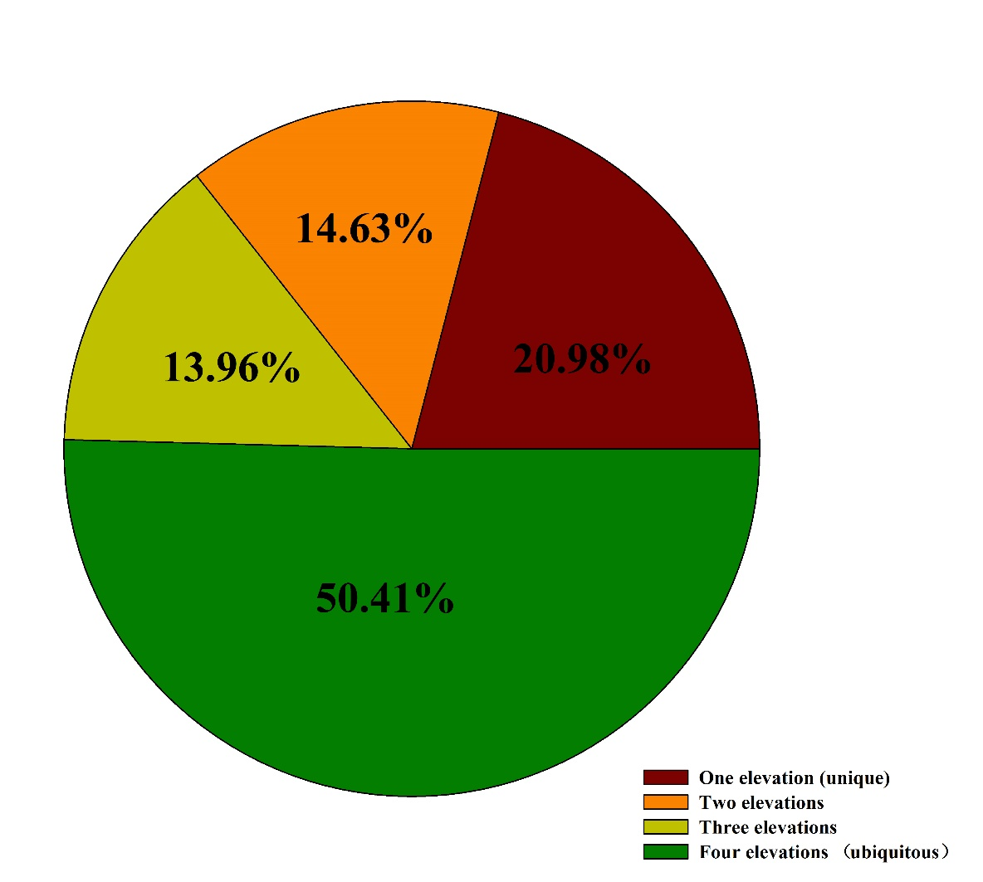

Fig. S2 Correlations between geographical distances and numbers of shared genes among different soil samples. Pearson correlation and TDIST tests were used to calculate r and P values, respectively.

Fig. S3 The canonical correspondence analysis (CCA) between GeoChip data and environmental variables. Symbols represent GeoChip data and arrows represent seven environmental variables (soil temperature (T), pH, nitrate (NO₃⁻), total phosphorus measured at 10-20cm depth (TP_{10-20 cm}), aboveground vegetation biomass, species number and diversity).
Fig. S4 Variation partitioning analysis that partitions environmental variables into three groups: (A) soil temperature (T); (B) soil pH, nitrate (NO₃⁻) and total phosphorus measured at 10-20 cm depth (TP_{10-20 cm}); (C) aboveground vegetation biomass, species number and diversity. Non-overlap area of each circle and overlap area of adjacent circles mean individual effects of each group and joint effects of adjacent groups, respectively. The unexplained microbial community structure showed at the bottom.
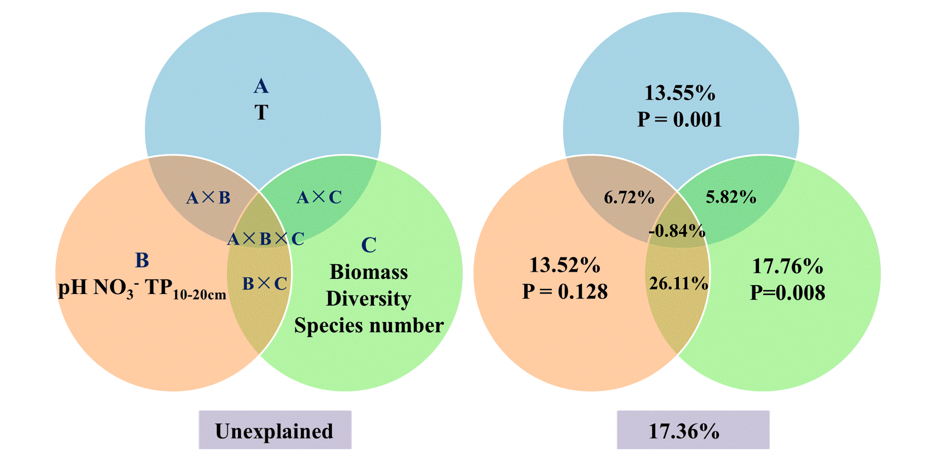
Fig. S5 Relative abundances of genes associated with (A) selected carbon degradation, (B) carbon fixation and (C) methane. All data are presented as mean ±s.e. calculated by biological triplicates. Significant (P < 0.050) differences among elevations are indicated by different alphabetic letters above the bars.
Fig. S6 Relative abundances of genes associated with nitrogen cycling. All data are presented as mean ±s.e.. Alphabetic letters above the bars represent significant (P < 0.050) differences among elevations.
Fig. S7 Relative abundances of genes associated with (A) cold shock, (B) oxygen limitation, (C) radiation, (D) glucose limitation and (E) mercury resistance. All data are presented as mean ±s.e. calculated by biological triplicates. Significant (P < 0.050) differences among elevations are indicated by different alphabetic letters above the bars.

SUPPORTING TABLES
Table S1. Correlations among total organic carbon, total nitrogen and total phosphorus.
 | r
TOC_{0-10 cm}ª - TN_{0-10 cm} | 0.88**^{b}
TOC_{0-10 cm} - TP_{0-10 cm} | 0.81**
TOC_{0-10 cm} - TN_{10-20 cm} | 0.87**
TOC_{10-20 cm} - TP_{0-10 cm} | 0.63*
TN_{0-10 cm} - TP_{0-10 cm} | 0.96***
ªAbbreviations: TOC - total organic carbon; TN - total nitrogen; TP - total phosphorus; 0-10 cm and 10-20 cm - soil variables measured at 0-10 and 10-20 cm depth, respectively.
^{b}*P < 0.050, **P < 0.010, ***P < 0.001
Table S2. The richness, diversity and evenness indices of functional genes at each elevation.
 | 3200m | 3400m | 3600m | 3800m
Richnessª | 31528 | 37752 | 42226 | 43816
Shannon index | 10.27c^{b} | 10.44b | 10.54a | 10.58a
Simpson index | 28900.04c | 34076.60b | 37935.60a | 39470.65a
Pielou evenness | 0.99961a | 0.99962a | 0.99967a | 0.99959a
Simpson evenness | 0.99210a | 0.99209a | 0.99297a | 0.99140a
ªDetected gene number.
^{b}Significant (P<0.05) differences among elevations are indicated by different alphabetic letters.

Table S3. Differences of microbial communities among elevations as examined by the dissimilarity tests of adonis.
Sites (m) | Statistic R² | P
3200-3400 | 0.62 | 0.031
3200-3600 | 0.73 | 0.001
3200-3800 | 0.81 | 0.001
3400-3600 | 0.66 | 0.001
3400-3800 | 0.70 | 0.001
3600-3800 | 0.73 | 0.001

Table S4 The elevation-decay relationships of different functional categories.
Group | r of correlation | P of correlationª | z | t | n | P^{b} | Lower 95% CI |  | Upper 95% CI^{c}
Whole microbial community | -0.80 | <0.001 | 0.0093 | -209.6 | 999 | <0.001 | -1.22E-04 | 5.30E-05
Carbon cycling | -0.85 | <0.001 | 0.0076 | -216.7 | 999 | <0.001 | -5.04E-05 | 8.76E-05
Carbon fixation | -0.83 | <0.001 | 0.0061 | -213.3 | 999 | <0.001 | -1.04E-04 | 8.87E-06
Carbon degradation | -0.86 | <0.001 | 0.0078 | -218.7 | 999 | <0.001 | -2.20E-05 | 1.16E-04
Methane | -0.73 | <0.001 | 0.0111 | -179.0 | 999 | <0.001 | -6.42E-05 | 1.79E-04
Nitrogen cycling | -0.83 | <0.001 | 0.0065 | -206.6 | 999 | <0.001 | -7.92E-05 | 4.37E-05
Ammonification | -0.82 | <0.001 | 0.0062 | -204.7 | 999 | <0.001 | -4.98E-05 | 6.82E-05
Anammox | -0.75 | <0.001 | 0.0127 | -184.4 | 999 | <0.001 | -1.11E-04 | 1.58E-04
Assimilatory N reduction | -0.83 | <0.001 | 0.0065 | -208.8 | 999 | <0.001 | -4.26E-05 | 8.02E-05
Denitrification | -0.78 | <0.001 | 0.0058 | -194.0 | 999 | <0.001 | -6.14E-06 | 1.10E-04
Dissimilatory N reduction | -0.83 | <0.001 | 0.0090 | -210.0 | 999 | <0.001 | -8.62E-05 | 8.29E-05
Nitrogen fixation | -0.80 | <0.001 | 0.0055 | -191.5 | 999 | <0.001 | -1.81E-05 | 9.33E-05
Nitrification | -0.81 | <0.001 | 0.0085 | -202.3 | 999 | <0.001 | -5.09E-05 | 1.13E-04
ªP value of Pearson correlation.
^{b}P value of one sample t-test.
^{c}CI, confidence interval.
Table S5. The percentages of unique genes to detected genes and numbers of unique genes at each elevation.
Category | 3200m | 3400m | 3600m | 3800m
Antibiotic resistance | 0.008 (10)ª | 0.025 (36) | 0.131 (216) | 0.123(197)
Bacteria phage | 0.016 (4) | 0.030 (4) | 0.167 (69) | 0.190 (80)
Bioleaching | 0.005 (1) | 0.038 (11) | 0.158 (57) | 0.202 (77)
Carbon cycling | 0.006 (25) | 0.026(131) | 0.100 (552) | 0.129 (742)
Energy process | 0.003 (1) | 0.017 (7) | 0.101 (47) | 0.131 (66)
Mental resistance | 0.006 (23) | 0.023 (100) | 0.089 (430) | 0.125 (639)
Nitrogen cying | 0.006 (19) | 0.025 (89) | 0.096 (370) | 0.114 (453)
Complex carbon degradation | 0.004 (33) | 0.021 (193) | 0.062 (586) | 0.112 (1137)
Phosphorus  cyling | 0.004 (2) | 0.017 (10) | 0.119 (81) | 0.164 (118)
Stress | 0.007 (53) | 0.027 (243) | 0.123 (1276) | 0.143 (1514)
Sulphur cyling | 0.009 (11) | 0.031 (44) | 0.107 (168) | 0.149 (244)
Virulence | 0.005 (6) | 0.026 (38) | 0.131 (234) | 0.139 (249)
ªValues in parentheses are endemic gene numbers.

Table S6. The number of shared genes and the percentage of shared to detected genes between two elevations.
Sites | 3200m | 3400m | 3600m | 3800m
3200m |  | 29669 (56.12)ª | 29832 (56.41) | 28852 (54.57)
3400m |  |  | 33250 (62.89) | 33590 (63.54)
3600m |  |  |  | 34614 (65.47)
3800m
ªValues in parentheses are percentages.

Table S7. Major topological properties of the molecular ecological networks of carbon fixation genes and amoA genes.
Community | Carbon fixation genes | amoA genes
Number of genes used for network construction | 684 | 371
Network size (n) | 350 | 250
Modularity (number of modules) | 0.637 (45) | 0.626 (25)
R² of power-law | 0.923 | 0.923
Average connectivity (avgK) | 3.943 | 4.696
Average clustering coefficient (avgCC) | 0.207 | 0.267
Average path distance (GD) | 3.488 | 3.479
Harmonic geodesic distance (HD) | 6.361 | 5.328
Centralization of degree (CD) | 0.046 | 0.082
Centralization of betweenness (CB) | 0.100 | 0.119
Centralization of stress centrality (CS) | 0.513 | 0.537
Maximal eigenvector centrality | 0.265 | 0.272
Centralization of eigenvector centrality (CE) | 0.244 | 0.244
Density (D) | 0.011 | 0.019
Connectedness (Con) | 0.668 | 0.726
Efficiency | 0.987 | 0.979

Table S8. The correlations between relative abundances of functional genes and environmental variables.
Number | Environmental variable | Gene name | r | P
1 | NO₃— | nirK | 0.62 | 0.041
2 | NO₃— | nirS | 0.58 | 0.048
3 | NO₃— | norB | 0.74 | 0.014
4 | NO₃— | napA | 0.68 | 0.024
5 | NO₃— | amoA | 0.57 | 0.051
6 | NO₃— | gdh | 0.60 | 0.046
7 | NO₃— | hzo | 0.61 | 0.041
8 | NO₃— | NirB | 0.69 | 0.022
9 | NH₄⁺ | nirK | -0.58 | 0.046
10 | NH₄⁺ | nirS | -0.64 | 0.035
11 | NH₄⁺ | NiR | -0.59 | 0.045
12 | NH₄⁺ | nirK/nirS | 0.59 | 0.046
13 | Moisture | nirK/nirS | -0.46 | 0.123
14 | T | cspA | -0.74 | 0.010
15 | T | cspB | -0.90 | <0.001
16 | pH | mer | -0.78 | 0.001
17 | pH | merG | -0.64 | 0.021
ªAbbreviation: T - soil temperature

Table S9. The correlations between relative abundances of functional probes and N₂O flux.
Genebank number | Environemntal variables | Gene name | Organism | r | P
83972416 | N₂O flux | nosZ | uncultured alpha proteobacterium | 0.81 | 0.008
55469821 | N₂O flux | nosZ | uncultured bacterium | 0.69 | 0.036
110678855 | N₂O flux | nosZ | Roseobacter denitrificans OCh 114 | 0.71 | 0.034
157285377 | N₂O flux | nosZ | uncultured bacterium | -0.87 | 0.002
215512185 | N₂O flux | norB | Moraxella catarrhalis | -0.88 | 0.002

