Table S1. Summary of soil and site characteristics.

Site | Distance to center (m) | Direction | Latitude | Elevation (m) | Mean annual temperature (ºC) | Annual precipitation (mm³) | Soil water content / moisture (%) | pH | Total Carbon (g/kg) | Total Nitrogen (g/kg)
NWT | 0 | Center | 40.04 | 3186.00 | 2.50 | 798.74 | 7.79 | 5.15 | 3.93 | 0.15
 | 1 | East | 40.04 | 3186.00 | 2.50 | 798.74 | 10.07 | 5.03 | 5.66 | 0.22
 | 1 | North | 40.04 | 3186.00 | 2.50 | 798.74 | 8.07 | 5.27 | 2.36 | 0.11
 | 1 | South | 40.04 | 3186.00 | 2.50 | 798.74 | 13.18 | 4.76 | 9.95 | 0.35
 | 1 | West | 40.04 | 3186.00 | 2.50 | 798.74 | 10.29 | 5.03 | 3.70 | 0.16
 | 10 | East | 40.04 | 3186.00 | 2.50 | 798.74 | 12.55 | 4.59 | 12.78 | 0.33
 | 10 | North | 40.04 | 3186.00 | 2.50 | 798.74 | 8.77 | 4.82 | 16.95 | 0.48
 | 10 | South | 40.04 | 3186.00 | 2.50 | 798.74 | 35.01 | 5.33 | 16.47 | 0.42
 | 10 | West | 40.04 | 3186.00 | 2.50 | 798.74 | 16.90 | 4.25 | 13.91 | 0.32
 | 50 | East | 40.04 | 3186.00 | 2.50 | 798.74 | 14.25 | 4.30 | 24.83 | 0.68
 | 50 | North | 40.04 | 3186.00 | 2.50 | 798.74 | 10.73 | 4.45 | 26.36 | 0.81
 | 50 | South | 40.04 | 3186.00 | 2.50 | 798.74 | 25.42 | 5.22 | 4.05 | 0.16
 | 50 | West | 40.04 | 3186.00 | 2.50 | 798.74 | 18.97 | 5.01 | 6.91 | 0.21
 | 100 | East | 40.04 | 3186.00 | 2.50 | 798.74 | 34.91 | 4.58 | 9.84 | 0.26
 | 100 | North | 40.04 | 3186.00 | 2.50 | 798.74 | 21.48 | 4.29 | 17.15 | 0.41
 | 100 | South | 40.04 | 3186.00 | 2.50 | 798.74 | 19.30 | 5.07 | 14.82 | 0.41
 | 100 | West | 40.04 | 3186.00 | 2.50 | 798.74 | 9.72 | 4.66 | 11.37 | 0.32
 | 200 | East | 40.04 | 3186.00 | 2.50 | 798.74 | 5.82 | 4.92 | 8.84 | 0.28
 | 200 | North | 40.04 | 3186.00 | 2.50 | 798.74 | 22.75 | 4.52 | 20.39 | 0.57
 | 200 | South | 40.04 | 3186.00 | 2.50 | 798.74 | 5.60 | 4.74 | 4.20 | 0.15
 | 200 | West | 40.04 | 3186.00 | 2.50 | 798.74 | 24.50 | 5.53 | 6.24 | 0.20
HFR | 0 | Center | 42.54 | 356.40 | 8.27 | 1099.73 | 33.93 | 4.00 | 11.99 | 0.42
 | 1 | East | 42.54 | 356.40 | 8.27 | 1099.73 | 30.00 | 4.17 | 16.59 | 0.49
 | 1 | North | 42.54 | 356.40 | 8.27 | 1099.73 | 33.14 | 3.74 | 16.80 | 0.55
 | 1 | South | 42.54 | 356.40 | 8.27 | 1099.73 | 35.87 | 3.70 | 8.65 | 0.31
 | 1 | West | 42.54 | 356.40 | 8.27 | 1099.73 | 29.87 | 3.78 | 16.28 | 0.47
 | 10 | East | 42.54 | 356.40 | 8.27 | 1099.73 | 36.55 | 3.41 | 15.14 | 0.46
 | 10 | North | 42.54 | 356.40 | 8.27 | 1099.73 | 50.95 | 3.95 | 22.03 | 0.68
 | 10 | South | 42.54 | 356.40 | 8.27 | 1099.73 | 29.47 | 3.69 | 25.17 | 0.76
 | 10 | West | 42.54 | 356.40 | 8.27 | 1099.73 | 44.80 | 3.69 | 22.15 | 0.72
 | 50 | East | 42.54 | 356.40 | 8.27 | 1099.73 | 55.15 | 4.70 | 35.21 | 1.38
 | 50 | North | 42.54 | 356.40 | 8.27 | 1099.73 | 24.39 | 3.61 | 28.95 | 0.92
 | 50 | South | 42.54 | 356.40 | 8.27 | 1099.73 | 31.18 | 3.72 | 17.46 | 0.60
 | 50 | West | 42.54 | 356.40 | 8.27 | 1099.73 | 24.35 | 4.04 | 8.93 | 0.30
 | 100 | East | 42.54 | 356.40 | 8.27 | 1099.73 | 34.27 | 3.68 | 14.13 | 0.49
 | 100 | North | 42.54 | 356.40 | 8.27 | 1099.73 | 18.20 | 3.94 | 10.92 | 0.40
 | 100 | South | 42.54 | 356.40 | 8.27 | 1099.73 | 18.93 | 4.07 | 11.61 | 0.43
 | 100 | West | 42.54 | 356.40 | 8.27 | 1099.73 | 45.73 | 3.62 | 39.22 | 1.27
 | 200 | East | 42.54 | 356.40 | 8.27 | 1099.73 | 18.25 | 4.19 | 8.90 | 0.32
 | 200 | North | 42.54 | 356.40 | 8.27 | 1099.73 | 41.54 | 3.77 | 28.08 | 0.68
 | 200 | South | 42.54 | 356.40 | 8.27 | 1099.73 | 39.48 | 3.78 | 20.90 | 0.71
 | 200 | West | 42.54 | 356.40 | 8.27 | 1099.73 | 45.26 | 3.44 | 24.32 | 0.58
AND | 0 | Center | 44.23 | 860.00 | 8.94 | 2261.22 | 25.05 | 5.91 | 4.66 | 0.21
 | 1 | East | 44.23 | 860.00 | 8.94 | 2261.22 | 29.29 | 5.37 | 11.30 | 0.26
 | 1 | North | 44.23 | 860.00 | 8.94 | 2261.22 | 64.63 | 4.43 | 35.51 | 0.42
 | 1 | South | 44.23 | 860.00 | 8.94 | 2261.22 | 22.45 | 6.13 | 3.67 | 0.17
 | 1 | West | 44.23 | 860.00 | 8.94 | 2261.22 | 32.95 | 6.09 | 16.18 | 0.45
 | 10 | East | 44.23 | 860.00 | 8.94 | 2261.22 | 50.48 | 5.18 | 21.09 | 0.46
 | 10 | North | 44.23 | 860.00 | 8.94 | 2261.22 | 28.49 | 5.37 | 10.45 | 0.36
 | 10 | South | 44.23 | 860.00 | 8.94 | 2261.22 | 34.69 | 5.56 | 13.40 | 0.39
 | 10 | West | 44.23 | 860.00 | 8.94 | 2261.22 | 39.92 | 5.83 | 34.19 | 0.59
 | 50 | East | 44.23 | 860.00 | 8.94 | 2261.22 | 44.60 | 4.00 | 41.89 | 0.63
 | 50 | North | 44.23 | 860.00 | 8.94 | 2261.22 | 56.34 | 4.07 | 36.13 | 0.42
 | 50 | South | 44.23 | 860.00 | 8.94 | 2261.22 | 32.30 | 5.45 | 31.15 | 0.81
 | 50 | West | 44.23 | 860.00 | 8.94 | 2261.22 | 24.95 | 5.62 | 8.76 | 0.30
 | 100 | East | 44.23 | 860.00 | 8.94 | 2261.22 | 56.12 | 4.80 | 34.86 | 0.65
 | 100 | North | 44.23 | 860.00 | 8.94 | 2261.22 | 60.38 | 4.16 | 44.91 | 0.67
 | 100 | South | 44.23 | 860.00 | 8.94 | 2261.22 | 28.15 | 5.61 | 13.33 | 0.40
 | 100 | West | 44.23 | 860.00 | 8.94 | 2261.22 | 42.87 | 5.22 | 13.52 | 0.35
 | 200 | East | 44.23 | 860.00 | 8.94 | 2261.22 | 34.93 | 5.07 | 19.17 | 0.43
 | 200 | North | 44.23 | 860.00 | 8.94 | 2261.22 | 19.70 | 5.46 | 2.59 | 0.12
 | 200 | South | 44.23 | 860.00 | 8.94 | 2261.22 | 19.35 | 5.77 | 3.19 | 0.16
 | 200 | West | 44.23 | 860.00 | 8.94 | 2261.22 | 26.85 | 5.78 | 6.54 | 0.25
CWT | 0 | Center | 35.05 | 864.00 | 12.62 | 1789.92 | 31.87 | 4.90 | 6.95 | 0.29
 | 1 | East | 35.05 | 864.00 | 12.62 | 1789.92 | 28.29 | 4.94 | 4.62 | 0.21
 | 1 | North | 35.05 | 864.00 | 12.62 | 1789.92 | 29.12 | 4.84 | 5.23 | 0.23
 | 1 | South | 35.05 | 864.00 | 12.62 | 1789.92 | 29.60 | 4.97 | 6.61 | 0.28
 | 1 | West | 35.05 | 864.00 | 12.62 | 1789.92 | 28.67 | 4.89 | 6.19 | 0.26
 | 10 | East | 35.05 | 864.00 | 12.62 | 1789.92 | 38.00 | 4.76 | 6.68 | 0.27
 | 10 | North | 35.05 | 864.00 | 12.62 | 1789.92 | 26.36 | 5.09 | 5.19 | 0.22
 | 10 | South | 35.05 | 864.00 | 12.62 | 1789.92 | 29.62 | 4.69 | 4.35 | 0.22
 | 10 | West | 35.05 | 864.00 | 12.62 | 1789.92 | 26.58 | 4.99 | 4.00 | 0.19
 | 50 | East | 35.05 | 864.00 | 12.62 | 1789.92 | 44.23 | 3.81 | 14.44 | 0.44
 | 50 | North | 35.05 | 864.00 | 12.62 | 1789.92 | 27.34 | 4.73 | 3.72 | 0.18
 | 50 | South | 35.05 | 864.00 | 12.62 | 1789.92 | 19.30 | 4.67 | 2.82 | 0.14
 | 50 | West | 35.05 | 864.00 | 12.62 | 1789.92 | 32.56 | 4.51 | 8.24 | 0.29
 | 100 | East | 35.05 | 864.00 | 12.62 | 1789.92 | 31.04 | 4.43 | 5.72 | 0.22
 | 100 | North | 35.05 | 864.00 | 12.62 | 1789.92 | 43.04 | 4.05 | 20.46 | 0.48
 | 100 | South | 35.05 | 864.00 | 12.62 | 1789.92 | 29.86 | 4.92 | 5.20 | 0.25
 | 100 | West | 35.05 | 864.00 | 12.62 | 1789.92 | 22.35 | 4.78 | 5.89 | 0.22
 | 200 | East | 35.05 | 864.00 | 12.62 | 1789.92 | 33.71 | 4.04 | 9.54 | 0.32
 | 200 | North | 35.05 | 864.00 | 12.62 | 1789.92 | 23.88 | 5.20 | 3.24 | 0.15
 | 200 | South | 35.05 | 864.00 | 12.62 | 1789.92 | 26.82 | 4.62 | 3.65 | 0.18
 | 200 | West | 35.05 | 864.00 | 12.62 | 1789.92 | 33.60 | 5.22 | 7.55 | 0.28
LUQ | 0 | Center | 18.32 | 385.80 | 23.62 | 3687.38 | 37.18 | 5.39 | 3.35 | 0.24
 | 1 | East | 18.32 | 385.80 | 23.62 | 3687.38 | 37.64 | 5.43 | 3.22 | 0.24
 | 1 | North | 18.32 | 385.80 | 23.62 | 3687.38 | 37.75 | 5.19 | 5.89 | 0.38
 | 1 | South | 18.32 | 385.80 | 23.62 | 3687.38 | 43.85 | 5.57 | 4.82 | 0.26
 | 1 | West | 18.32 | 385.80 | 23.62 | 3687.38 | 35.07 | 5.38 | 4.48 | 0.30
 | 10 | East | 18.32 | 385.80 | 23.62 | 3687.38 | 41.17 | 5.45 | 8.41 | 0.47
 | 10 | North | 18.32 | 385.80 | 23.62 | 3687.38 | 39.20 | 5.39 | 12.27 | 0.73
 | 10 | South | 18.32 | 385.80 | 23.62 | 3687.38 | 51.41 | 5.53 | 4.45 | 0.31
 | 10 | West | 18.32 | 385.80 | 23.62 | 3687.38 | 37.22 | 4.83 | 8.67 | 0.56
 | 50 | East | 18.32 | 385.80 | 23.62 | 3687.38 | 38.15 | 4.99 | 10.63 | 0.71
 | 50 | North | 18.32 | 385.80 | 23.62 | 3687.38 | 41.33 | 4.81 | 5.71 | 0.43
 | 50 | South | 18.32 | 385.80 | 23.62 | 3687.38 | 44.31 | 4.88 | 11.08 | 0.54
 | 50 | West | 18.32 | 385.80 | 23.62 | 3687.38 | 38.88 | 4.81 | 8.19 | 0.51
 | 100 | East | 18.32 | 385.80 | 23.62 | 3687.38 | 36.98 | 4.86 | 4.27 | 0.37
 | 100 | North | 18.32 | 385.80 | 23.62 | 3687.38 | 38.99 | 4.40 | 11.55 | 0.69
 | 100 | South | 18.32 | 385.80 | 23.62 | 3687.38 | 38.86 | 5.51 | 5.45 | 0.31
 | 100 | West | 18.32 | 385.80 | 23.62 | 3687.38 | 52.18 | 4.32 | 10.59 | 0.70
 | 200 | East | 18.32 | 385.80 | 23.62 | 3687.38 | 42.92 | 4.55 | 12.90 | 0.73
 | 200 | North | 18.32 | 385.80 | 23.62 | 3687.38 | 40.02 | 4.67 | 8.44 | 0.60
 | 200 | South | 18.32 | 385.80 | 23.62 | 3687.38 | 37.58 | 4.91 | 7.16 | 0.43
 | 200 | West | 18.32 | 385.80 | 23.62 | 3687.38 | 40.48 | 5.38 | 6.81 | 0.41
BCI | 0 | Center | 9.16 | 157.15 | 25.71 | 2657.94 | 23.25 | 5.68 | 1.63 | 0.15
 | 1 | East | 9.16 | 157.15 | 25.71 | 2657.94 | 26.25 | 5.74 | 1.98 | 0.19
 | 1 | North | 9.16 | 157.15 | 25.71 | 2657.94 | 25.12 | 6.05 | 2.07 | 0.18
 | 1 | South | 9.16 | 157.15 | 25.71 | 2657.94 | 27.03 | 6.27 | 2.57 | 0.21
 | 1 | West | 9.16 | 157.15 | 25.71 | 2657.94 | 26.33 | 6.57 | 2.55 | 0.22
 | 10 | East | 9.16 | 157.15 | 25.71 | 2657.94 | 27.62 | 5.26 | 3.13 | 0.26
 | 10 | North | 9.16 | 157.15 | 25.71 | 2657.94 | 29.00 | 5.69 | 2.03 | 0.20
 | 10 | South | 9.16 | 157.15 | 25.71 | 2657.94 | 35.14 | 6.11 | 8.23 | 0.47
 | 10 | West | 9.16 | 157.15 | 25.71 | 2657.94 | 35.67 | 6.63 | 6.35 | 0.46
 | 50 | East | 9.16 | 157.15 | 25.71 | 2657.94 | 38.49 | 5.84 | 6.15 | 0.44
 | 50 | North | 9.16 | 157.15 | 25.71 | 2657.94 | 20.67 | 5.67 | 1.65 | 0.16
 | 50 | South | 9.16 | 157.15 | 25.71 | 2657.94 | 31.56 | 5.91 | 2.66 | 0.26
 | 50 | West | 9.16 | 157.15 | 25.71 | 2657.94 | 41.48 | 5.43 | 4.30 | 0.39
 | 100 | East | 9.16 | 157.15 | 25.71 | 2657.94 | 28.08 | 5.76 | 4.20 | 0.32
 | 100 | North | 9.16 | 157.15 | 25.71 | 2657.94 | 38.65 | 5.92 | 6.49 | 0.39
 | 100 | South | 9.16 | 157.15 | 25.71 | 2657.94 | 37.26 | 6.34 | 4.03 | 0.35
 | 100 | West | 9.16 | 157.15 | 25.71 | 2657.94 | 47.09 | 5.29 | 7.07 | 0.54
 | 200 | East | 9.16 | 157.15 | 25.71 | 2657.94 | 24.95 | 6.44 | 3.56 | 0.30
 | 200 | North | 9.16 | 157.15 | 25.71 | 2657.94 | 28.55 | 5.77 | 3.01 | 0.27
 | 200 | South | 9.16 | 157.15 | 25.71 | 2657.94 | 31.30 | 5.75 | 2.81 | 0.26
 | 200 | West | 9.16 | 157.15 | 25.71 | 2657.94 | 36.54 | 5.11 | 7.42 | 0.52

Table S2. Sequence statistics (OTU generated under 97% similarity)

Samples | # of sequence reads | Effective # of reads | Chao 1 estimator (Theoretical estimation) | Total numbers of OTUs (Empirical estimation) | Total number of OTUs after resampling
NWT_C | 58113 | 47663 | 20495.02 | 9789 | 6800.72±37.76
NWT_1E | 59299 | 49356 | 20924.50 | 10257 | 7046.88±36.1
NWT_1N | 50713 | 40432 | 20883.00 | 9445 | 7165.56±35.81
NWT_1S | 46567 | 38403 | 18504.63 | 8615 | 6812.26±27.41
NWT_1W | 42413 | 35222 | 18278.57 | 8495 | 7071.45±29.55
NWT_10E | 45492 | 37793 | 17661.18 | 7975 | 6347.61±28.7
NWT_10N | 50408 | 44404 | 12845.83 | 6726 | 5019.5±31.98
NWT_10S | 39376 | 33336 | 16146.45 | 7614 | 6572.84±26.32
NWT_10W | 46837 | 40519 | 14454.08 | 7245 | 5632.89±28.43
NWT_50E | 32349 | 28752 | 9593.45 | 4962 | 4687.32±13.46
NWT_50N | 48881 | 42219 | 14047.92 | 6733 | 5124.68±33.09
NWT_50S | 54555 | 47430 | 17985.12 | 8776 | 6163.4±36.41
NWT_50W | 61036 | 51122 | 19475.68 | 9354 | 6276.8±31.32
NWT_100E | 63339 | 53012 | 18667.86 | 9393 | 6232.16±38.36
NWT_100N | 39928 | 34442 | 13690.64 | 6407 | 5424.37±26.5
NWT_100S | 45883 | 39459 | 13578.03 | 6926 | 5475.69±32.32
NWT_100W | 39318 | 32941 | 15598.77 | 7392 | 6428.87±26.94
NWT_200E | 37978 | 31370 | 18001.81 | 8067 | 7190.18±22.22
NWT_200N | 47432 | 41328 | 14145.04 | 6737 | 5164.57±32.89
NWT_200S | 47172 | 39337 | 17227.67 | 7899 | 6175.17±33.48
NWT_200W | 39736 | 33913 | 16413.34 | 7970 | 6807.48±27.86
HFR_C | 63480 | 51991 | 22732.68 | 10616 | 6999.29±44.93
HFR_1E | 53968 | 43506 | 21195.30 | 9707 | 7053.66±37.34
HFR_1N | 46892 | 38242 | 20199.37 | 8987 | 7088.14±31.02
HFR_1S | 42772 | 33662 | 19494.26 | 8748 | 7435.09±27.04
HFR_1W | 48491 | 41298 | 16808.39 | 7966 | 6030.05±29.78
HFR_10E | 77623 | 62868 | 19997.35 | 10040 | 6012.1±37.84
HFR_10N | 116566 | 103821 | 23026.42 | 12490 | 5920.9±41.71
HFR_10S | 57423 | 43207 | 23772.06 | 10855 | 7879.17±39.42
HFR_10W | 55264 | 48415 | 16267.57 | 8260 | 5830.43±31.16
HFR_50E | 34854 | 25901 | 21370.66 | 8185 | 8185±0
HFR_50N | 70561 | 56055 | 21979.47 | 10369 | 6520.97±40.01
HFR_50S | 68678 | 59144 | 16712.65 | 8692 | 5495.59±38.67
HFR_50W | 34512 | 28116 | 16060.39 | 7101 | 6753.9±14.16
HFR_100E | 56425 | 49975 | 15122.43 | 8180 | 5707.18±31.8
HFR_100N | 38248 | 33010 | 15428.31 | 6954 | 6021.39±22.91
HFR_100S | 47051 | 39685 | 18486.53 | 8496 | 6559.85±33.2
HFR_100W | 48691 | 39739 | 14600.89 | 7161 | 5581.65±32.69
HFR_200E | 47773 | 38412 | 19122.76 | 8887 | 6985.44±34.95
HFR_200N | 70142 | 59361 | 17529.24 | 8951 | 5587.41±36.97
HFR_200S | 63669 | 51871 | 19916.99 | 9619 | 6379.76±39.39
HFR_200W | 42358 | 37428 | 13413.46 | 6535 | 5292.24±32.25
AND_C | 81547 | 61380 | 37635.53 | 15877 | 9096.16±48.64
AND_1E | 98944 | 79847 | 29903.56 | 16926 | 9001.29±48.22
AND_1N | 89431 | 72409 | 33293.69 | 16773 | 9107.93±55.62
AND_1S | 83258 | 61206 | 35657.20 | 15475 | 8943.78±43.9
AND_1W | 81120 | 60031 | 45701.74 | 18860 | 10735.89±54.45
AND_10E | 60567 | 53485 | 19445.04 | 11108 | 7556.75±40.85
AND_10N | 44176 | 36263 | 21085.51 | 9422 | 7639.38±34.23
AND_10S | 84566 | 73619 | 21765.32 | 12162 | 6872.98±43.65
AND_10W | 82216 | 66985 | 31026.08 | 16665 | 9704.75±53.08
AND_50E | 57327 | 47925 | 23954.85 | 12199 | 8459.39±48.2
AND_50N | 83784 | 71800 | 20927.50 | 10886 | 6188.58±38.46
AND_50S | 88861 | 75843 | 25155.45 | 13186 | 7155.53±43.24
AND_50W | 70891 | 54838 | 37225.45 | 15720 | 9579.35±51.6
AND_100E | 88036 | 74361 | 27501.65 | 13937 | 7566.29±44.65
AND_100N | 89414 | 70270 | 26363.17 | 12261 | 6727.93±39.6
AND_100S | 58554 | 48509 | 24856.37 | 11398 | 7757.24±44.06
AND_100W | 48112 | 40710 | 19872.84 | 9513 | 7272.18±34.96
AND_200E | 70641 | 56076 | 31913.09 | 15007 | 9234.02±49.52
AND_200N | 64954 | 48501 | 29018.71 | 12479 | 8316.8±46.4
AND_200S | 76130 | 63592 | 22793.31 | 12108 | 7276.69±41.55
AND_200W | 76796 | 57759 | 41354.28 | 16908 | 9906.49±47.03
CWT_C | 35521 | 31313 | 17754.06 | 7984 | 7101.41±22.05
CWT_1E | 35487 | 29455 | 20301.12 | 8125 | 7480.05±20.54
CWT_1N | 61804 | 52434 | 27164.48 | 12569 | 8105.05±44.86
CWT_1S | 61443 | 52868 | 21918.86 | 11127 | 7301.2±35.1
CWT_1W | 45804 | 38931 | 21975.07 | 9665 | 7495.09±35.06
CWT_10E | 36926 | 30901 | 22821.02 | 9516 | 8504.12±28.04
CWT_10N | 39512 | 32154 | 23803.77 | 10016 | 8710.32±29.45
CWT_10S | 38065 | 32008 | 19683.64 | 8385 | 7324.93±26
CWT_10W | 48942 | 40911 | 24534.63 | 10595 | 7944.3±42.67
CWT_50E | 41874 | 35000 | 18919.85 | 8264 | 6853.99±32.93
CWT_50N | 59641 | 45167 | 30936.95 | 12578 | 8723.58±41.56
CWT_50S | 46469 | 39046 | 20744.96 | 9060 | 7004.34±32.71
CWT_50W | 49289 | 41858 | 19911.30 | 9193 | 6862.12±33.89
CWT_100E | 50777 | 40538 | 21672.82 | 9237 | 6945.82±38.77
CWT_100N | 52550 | 43406 | 19878.64 | 9232 | 6762.27±32.23
CWT_100S | 62635 | 54072 | 22012.85 | 10391 | 6674.21±42.97
CWT_100W | 58705 | 46357 | 27384.91 | 10926 | 7484.18±40.34
CWT_200E | 50202 | 42624 | 17489.92 | 8954 | 6726.06±32.53
CWT_200N | 37665 | 30419 | 24036.65 | 9679 | 8705.74±24.39
CWT_200S | 38152 | 31869 | 20458.04 | 8582 | 7524.44±26.66
CWT_200W | 44761 | 37983 | 21387.60 | 9425 | 7430.64±33.49
LUQ_C | 52006 | 41894 | 33120.22 | 14309 | 10527.36±43.95
LUQ_1E | 38629 | 30387 | 25178.46 | 10334 | 9328.4±25.23
LUQ_1N | 48767 | 37935 | 32435.31 | 13349 | 10400.15±37.9
LUQ_1S | 46798 | 36156 | 33727.78 | 13483 | 10832.2±34.65
LUQ_1W | 51341 | 40040 | 32825.98 | 13003 | 9757.21±37.69
LUQ_10E | 43524 | 32840 | 33549.07 | 12647 | 10773.22±32.7
LUQ_10N | 56901 | 45523 | 31528.11 | 13411 | 9370.17±45.69
LUQ_10S | 48280 | 37500 | 33855.55 | 13658 | 10698.64±38.82
LUQ_10W | 69196 | 56242 | 23255.72 | 10567 | 6575.75±42.63
LUQ_50E | 68587 | 52990 | 30411.22 | 12729 | 8040.09±36.74
LUQ_50N | 61721 | 53911 | 22011.36 | 11705 | 7741.54±39.55
LUQ_50S | 48862 | 41263 | 23210.39 | 10258 | 7720.6±36.03
LUQ_50W | 75719 | 58628 | 32635.56 | 14932 | 8900.29±43.86
LUQ_100E | 47564 | 38736 | 23165.73 | 9813 | 7631.61±35.6
LUQ_100N | 71767 | 56490 | 28898.38 | 12659 | 7807.24±43.61
LUQ_100S | 44262 | 33661 | 30044.16 | 11146 | 9334.99±37.36
LUQ_100W | 59908 | 50528 | 22272.78 | 10754 | 7270.38±36
LUQ_200E | 70105 | 54975 | 24808.02 | 11266 | 7052.96±41.49
LUQ_200N | 74466 | 58362 | 23891.57 | 10960 | 6709.42±45.18
LUQ_200S | 41731 | 38400 | 11170.51 | 6698 | 5572.86±24
LUQ_200W | 47463 | 40038 | 24566.20 | 11033 | 8426.71±40.29
BCI_C | 65161 | 48927 | 38091.70 | 14160 | 9195.96±42.07
BCI_1E | 75449 | 56939 | 45624.72 | 17622 | 10293.43±47.71
BCI_1N | 64682 | 49599 | 34203.01 | 13692 | 8886.11±42.68
BCI_1S | 85352 | 65544 | 46319.00 | 18419 | 9819.34±55.14
BCI_1W | 83925 | 66924 | 35019.23 | 15658 | 8531.85±45.13
BCI_10E | 53215 | 41143 | 32025.55 | 12584 | 9226.67±36.59
BCI_10N | 78267 | 60455 | 38258.20 | 17084 | 9820.19±52.88
BCI_10S | 78498 | 59937 | 41106.60 | 18000 | 10369.07±50.83
BCI_10W | 73968 | 57669 | 34925.40 | 14508 | 8549.35±44.73
BCI_50E | 75582 | 61649 | 31799.60 | 14236 | 8257.24±46.67
BCI_50N | 66651 | 50961 | 37594.76 | 14414 | 9053.26±47.12
BCI_50S | 75015 | 56979 | 36928.03 | 14674 | 8697.52±40.09
BCI_50W | 96699 | 75495 | 44518.58 | 19337 | 9594.31±52.09
BCI_100E | 78114 | 70520 | 22039.99 | 12673 | 7457.25±43.53
BCI_100N | 66118 | 49967 | 44183.20 | 16841 | 10696.67±46.13
BCI_100S | 39796 | 32320 | 21359.63 | 8921 | 7747.66±31.22
BCI_100W | 78154 | 60884 | 38167.29 | 16310 | 9299.57±49.05
BCI_200E | 92153 | 70993 | 42849.02 | 19606 | 10276.98±39.59
BCI_200N | 65528 | 48163 | 44129.07 | 16379 | 10640.85±51.81
BCI_200S | 76852 | 59389 | 35774.72 | 15000 | 8694±54.33
BCI_200W | 88221 | 72522 | 22532.78 | 13481 | 8096.09±42.89

Table S3. Model to fit the experimental data

Model name | Formula | BCI |  | LUQ |  | CWT |  | AND |  | HFR |  | NWT
 |  | AIC | R² | AIC | R² | AIC | R² | AIC | R² | AIC | R² | AIC | R²
Power | S = cA^{z} | 74.91 | 1.00 | 75.68 | 0.99 | 68.67 | 1.00 | 76.94 | 0.99 | 59.81 | 1.00 | 71.15 | 0.99
Exponential | S = c+zlog(A) | 83.51 | 0.98 | 79.35 | 0.99 | 79.63 | 0.98 | 83.60 | 0.96 | 75.29 | 0.99 | 76.58 | 0.97
Negative exponential | S = c(1-exp(-zA)) | 97.24 | 0.61 | 96.01 | 0.66 | 94.02 | 0.61 | 95.34 | 0.55 | 91.45 | 0.62 | 89.91 | 0.62
Monod | S = (cA)/(z+A) | 100.64 | 0.23 | 95.79 | 0.67 | 97.58 | 0.20 | 95.19 | 0.57 | 91.25 | 0.64 | 89.74 | 0.63
Logistic | S = c/(1+exp(-zA+f)) | 93.34 | 0.88 | 92.74 | 0.88 | 89.60 | 0.89 | 89.63 | 0.90 | 86.93 | 0.90 | 86.23 | 0.88
Rational function | S = (c+zA)/(1+fA) | 114.47 | -7.16 | 114.75 | -8.73 | 111.33 | -7.35 | 113.35 | -10.02 | 109.83 | -9.00 | 91.78 | 0.63
Lomolino | S = c/(1+z^{log(f/A)}) | 77.07 | 1.00 | 77.19 | 0.99 | 70.68 | 1.00 | 79.14 | 0.99 | 62.44 | 1.00 | 73.15 | 0.99
Cumulative Weibull | S = c(1-exp(-zA^{f})) | 76.91 | 1.00 | 77.21 | 0.99 | 70.67 | 1.00 | 78.94 | 0.99 | 61.81 | 1.00 | 73.15 | 0.99

Table S4. Slopes of taxa-area relationships for the whole microbial communities across different sites
Sites | resolution | Observed empirical OTUs |  |  |  | Chao 1-based theoretical OTU estimation
 |  | n# | c | z* | P& | n | c | z | P
BCI | 99% | 11641.6 | 43118.8 | 0.104 | <0.001 | 78309.7 | 254160.8 | 0.091 | <0.001
 | 98% | 9354.8 | 30831.7 | 0.091 | <0.001 | 45291.4 | 124686.8 | 0.081 | <0.001
 | 97% | 8290.7 | 26388.9 | 0.085 | <0.001 | 36545.2 | 96137.2 | 0.072 | <0.001
LUQ | 99% | 12783.9 | 46013.2 | 0.098 | <0.001 | 56776.0 | 201046.6 | 0.096 | <0.001
 | 98% | 10281.3 | 33840.3 | 0.084 | <0.001 | 33822.7 | 107974.0 | 0.081 | <0.001
 | 97% | 9201.3 | 29052.1 | 0.078 | <0.001 | 27455.3 | 81344.0 | 0.075 | <0.001
CWT | 99% | 10741.5 | 32424.0 | 0.106 | <0.001 | 46837.9 | 121181.6 | 0.100 | <0.001
 | 98% | 8518.4 | 22902.0 | 0.091 | <0.001 | 27180.8 | 63031.5 | 0.085 | <0.001
 | 97% | 7507.8 | 19572.2 | 0.084 | <0.001 | 22132.9 | 49005.3 | 0.077 | <0.001
AND | 99% | 9683.0 | 44508.4 | 0.090 | <0.001 | 62287.5 | 236370.1 | 0.073 | <0.001
 | 98% | 7432.7 | 31606.6 | 0.075 | <0.001 | 35724.7 | 115876.0 | 0.061 | <0.001
 | 97% | 6444.3 | 26826.7 | 0.070 | <0.001 | 28878.6 | 87191.6 | 0.055 | <0.001
HFR | 99% | 11800.7 | 32059.7 | 0.097 | <0.001 | 42561.7 | 124218.3 | 0.090 | <0.001
 | 98% | 9599.2 | 21614.8 | 0.081 | <0.001 | 23582.0 | 60301.2 | 0.075 | <0.001
 | 97% | 8593.5 | 17910.9 | 0.076 | <0.001 | 18725.6 | 46081.8 | 0.068 | <0.001
NWT | 99% | 9068.9 | 31414.0 | 0.087 | <0.001 | 35028.2 | 118540.6 | 0.076 | <0.001
 | 98% | 6976.2 | 21345.3 | 0.072 | <0.001 | 20141.6 | 58543.4 | 0.061 | <0.001
 | 97% | 6172.5 | 18068.6 | 0.068 | <0.001 | 16600.9 | 44641.7 | 0.057 | <0.001

#n is the mean number of OTUs from 21 samples
*z value is estimated based on the mean OTUs over 100 resampling
&P is the significance value to evaluate whether z is significantly different from 0 based on 10,000 bootstrapping permutations.

Table S5. The significances (P values) of Spearman correlation between z values of TARs from different phylogenetic groups and environmental variables
Taxa | Relative abundance (%) | z values correlate with
 |  | temperature | precipitation | moisture | pH | TC | TN | NH4.N | NO3.N
Bacteria | 99.73 | 0.033* | 0.103 | 0.919 | 0.658 | 0.058 | 0.419 | 0.497 | 0.356
Acidobacteria | 22.07 | 0.242 | 0.175 | 1.000 | 0.714 | 0.103 | 0.497 | 0.919 | 0.564
Actinobacteria | 8.54 | 0.297 | 0.242 | 1.000 | 0.564 | 0.136 | 0.803 | 0.419 | 0.242
Armatimonadetes | 0.28 | 0.175 | 0.419 | 1.000 | 0.497 | 0.356 | 0.297 | 0.658 | 0.658
Bacteroidetes | 2.70 | 0.913 | 0.827 | 0.742 | 0.618 | 0.658 | 0.742 | 0.288 | 0.913
Chlamydiae | 0.16 | 0.242 | 0.175 | 0.103 | 0.175 | 0.919 | 0.919 | 0.242 | 0.103
Chloroflexi | 0.81 | 0.242 | 0.356 | 0.356 | 0.564 | 0.658 | 0.564 | 0.103 | 0.564
Cyanobacteria | 0.51 | 0.419 | 0.497 | 0.803 | 0.297 | 0.419 | 0.803 | 0.103 | 0.356
Firmicutes | 0.99 | 0.175 | 0.297 | 0.564 | 0.803 | 0.356 | 0.803 | 0.242 | 0.658
Bacilli | 0.27 | 0.356 | 0.419 | 1.000 | 0.497 | 0.175 | 1.000 | 0.242 | 0.419
Clostridia | 0.31 | 0.257 | 0.321 | 0.389 | 0.321 | 0.538 | 0.499 | 0.015* | 0.321
Gemmatimonadetes | 0.47 | 0.297 | 0.356 | 0.803 | 0.658 | 0.242 | 0.803 | 0.175 | 0.497
OD1 | 0.02 | 0.714 | 0.419 | 0.919 | 1.000 | 0.658 | 0.658 | 0.714 | 0.356
Planctomycetes | 7.61 | 0.103 | 0.242 | 0.658 | 0.136 | 0.497 | 0.419 | 0.297 | 0.242
Proteobacteria | 36.47 | 0.419 | 0.658 | 0.419 | 0.497 | 0.297 | 0.017* | 0.803 | 0.658
Alpha- | 20.44 | 0.033* | 0.017* | 0.497 | 0.242 | 0.175 | 0.564 | 0.297 | 0.017*
Beta- | 3.71 | 0.175 | 0.103 | 0.175 | 0.136 | 0.803 | 1.000 | 0.242 | 0.017*
Delta- | 4.43 | 0.497 | 0.919 | 0.356 | 0.419 | 0.356 | 0.058 | 1.000 | 0.919
Gamma- | 6.08 | 0.033* | 0.103 | 1.000 | 0.242 | 0.058 | 0.136 | 0.497 | 0.136
Verrucomicrobia | 12.07 | 0.658 | 0.497 | 0.356 | 0.356 | 0.919 | 0.356 | 0.919 | 1.000
WS3 | 0.14 | 0.499 | 0.321 | 0.257 | 0.125 | 0.913 | 0.827 | 0.257 | 0.050*
Archaea | 0.26 | 0.714 | 0.497 | 0.017* | 0.564 | 0.419 | 0.103 | 0.175 | 0.356

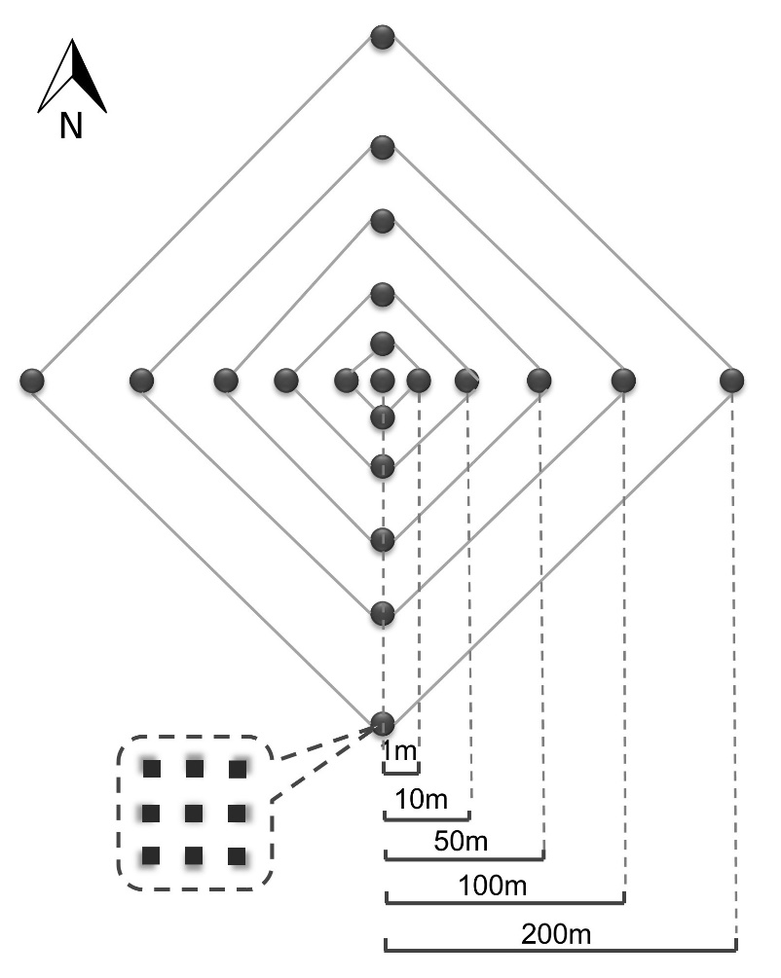

Supplementary Fig. 1. The strategy of soil sampling. At each site, 21 nested samples including center sample have been collected from the distance of 1, 10, 50, 100, and 250m to the center. At each sample point (1 x 1m), nine soil cores were composited for microbial and soil analysis.

Supplementary Fig. 2. Rarefaction analysis on OTUs from different soil samples. Each curve represented a single sample and the color indicated its sampling site.

Supplementary Fig. 3. The correlation on microbial z values and plant z values from 6 sampling sites. r is the Pearson correlation coefficient and P is its significant level.

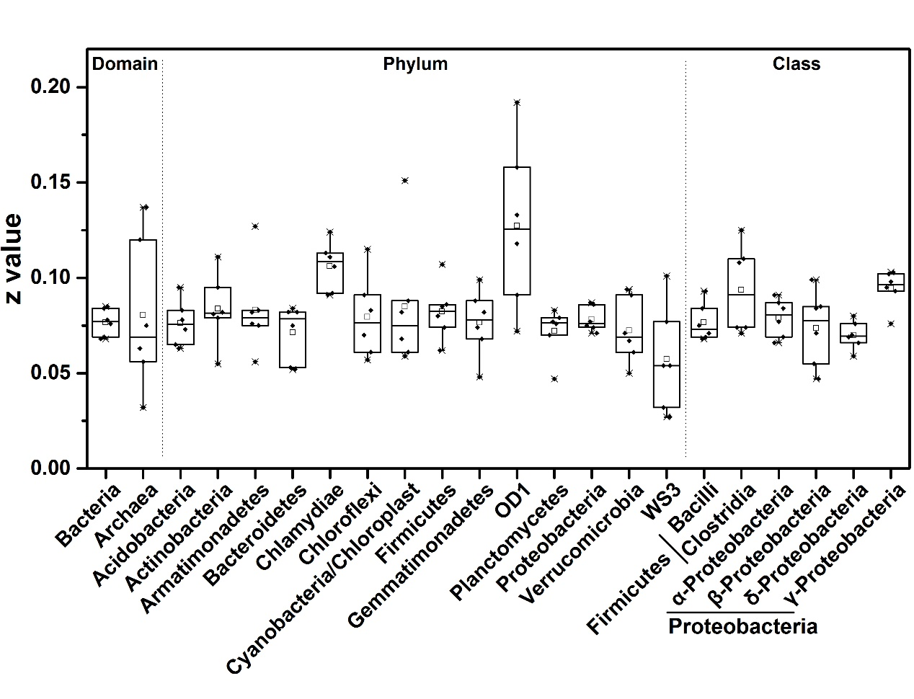
Supplementary Fig. 4. The z values of TARs from different phylogenetic groups at domain, phylum and class level based on 97% similarity OTU table.

