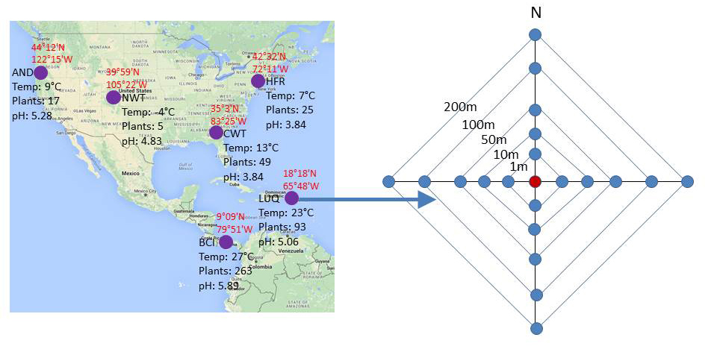
Figure S1. The location of six forest ecosystems selected in this study (left) and the nested sampling design (right) implemented for sample collection in each site.

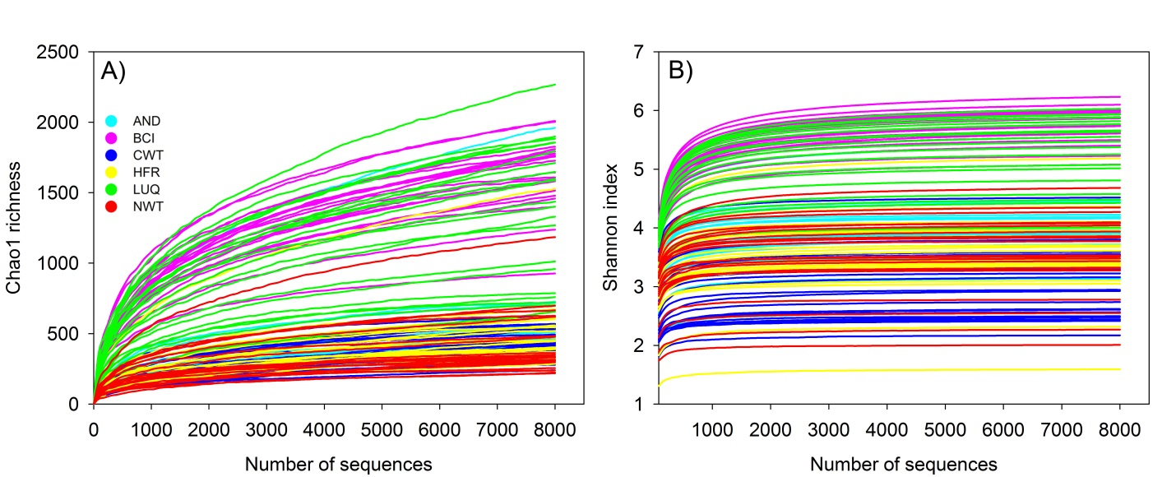
Figure S2. Rarefaction analysis of Chao1 richness (A) and Shannon diversity index (B) in each sample across the six forests. A random resampling effort of 8000 sequences per sample was performed.
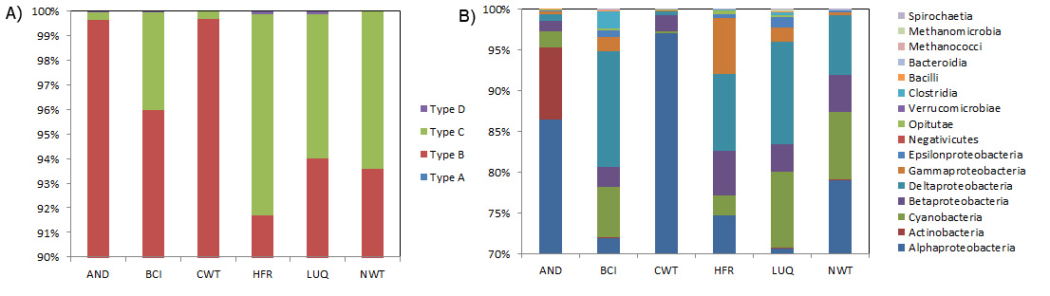
Figure S3. The phylogenetic (A) and taxonomic (B) composition of soil diazotrophs. All forest ecosystems were dominated by type B and alphaproteobacteria, and markedly different compositions could be observed for less dominant taxonomic groups. Types of nifH genes were defined according to the Young groups (Young, 2005), in which type A refers to Mo-independent nitrogenase, B to “bacterial” Mo-dependent nitrogenase, C to “clostridial” Mo-dependent nitrogenase, and D to uncharacterized nitrogenase.

Figure S4. Dominant nifH OTUs that present in >50% samples and with >0.5% relative abundance. Distinctly different nifH OTU compositions were observed across different forest ecosystems.

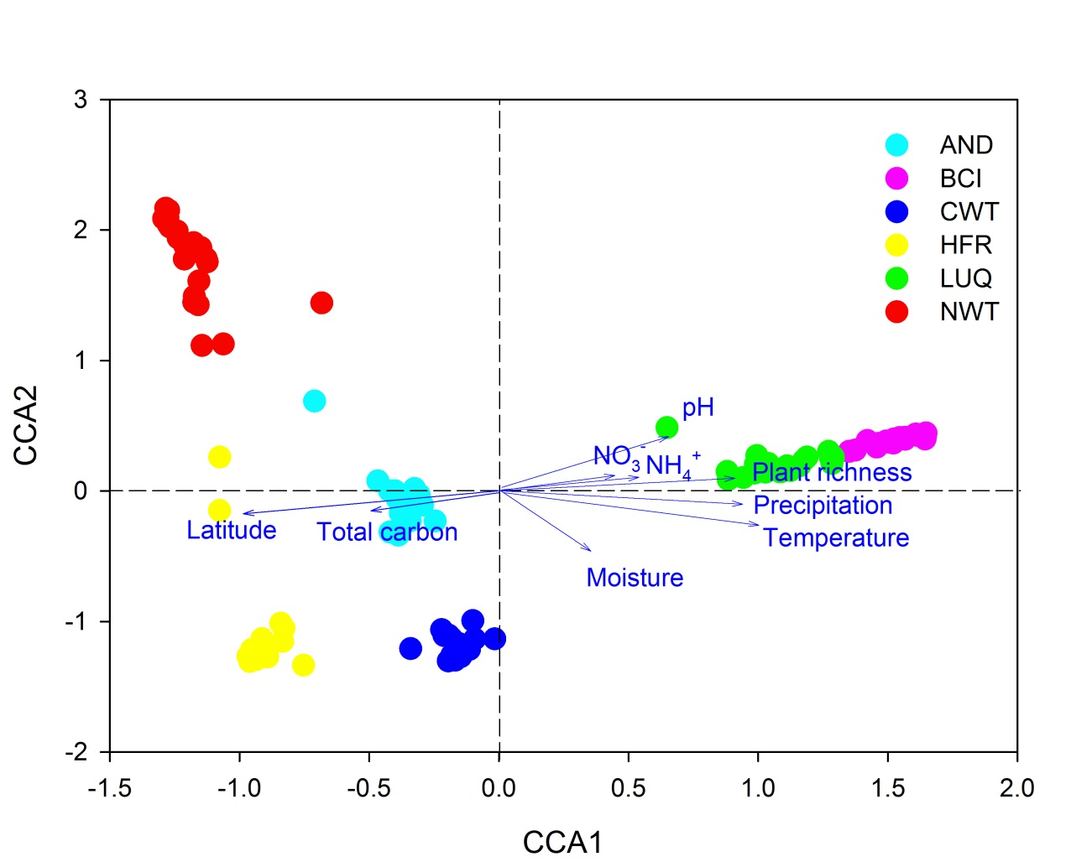
Figure S5. Canonical correspondence analysis of nifH OTU abundance profiles and environmental factors. The results indicated that latitude, temperature, precipitation and plant species richness were the major factors shaping the structure of soil diazotrophic communities.
Table S1. Significance tests of community structure between different forest ecosystems with three different statistical approaches.
 |  | AND | BCI | CWT | HFR | LUQ
ANOSIM  R (P-value) | BCI | 0.99(0.001)
 | CWT | 0.83(0.001) | 1(0.001)
 | HFR | 0.82(0.001) | 0.86(0.001) | 0.82(0.001)
 | LUQ | 0.86(0.001) | 0.74(0.001) | 0.86(0.001) | 0.56(0.001)
 | NWT | 0.78(0.001) | 0.87(0.001) | 0.86(0.001) | 0.69(0.001) | 0.87(0.001)
ADONIS  F (P-value) | BCI | 0.29(0.001)
 | CWT | 0.33(0.001) | 0.45(0.001)
 | HFR | 0.24(0.001) | 0.30(0.001) | 0.38(0.001)
 | LUQ | 0.20(0.001) | 0.20(0.001) | 0.34(0.001) | 0.23(0.001)
 | NWT | 0.21(0.001) | 0.29(0.001) | 0.38(0.001) | 0.21(0.001) | 0.22(0.001)
MRPP  δ (P-value) | BCI | 0.72(0.001)
 | CWT | 0.61(0.001) | 0.57(0.001)
 | HFR | 0.77(0.001) | 0.74(0.001) | 0.62(0.001)
 | LUQ | 0.78(0.001) | 0.74(0.001) | 0.63(0.001) | 0.79(0.001)
 | NWT | 0.78(0.001) | 0.75(0.001) | 0.63(0.001) | 0.80(0.001) | 0.80(0.001)

