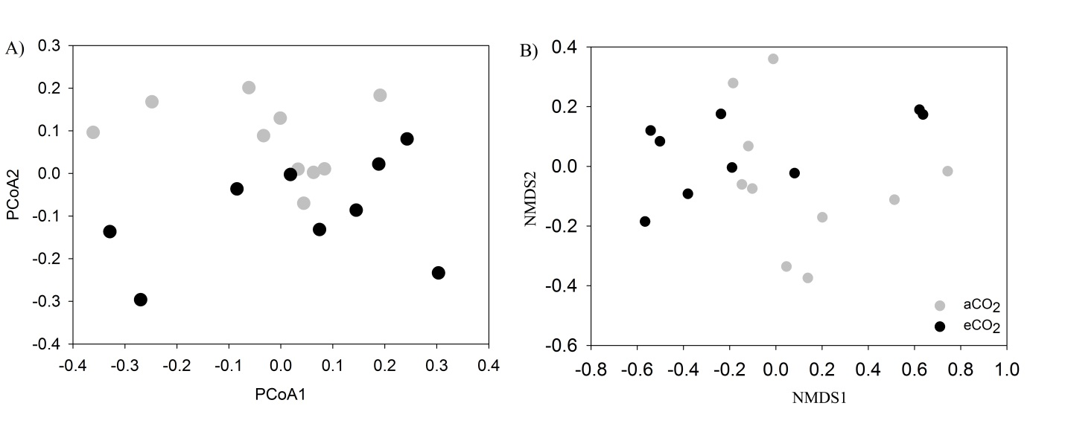
Fig. S1 Ordination analysis of the nifH community structure using unweighted PCoA (A) and NMDS analysis based on Bray-Curtis distance matrix (B). A trend of separation could be found in both analyses.

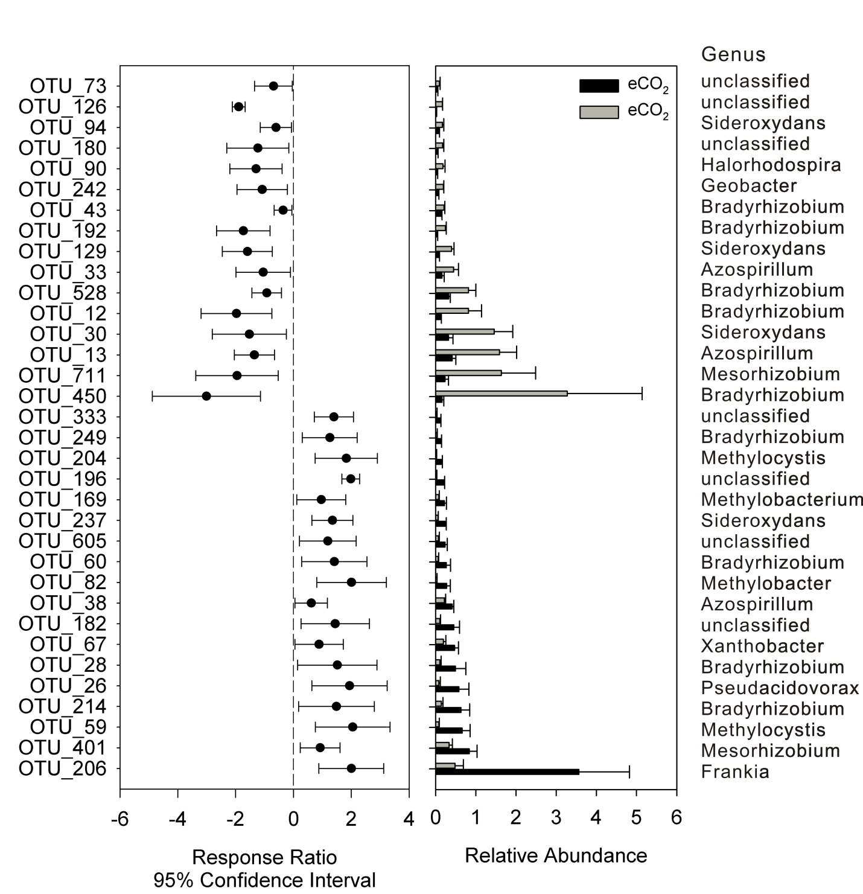
Fig. S2 Response ratio analysis of significantly changed nifH OTUs. Relative abundance and genus assignment for these OTUs were also included. Error bars plotted at the right side of the dashed line indicate significantly increased relative abundance at eCO₂, while error bars plotted at the left side indicate significantly decreased relative abundance at aCO₂.

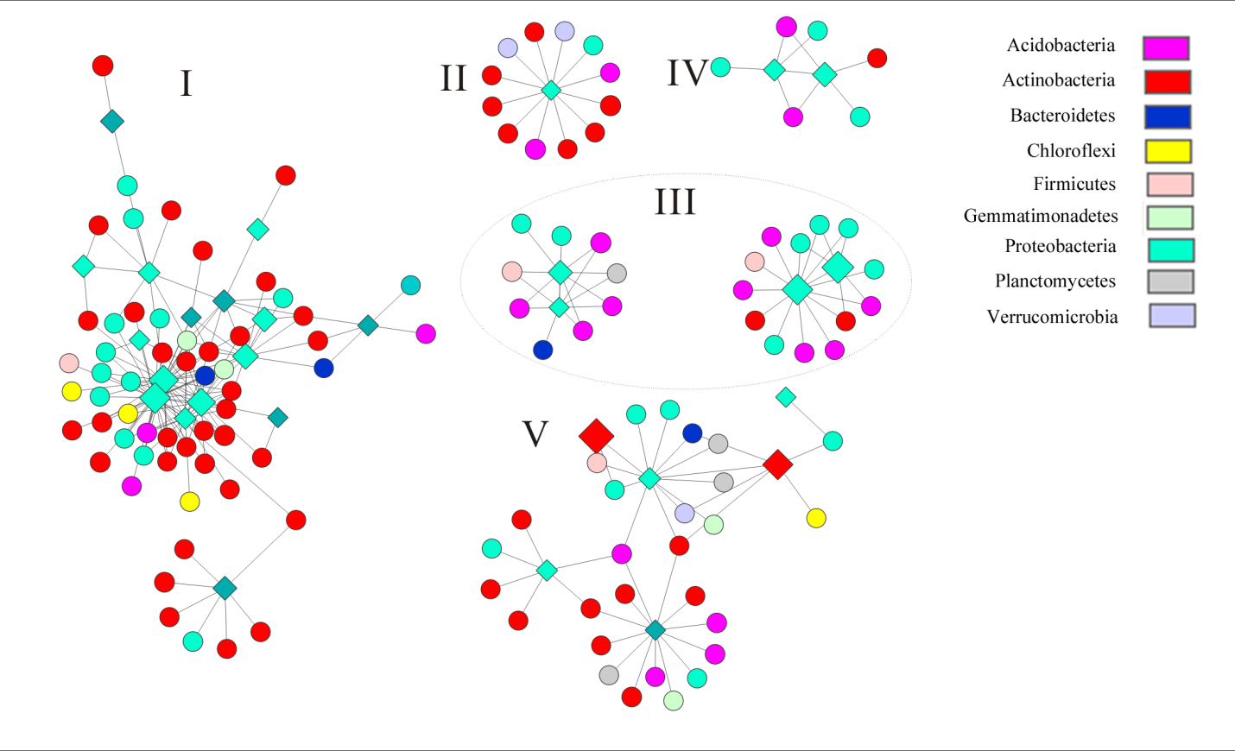
Fig. S3 All nifH-centered modules identified in this study. Only modules with >5 nodes were included. Diamond nodes represent nifH OTUs. Circular nodes represent 16S OTUs.

