A
B
E
C
D
Figure S1. DCA of reactor performance variables. Analysis was done using H₂, CH₄, and CO₂ production and coloumbic efficiency values. Letters indicate reactor name. Error bars are standard deviation of triplicate reactors.

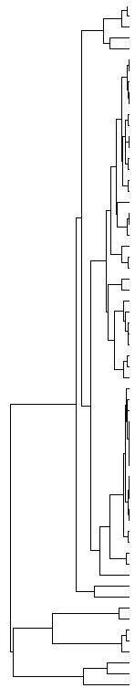
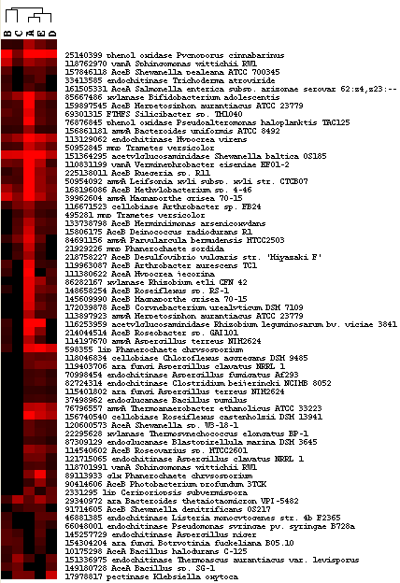

Figure S2. Hierarchical cluster analysis of carbon degradation genes. Signal intensities were averaged for replicate reactors. Results were generated in CLUSTER and visualized in TREEVIEW. Red indicates signal intensities above background and black indicates signals below background. Higher intensity reds indicate higher signal intensities.
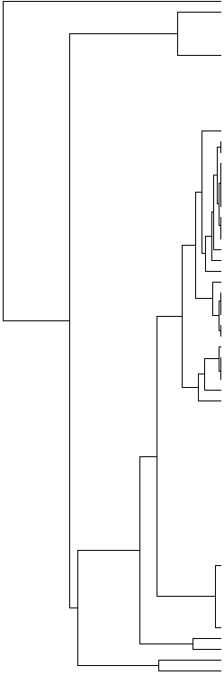
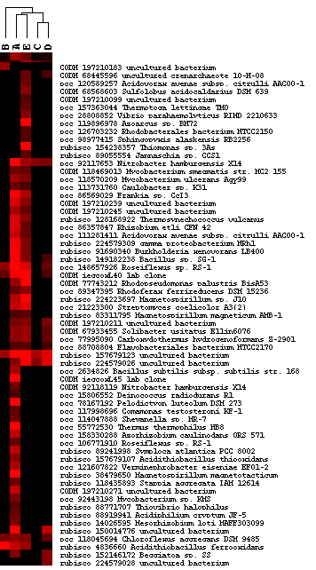
Figure S3. Hierarchical cluster analysis of carbon fixation genes. Signal intensities were averaged for replicate reactors. Results were generated in CLUSTER and visualized in TREEVIEW. Red indicates signal intensities above background and black indicates signals below background. Higher intensity reds indicate higher signal intensities.

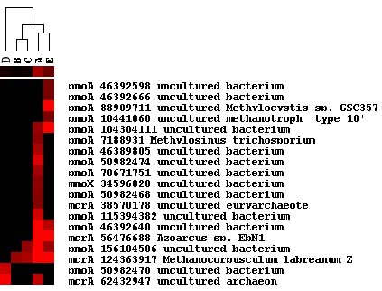
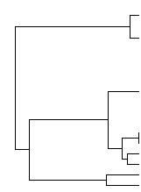

Figure S4. Hierarchical cluster analysis of methane cycling genes. Signal intensities were averaged for replicate reactors. Results were generated in CLUSTER and visualized in TREEVIEW. Red indicates signal intensities above background and black indicates signals below background. Higher intensity reds indicate higher signal intensities.

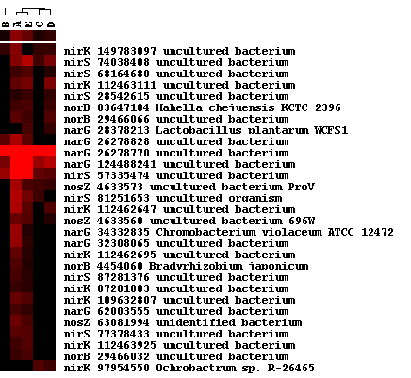
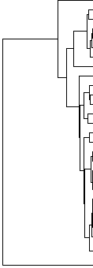

Figure S5. Hierarchical cluster analysis of denitrification genes. Signal intensities were averaged for replicate reactors. Results were generated in CLUSTER and visualized in TREEVIEW. Red indicates signal intensities above background and black indicates signals below background. Higher intensity reds indicate higher signal intensities.

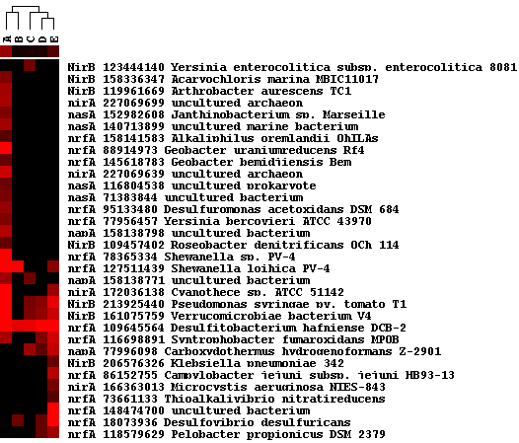
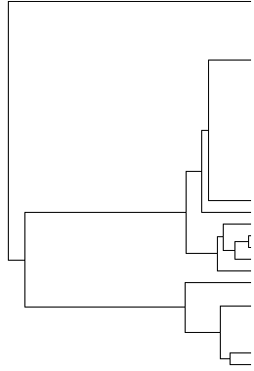

Figure S6. Hierarchical cluster analysis of nitrogen reduction genes. Signal intensities were averaged for replicate reactors. Results were generated in CLUSTER and visualized in TREEVIEW. Red indicates signal intensities above background and black indicates signals below background. Higher intensity reds indicate higher signal intensities.

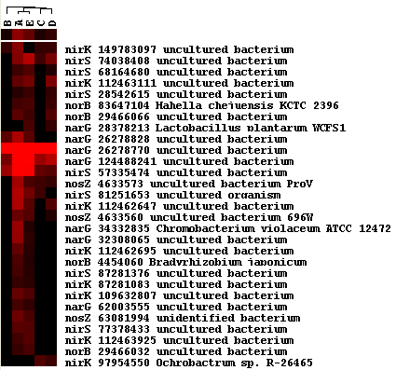
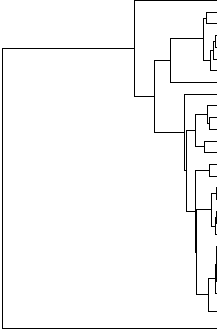
Figure S7. Hierarchical cluster analysis of nitrogen fixation genes. Signal intensities were averaged for replicate reactors. Results were generated in CLUSTER and visualized in TREEVIEW. Red indicates signal intensities above background and black indicates signals below background. Higher intensity reds indicate higher signal intensities.

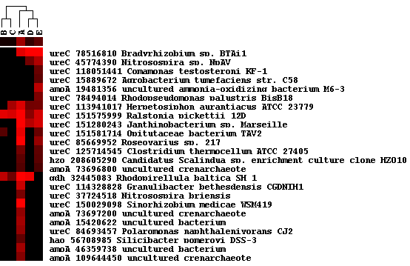
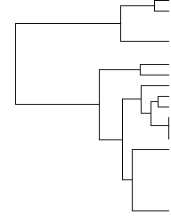

Figure S8. Hierarchical cluster analysis of ammonification and nitrification genes. Signal intensities were averaged for replicate reactors. Results were generated in CLUSTER and visualized in TREEVIEW. Red indicates signal intensities above background and black indicates signals below background. Higher intensity reds indicate higher signal intensities.

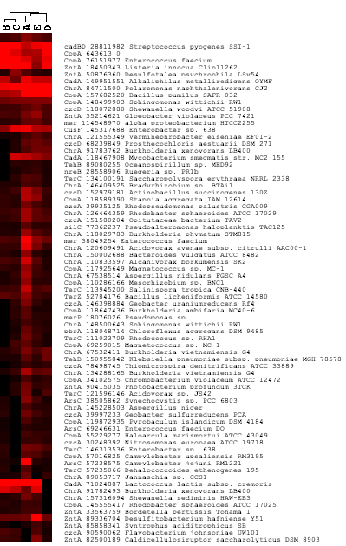

Figure S9. Hierarchical cluster analysis of metal resistance genes. Signal intensities were averaged for replicate reactors. Results were generated in CLUSTER and visualized in TREEVIEW. Red indicates signal intensities above background and black indicates signals below background. Higher intensity reds indicate higher signal intensities.
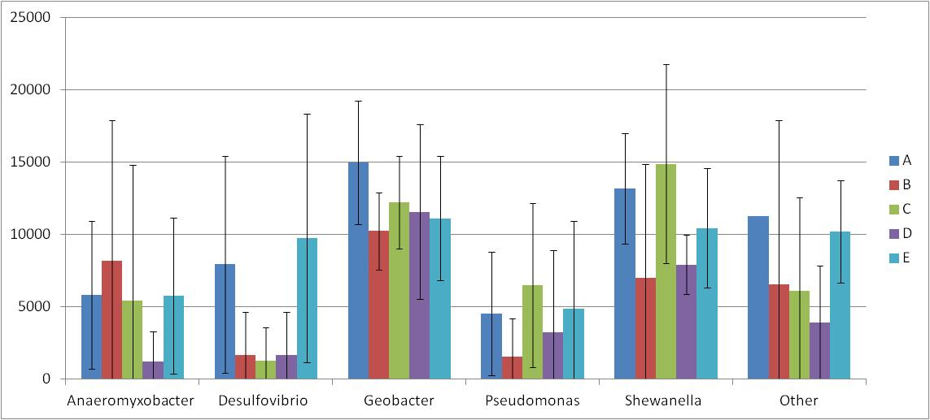
Figure S10. Abundance of cytochrome containing microorganisms detected by GeoChip. Error bars indicated standard deviation of triplicate reactors.

