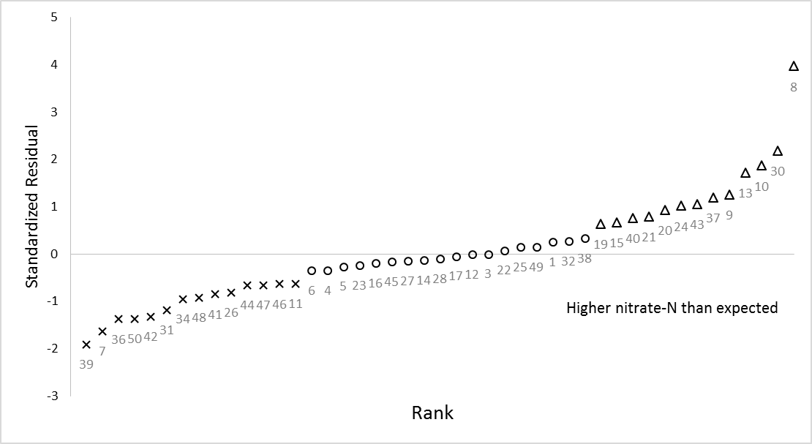

**Supplementary Fig. 1: Standardized residual plot against rank. Soils with anomalous ${NO}_{3}^{-}$-N content were identified using a “leave-out-one” prediction strategy in which each soil was individually omitted from the dataset, it’s predicted based on a linear regression on soil total N content, and its standardized residual evaluated. The standardized residuals were then ranked to identify soils with anomalously low and high nitrate-N contents. Symbols are used to denote the points that were classed as having lower (crosses) or higher (triangles) than expected nitrate-N levels. The points are labelled by soil ID.**

**Supplementary Table 1**

Matching of soils between New Zealand and US Department of Agriculture classifications (inferred).

|  |  |  |  |
| --- | --- | --- | --- |
| Soil ID† | New Zealand Soil Group‡ | New Zealand Soil Sub-group‡ | USDA soil classification§ (inferred) |
| 1 | Gley | Typic Orthic Gley Soils | Aquept or Aquent |
| 2 | Pallic | Calcareous Argillic Pallic Soils | Haplustalfs or Hapludalfs |
| 3 | Brown | Acidic Orthic Brown Soils | Dystrochrepts |
| 4 | Melanic | Typic Mafic Melanic Soils | Ustrochrepts, Eutrochrepts, Ustolls, or Udolls |
| 5 | Pallic | Mottled Immature Pallic Soils | Eutrochrepts or Ustochrepts |
| 6 | Pallic | Argillic-fragic Perch-gley Pallic Soils | Aquepts or Aqualfs |
| 7 | Brown | Typic Acid Brown Soils | Dystrochrepts |
| 8 | Brown | Acidic Orthic Brown Soils | Dystrochrepts |
| 9 | Gley | Typic Orthic Gley Soils | Aquept or Aquent |
| 10 | Recent | Weathered Fluvial Recent Soils | Fluvents or Ochrepts |
| 11 | Recent | Weathered Fluvial Recent Soils | Fluvents or Ochrepts |
| 12 | Brown | Acidic Orthic Brown Soils | Dystrochrepts |
| 13 | Recent | Weathered Fluvial Recent Soils | Fluvents or Ochrepts |
| 14 | Podzol | Humus-pan Perch-gley Podzols | Aquods |
| 15 | Brown | Acidic Orthic Brown Soils | Dystrochrepts |
| 16 | Recent | Weathered Orthic Recent Soils | Entisols or not-soil |
| 17 | Brown | Acidic Orthic Brown Soils | Dystrochrepts |
| 18 | Podzol | Silt-mantled Perch-gley Podzols | Aquods |
| 19 | Recent | Typic Sandy Recent Soils | Psamments |
| 20 | Recent | Mottled Fluvial Recent Soils | Fluvents or Ochrepts |
| 21 | Recent | Mottled Fluvial Recent Soils | Fluvents or Ochrepts |
| 22 | Recent | Mottled Fluvial Recent Soils | Fluvents or Ochrepts |
| 23 | Recent | Mottled Fluvial Recent Soils | Fluvents or Ochrepts |
| 24 | Recent | Typic Fluvial Recent Soils | Fluvents or Ochrepts |
| 25 | Recent | Weathered Fluvial Recent Soils | Fluvents or Ochrepts |
| 26 | Recent | Mottled Fluvial Recent Soils | Fluvents or Ochrepts |
| 27 | Brown | Typic Orthic Brown Soils | Dystrochrepts |
| 28 | Pallic | Argillic-mottled Fragic Pallic Soils | Fragiudalfs or Fragiochrepts |
| 29 | Brown | Typic Mafic Brown Soils | Dystrochrepts |
| 30 | Brown | Typic Firm Brown Soils | Dystrochrepts or Ustochrepts |
| 31 | Brown | Typic Firm Brown Soils | Dystrochrepts or Ustochrepts |
| 32 | Pallic | Mottled Fragic Pallic Soils | Fluvents or Ochrepts |
| 33 | Recent | Weathered Fluvial Recent Soils | Fluvents or Ochrepts |
| 34 | Pallic | Mottled-calcareous Fragic Pallic Soils | Fragiudalfs or Fragiochrepts |
| 35 | Semiarid | Typic Immature Semiarid Soils | Camborthids |
| 36 | Recent | Acid-weathered Orthic Recent Soils | Orthents or Orchrepts |
| 37 | Recent | Weathered Orthic Recent Soils | Entisols or not-soil |
| 38 | Recent | Weathered Fluvial Recent Soils | Fluvents or Ochrepts |
| 39 | Brown | Humose Orthic Brown Soils | Dystrochrepts |
| 40 | Pallic | Fragic Perch-gley Pallic Soils | Aquepts or Aqualfs |
| 41 | Brown | Mottled Acid Brown Soils | Dystrochrepts |
| 42 | Brown | Typic Orthic Brown Soils | Dystrochrepts |
| 43 | Ultic | Mottled Yellow Ultic Soils | Hapludults |
| 44 | Granular | Typic Orthic Granular Soils | Humults |
| 45 | Allophanic | Typic Orthic Allophanic Soils | Ustolls, Udolls, or Eutrochrepts |
| 46 | Pumice | Immature Orthic Pumice Soils | Vitrands or Vitricryands |
| 47 | Recent | Mottled Fluvial Recent Soils | Fluvents or Ochrepts |
| 48 | Brown | Typic Allophanic Brown Soils | Dystrochrepts |
| 49 | Allophanic | Typic Orthic Allophanic Soils | Ustolls, Udolls, or Eutrochrepts |
| 50 | Pallic | Mottled Argillic Pallic Soils | Haplustalfs or Hapludalfs |

**† From: Wakelin SA, van Koten C, O’Callaghan M, Brown M (2013b) Physicochemical properties of 50 New Zealand pasture soils: a starting point for assessing and managing soil microbial resources. New Zealand Journal of Agricultural Research 56: 248-260.**

**‡ Sensu: Hewitt AE (1998) New Zealand soil classification. Landcare Research science series No. 2. Lincoln, New Zealand, Manaaki Whenua Press. 71-p.**

**§  Sensu: Soil Survey Staff (2010) Keys to Soil Taxonomy,11th ed. USDA-Natural Resources Conservation Service, Washington, DC.**

**Supplementary Table 2**

**Summary effects table following testing (linear regression) of** standardized residuals (Suppl. Fig. 1) with other **physiochemical properties. The residual means square error (RMSE), adjusted R2, and the p-value for the fitted model detail the amount of variation explained by each physiochemical property in explaining the standardised residuals.**

