Supplementary Information:
Evaluating the lingering effect of livestock grazing on functional potentials of microbial communities in Tibetan grassland soils
Mengmeng Wangª, Shiping Wang^{b,c}, Linwei Wuª, Depeng Xu^{a,d}, Qiaoyan Lin^{e}, Yigang Hu^{e,f}, Xiangzhen Li^{g}, Jizhong Zhou^{a,d,h,i} and Yunfeng Yang^{a,i,*}
ªState Key Joint Laboratory of Environment Simulation and Pollution Control, School of Environment, Tsinghua University, Beijing 100084, China
^{b}Key Laboratory of Alpine Ecology and Biodiversity, Institute of Tibetan Plateau Research, Chinese Academy of Sciences, Beijing 100101, China
^{c}CAS Center for Excellence in Tibetan Plateau Earth Science, Beijing 100101, China
^{d}Institute for Environmental Genomics and Department of Botany and Microbiology, University of Oklahoma, Norman, OK 73019, USA
^{e}Key Laboratory of Adaption and Evolution of Plateau Biota, Northwest Institute of Plateau Biology, Chinese Academy of Sciences, Xining 810008, China
^{f}Shapotou Desert Experiment and Research Station, Cold and Arid Regions and Environmental & Engineering Research Institute, Chinese Academy of Sciences, Lanzhou 730000, China
^{g}Chengdu Institute of Biology, Chinese Academy of Sciences, Chengdu 610041, China
^{h}Earth Sciences Division, Lawrence Berkeley National Laboratory, Berkeley, CA 94720, USA
^{i}Collaborative Innovation Center for Regional Environmental Quality, School of Environment, Tsinghua University, Beijing 100084, China

Supplementary Tables

Table S1. Plant biomass of each species within different plant functional group (g·m⁻²).
Species | Functional groupª | 3200-m |  |  |  | 3400-m
 |  | Control | Post-grazing | P^{e} |  | Control | Post-grazing | P
Poa annua | GG | 16.3 | 1.4 | 0.42 |  | 4.2 | 5.0 | 0.84
Elymus dahuricus | GG | - | - | - |  | 0.1 | - | 0.37
Elymus nutans | GG | 21.7 | 23.2 | 0.77 |  | 8.7 | 7.4 | 0.70
Festuca^{b} | GG | 42.0 | 34.8 | 0.44 |  | 9.0 | 8.1 | 0.92
Festuca ovina | GG | 11.0 | 4.0 | 0.58 |  | 2.0 | - | 0.37
Graminoids^{c} | GG | 42.4 | 54.9 | 0.68 |  | 13.1 | 10.8 | 0.83
Koeleria glauca | GG | - | - | - |  | 0.1 | 2.3 | 0.36
Stipa aliena | GG | 1.9 | 16.1 | 0.17 |  | - | - | -
Stipa capillata | GG | 17.2 | 16.1 | 0.95 |  | 8.9 | 2.0 | 0.31
Carex tristachya | SG | 0.3 | 3.9 | 0.08 |  | 2.1 | 0.5 | 0.01
Kobresia capillifolia | SG | - | - | - |  | - | 0.3 | 0.37
Kobresia humilis | SG | 6.7 | 12.9 | 0.10 |  | 3.2 | 8.5 | 0.34
Kobresia tibetica | SG | 1.4 | 12.1 | 0.26 |  | 1.4 | 0.5 | 0.33
Scripus distigmaticus | SG | 8.1 | 23.2 | 0.19 |  | 0.8 | 3.0 | 0.04
Astragalus membranaceus | LG | 0.3 | 0.5 | 0.65 |  | 2.8 | 0.3 | 0.19
Gueldenstaedtia multiflora | LG | 6.0 | 21.8 | 0.14 |  | 0.1 | 0.1 | 0.80
Leguminosae | LG | 1.6 | 7.4 | 0.03^{f} |  | 1.4 | 6.3 | 0.24
Medicago ruthenica | LG | 4.8 | 9.9 | 0.15 |  | - | - | 0.37
Oxytropis | LG | - | - | 0.37 |  | 2.1 | 7.0 | 0.41
Oxytropis deflexa | LG | 4.9 | 5.1 | 0.97 |  | - | - | -
Ajania tenuifolia | FG | - | 0.8 | 0.37 |  | 0.2 | 1.9 | 0.42
Allium ramosum | FG | - | - | - |  | - | - | 0.37
Anaphalis lactea | FG | - | - | - |  | 1.0 | 0.4 | 0.53
Anaphalis sinica Hance | FG | - | - | - |  | - | 0.3 | 0.37
Aster tataricus | FG | - | 0.2 | 0.21 |  | 9.9 | 5.7 | 0.28
Chrysosplenium sinicum | FG | - | - | - |  | 0.3 | 0.2 | 0.83
Compositae sp. | FG | 0.4 | - | 0.37 |  | - | - | -
Cruciferae | FG | - | - | 0.37 |  | - | - | -
Euphrasia pectinata Ten | FG | 0.1 | 0.5 | 0.05 |  | 0.7 | 2.7 | 0.02
Geranium pylzowianum | FG | - | - | 0.37 |  | 6.4 | 7.6 | 0.64
Herba Taraxaci | FG | 1.4 | 4.6 | 0.27 |  | 1.3 | 2.9 | 0.27
Hippophae rhamnoides | FG | - | - | - |  | 3.6 | - | 0.37
Iris tectorum | FG | 1.2 | - | 0.35 |  | - | - | -
Lancea tibetica | FG | 1.0 | 4.0 | 0.12 |  | 7.8 | 10.4 | 0.63
Leontopodium leontopodioides | FG | 0.2 | 0.5 | 0.36 |  | 3.2 | 5.4 | 0.47
Microula sikkimensis Hemsl | FG | - | - | - |  | 0.4 | - | 0.37
Morina coulteriana | FG | - | 3.6 | 0.38 |  | - | - | -
Notopterygium incisum | FG | 0.2 | 0.1 | 0.51 |  | 0.1 | 0.1 | 0.54
Pedicularis kansuensis | FG | 0.7 | 0.6 | 0.82 |  | 0.8 | 4.5 | 0.42
Plantago asiatica | FG | - | 0.1 | 0.37 |  | - | - | -
Polygonum sibioicum | FG | - | - | 0.37 |  | 0.4 | 0.1 | 0.23
Polygonum viviparum | FG | - | - | - |  | 11.9 | 9.1 | 0.12
Potentilla anserina | FG | 23.9 | 8.1 | 0.14 |  | 3.0 | 6.4 | 0.07
Potentilla bifurca | FG | 0.8 | 0.4 | 0.31 |  | 0.2 | - | 0.18
Potentilla fruticosa | FG | - | - | - |  | 3.3 | 3.0 | 0.89
Potentilla nivea | FG | 10.0 | 7.5 | 0.72 |  | 3.0 | 5.3 | 0.18
Saussurea | FG | - | - | - |  | - | - | 0.37
Saussurea japonica | FG | - | - | 0.37 |  | - | - | -
Saussurea nigrescens | FG | 0.5 | 0.2 | 0.40 |  | 3.6 | 4.4 | 0.69
Saussurea superba Anthony | FG | 3.4 | 5.8 | 0.02 |  | - | 0.8 | 0.37
Saxifraga stolonifera | FG | - | - | - |  | - | - | 0.37
Unclassified^{d} | FG | 1.4 | 4.4 | 0.15 |  | 1.6 | 22.9 | 0.02
Anemone obtusiloba | NG | - | - | 0.37 |  | 2.5 | 1.7 | 0.56
Delphinium caeruleum | NG | 0.2 | 0.3 | 0.79 |  | - | - | -
Gentiana farreri | NG | 1.4 | 0.4 | 0.24 |  | 0.1 | - | 0.37
Gentiana scabra Bunge | NG | - | 0.1 | 0.37 |  | 0.7 | 0.5 | 0.62
Gentiana spathulifolia | NG | 0.4 | 1.1 | 0.12 |  | - | - | -
Gentiana straminea | NG | 35.3 | 16.6 | 0.02 |  | - | - | -
Gentianopsis paludosa | NG | 0.2 | 1.2 | 0.33 |  | - | - | -
Ligularia virgaurea | NG | - | - | - |  | 6.8 | 4.8 | 0.39
Ranunculus | NG | - | 0.1 | 0.55 |  | - | - | -
Ranunculus tanguticus | NG | - | 0.9 | 0.01 |  | 1.4 | 0.9 | 0.50
Stellariamedia | NG | 1.6 | 1.5 | 0.91 |  | 1.5 | 0.3 | 0.06
Swertia | NG | - | 0.2 | 0.18 |  | 0.2 | 0.2 | 0.94
Swertia tetraptera Maxim. | NG | - | - | - |  | 0.1 | 0.1 | 0.97
Thalictrum alpinum | NG | 4.6 | 4.7 | 0.97 |  | 1.7 | 5.9 | 0.17
ªPlants can be divided into five functional groups based on selective consumption by livestock: graminoids species group (GG), sedge species group (SG) and leguminous species group (LG) are palatable; forbs species group (FG) are less palatable; and noxious species group (NG) are noxious for animals.
^{b}Festuca is the sum of plant species belonging to genus of Festuca. It is difficult to examine at the species level.
^{c}Graminoids is the sum of plant species in the category of grass. It is difficult to examine those plant species at a finer level.
^{d}Unclassified is the sum of unclassified species.
^{e}Differences between control and post-grazing grassland samples were examined by two tailed t-test.
^{f}Significantly (P<0.05) changed values are shown in bold.

Table S2. Functional genes detected by GeoChip 4.0.
Gene category | Number of detected genes | Number of detected probes
Carbon cycling | 41 | 11 034
Acetogenesis | 1 | 52
Methane cycling | 3 | 251
Carbon fixation | 4 | 1077
Carbon degradation | 33 | 4759
Cellulose | 4 | 412
Chitin | 3 | 776
Hemicellulose | 5 | 749
Lignin | 4 | 486
Pectin | 1 | 40
Starch | 8 | 1207
Others | 8 | 1089
Nitrogen cycling | 17 | 4305
Ammonification | 2 | 518
Anammox | 1 | 18
Assimilatory N reduction | 4 | 261
Dissimilatory N reduction | 2 | 337
Nitrification | 2 | 625
Denitrification | 5 | 1720
Nitrogen fixation | 1 | 826
Phosphorus utilization | 3 | 792
Sulphur | 6 | 1794
Adenylsulphate reductase | 3 | 260
Sulphite reductase | 2 | 1232
Sulphur oxidation | 1 | 302
Energy process | 4 | 530
Cytochrome | 1 | 378
Hydrogenase | 2 | 127
P450 | 1 | 25
Metal resistance | 44 | 5515
Aluminium | 1 | 67
Arsenic | 5 | 551
Cadmium | 2 | 396
Cadmium, cobalt, zinc | 3 | 882
Chromium | 1 | 637
Cobalt | 1 | 30
Cobalt, nickel | 3 | 12
Copper | 5 | 1041
Lead | 3 | 38
Mercury | 7 | 480
Nickel | 1 | 24
Selenium | 1 | 2
Silver | 4 | 285
Tellurium | 4 | 703
Zinc | 2 | 350
Miscellaneous | 1 | 17
Complex C metabolism | 182 | 10 949
Aromatics | 131 | 8220
Aromatic carboxylic acid | 37 | 3813
BTEX and related aromatics | 21 | 679
Chorinated aromatics | 11 | 485
Heterocyclic aromatics | 9 | 94
Nitoaromatics | 11 | 698
Polycyclic aromatics | 19 | 591
Other aromatics | 23 | 1652
Chlorinated solvents | 6 | 376
Herbicides related compounds | 13 | 948
Pesticides related compounds | 4 | 317
Other hydrocarbons | 14 | 515
Others | 14 | 573
Antibiotic resistance | 11 | 1,730
Transporters | 5 | 1186
β-lactamases | 4 | 377
Others | 2 | 167
Stress | 45 | 11 367
Cold shock | 4 | 36
Heat shock | 5 | 858
Glucose limitation | 2 | 39
Nitrogen limitation | 3 | 893
Osmotic stress | 4 | 240
Oxygen limitation | 7 | 557
Oxygen stress | 7 | 2666
Phosphate limitation | 6 | 2646
Protein stress | 2 | 310
Radiation stress | 1 | 665
Sigma factors | 4 | 2457
Bacteria phage | 39 | 391
Replication | 24 | 261
Lysis | 7 | 71
Structural | 6 | 35
Host recognition/structural | 2 | 24
Bioleaching | 121 | 642
Virulence | 13 | 1879
Other (gyrB, bchY) | 2 | 1243
Total | 528 | 47 327

Supplementary Figures
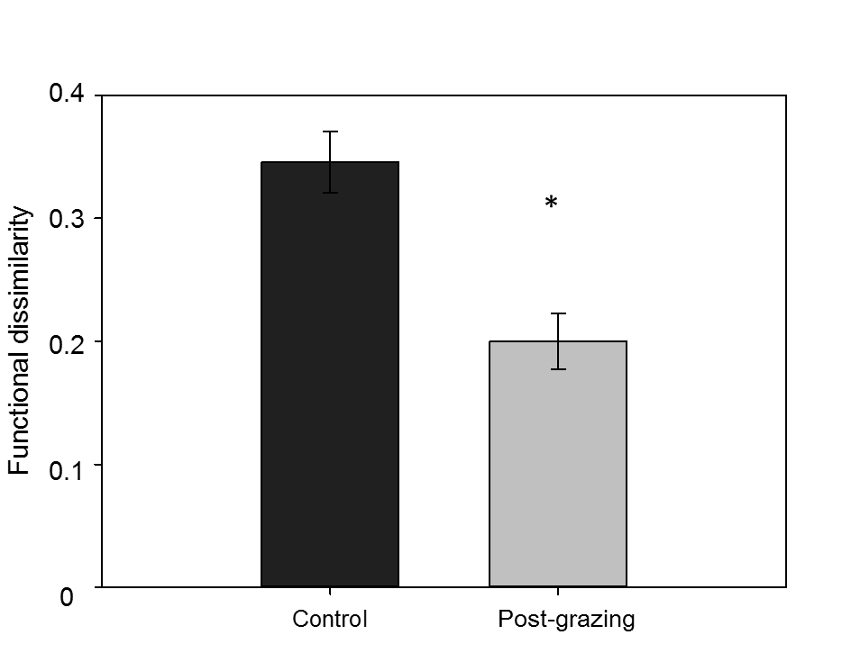

Figure S1. Dissimilarity of functional gene compositions between control and post-grazing grassland samples based on Bray-Curtis coefficients. Significance was examined by ANOVA: ‘*’ P<0.05.

(A)
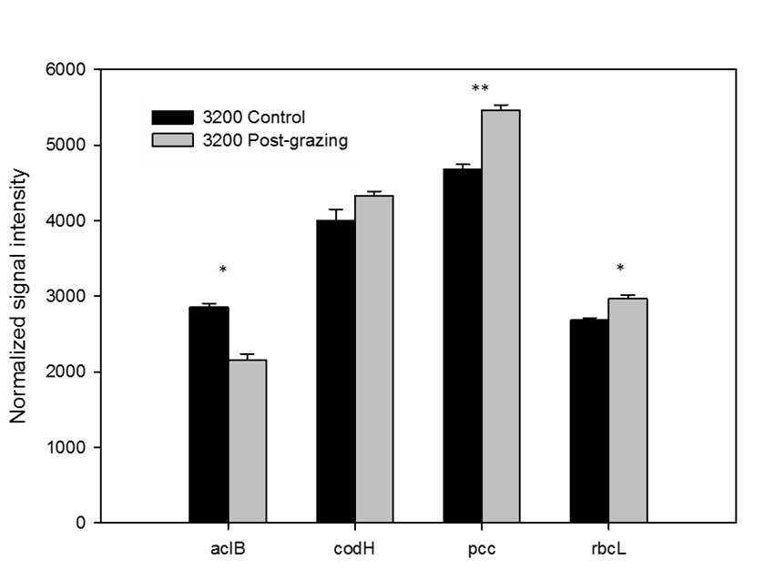
(B)
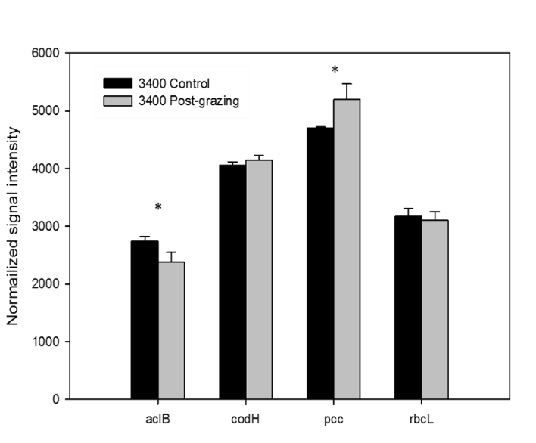

Figure S2. Relative abundances of functional genes associated with C fixation at (A) the 3200-m site and (B) the 3400-m site. The normalized signal intensity for each gene was the sum of signal intensities of detected genes divided by detected gene number across all samples. Significance was examined by two-tailed t-test: ‘*’ P<0.05 and ‘**’ P<0.01.

(A)
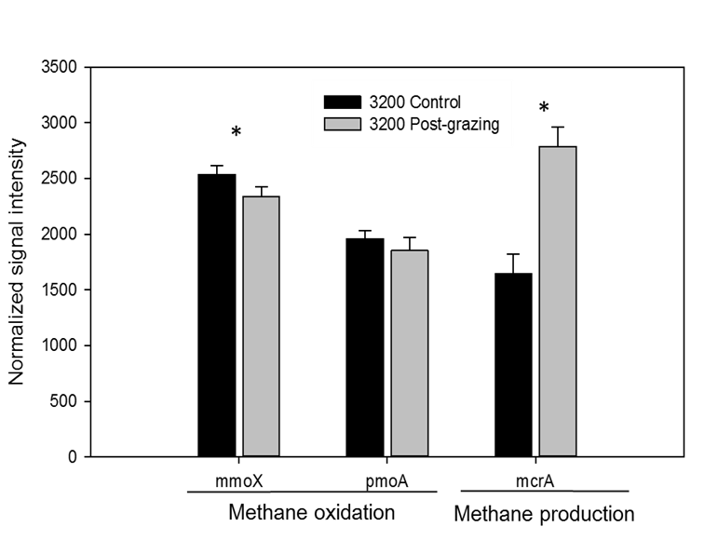
(B)
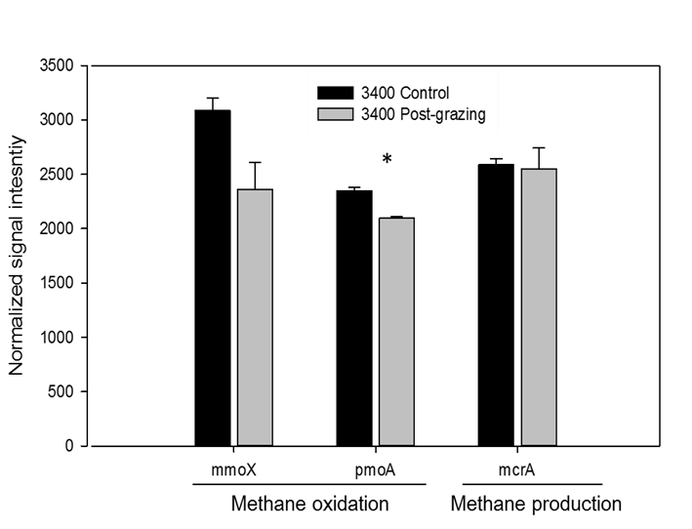

Figure S3. Relative abundances of functional genes associated with CH₄ production and oxidation at (A) the 3200-m site and (B) the 3400-m site. The normalized signal intensity for each gene was the sum of signal intensities of detected genes divided by detected gene number across all samples. Significance was examined by two-tailed t-test: ‘*’ P<0.05.

(A)
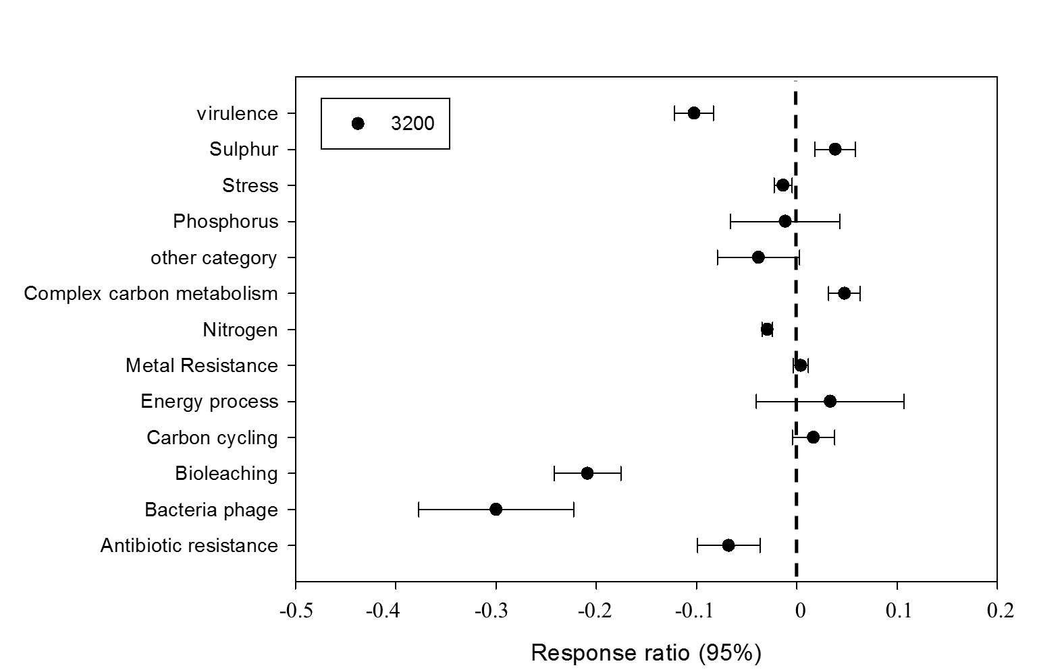
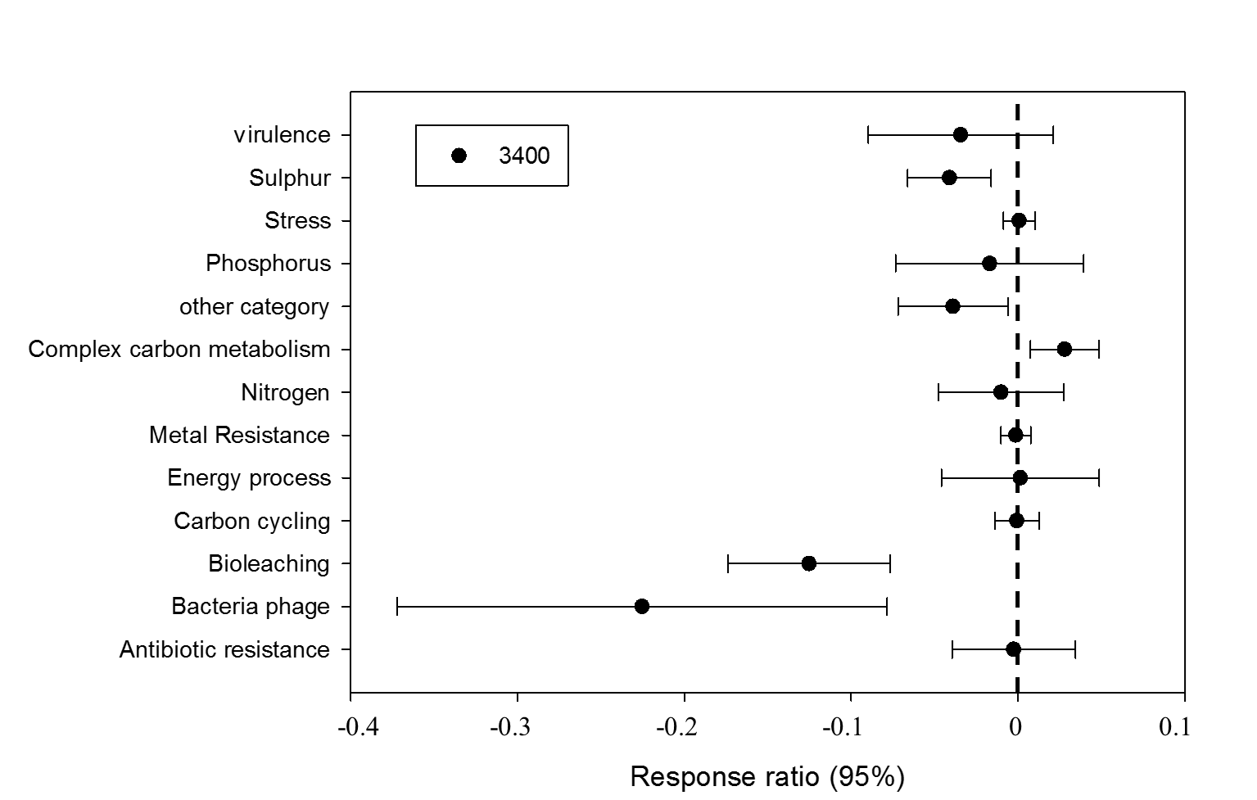

(B)
Figure S4. Response ratio analyses of genes associated with (A) different gene categories and (B) complex carbon metabolism genes at the confidence level of 0.95.

