Dockerin-containing protease inhibitor protects key cellulosomal cellulases from proteolysis in Clostridium cellulolyticum
Supporting Information

Tao Xu^{1,2}, Yongchao Li^{1,2}, Zhili He^{1,5}, and Jizhong Zhou ^{1,3,4,5,*}

¹Institute for Environmental Genomics, ²Department of Microbiology and Plant Biology, University of Oklahoma, Norman, Oklahoma 73071, USA;
³Earth Sciences Division, Lawrence Berkeley National Laboratory, Berkeley, California 94720, USA;
⁴Department of Environmental Science and Engineering, Tsinghua University, Beijing 100084, China; and ⁵Virtual Institute for Microbial Stress and Survival

*For correspondence. E-mail jzhou@ou.edu; Tel. (+1) 405 325 6073; Fax (+1) 405 325-7552

Running title: Role of Dpi in protecting cellulases
Key words: cellulosome; cellulase; protease inhibitor; biofuels; Clostridium cellulolyticum
Table S1 Mass spectrometry analysis of gel slices from SDS-PAGE.
Hit | Accession | Mascot Score | Mass (Da) | Avg. Intensity | Gene number | Predicted functions
B1 | gi|220928179 | 2608 | 80608 | 5.611e+4 | Ccel_0729 | Cel48F
B2 | gi|220928182 | 3301 | 97127 | 9.375e+4 | Ccel_0732 | Cel9E
B3 | gi|220928185 | 1271 | 85039 | 1.659e+4 | Ccel_0735 | Cel9J
B4 | gi|220928187 | 1058 | 58027 | 2.347e+4 | Ccel_0737 | Cel9M

Table S2 Oligonucleotide primers in this study.
Primer name | Sequenceª | Application
EBSu | CGAAATTAGAAACTTGCGTTCAGTAAAC | Intron modification
Dpi-171|172a-IBS | AAAACCCGGGATAATTATCCTTAGACCTCATTATCGTGCGCCCAGATAGGGTG | Intron modification
Dpi-171|172a-EBS1d | CAGATTGTACAAATGTGGTGATAACAGATAAGTCATTATCACTAACTTACCTTTCTTTGT | Intron modification
Dpi-171|172a-EBS2 | TGAACGCAAGTTTCTAATTTCGATTAGGTCTCGATAGAGGAAAGTGTCT | Intron modification
Cel48F-764a-IBS | AAAACCCGGGATAATTATCCTTACTGGACCATTTGGTGCGCCCAGATAGGGTG | Intron modification
Cel48F-764a-EBS1d | CAGATTGTACAAATGTGGTGATAACAGATAAGTCCATTTGTATAACTTACCTTTCTTTGT | Intron modification
Cel48F-764a-EBS2 | TGAACGCAAGTTTCTAATTTCGGTTTCCAGTCGATAGAGGAAAGTGTCT | Intron modification
Cel9E-653a-IBS | AAAACCCGGGATAATTATCCTTACTACCCGATTCAGTGCGCCCAGATAGGGTG | Intron modification
Cel9E-653a-EBS1d | CAGATTGTACAAATGTGGTGATAACAGATAAGTCGATTCAAATAACTTACCTTTCTTTGT | Intron modification
Cel9E-653a-EBS2 | TGAACGCAAGTTTCTAATTTCGGTTGGTAGTCGATAGAGGAAAGTGTCT | Intron modification
Dpi-171 F | TTGCTCCGGCAAAAGTAAAC | Mutant identification
Dpi-171 R | CACTGATAGCCCGTTGATCC | Mutant identification
Cel48F F | GATGAACATAAATTTGGTGGACAGT | Mutant identification
Cel48F R | TGCATAGTACCATGAAAGCAGATAA | Mutant identification
Cel9E F | CTGGAATTACAGGCTAATACTCCAA | Mutant identification
Cel9E R | TGCAATACCACCATTAACAACATAC | Mutant identification
Intron F1 | CCTATGGGAACGAAACGAAA | Mutant identification
Intron R1 | CGAGTACTCCGTACCCTTGC | Mutant identification
NtDpi F(NdeI) | GGAATTCCATATGGTGGTAGGAAGTTATACACTTTTCGG | Construct pET28a(+)-Dpi expression vector
NtDpi R(Not I) | ATAGTTTAGCGGCCGCTTAAATTACATTTATTTCACATTGG | Construct pET28a(+)-Dpi expression vector
Dpi-over F | CGCGGATCCCCCGGGATGGAAAAGAATTACACACCAA | Construct pClostron3-Dpiover complementation vector
Dpi-over R | TTATTTCGATCGTTAAATTACATTTATTTCACA | Construct pClostron3-Dpiover complementation vector
RTrecA F | GCAAAGAAACTTGGGGTTGA | recA qPCR
RTrecA R | TGAGACATCAGCCTTGCTTG | recA qPCR
RTcipC F | TACTGGCGTCGTATCAGTGC | cipC qPCR
RTcipC R | TGTCCGCATCCTGAGTGTAA | cipC qPCR
RTcel48F F | AACAAACCGGCTACATACGC | cel48F qPCR
RTcel48F R | GGTTCCATCAGCTCTTGCTC | cel48F qPCR
RTcel9E F | ACCTGGACCGTAATGAATGC | cel9E qPCR
RTcel9E R | TCATGAGCTTTGTGGTGAGC | cel9E qPCR
RTcel8C F | GGATACGGTTTGCTGCTTTC | cel8C qPCR
RTcel8C R | AGCAAACACAAGGGATACCG | cel8C qPCR
RTorfX F | AAGCAGCAACAGTGGTAAGG | orfX qPCR
RTorfX R | AATGCACCGGAAGTACCTTG | orfX qPCR

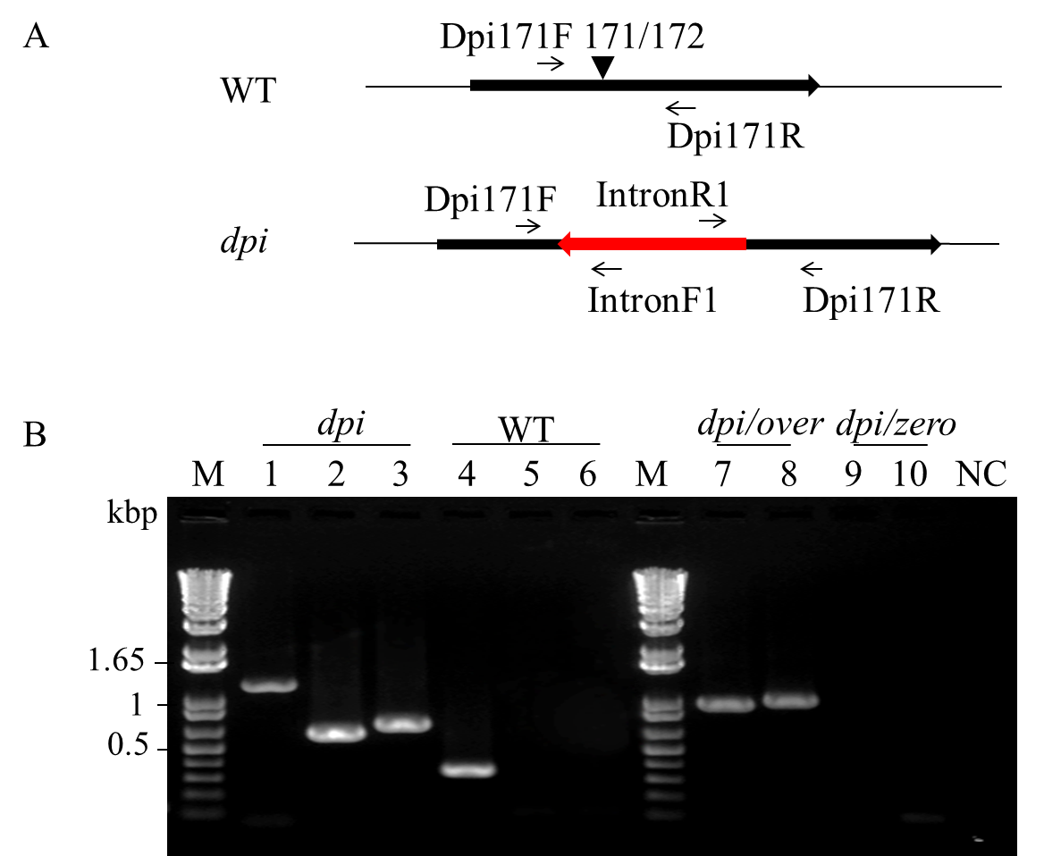
Fig. S1 Diagram of intron insertion in dpi gene and strains identification. A. The group II intron (red arrow) potentially inserted into the dpi ORF (bold black arrow) at 171/172nt in the anti-sense direction. Small arrows indicated locations of four primers (Dpi171F, Dpi171R, IntronF1 and Intron R1) that were applied to identify the anticipated intron insertion. B. PCR identification. Primers used in each PCR reaction are as follows: Dpi171F-Dpi171R (lane 1 and 4); Dpi171F-IntroF1 (lane 2 and 3), IntronR1-Dpi171R (lane 5 and 6); pClostron3RBSF-Dpi overexpR (lane 7 and 9); pClostron3RBSF-pClostron3seqR (lane 8 and 10). NC indicates negative control without any templates in the PCR system.

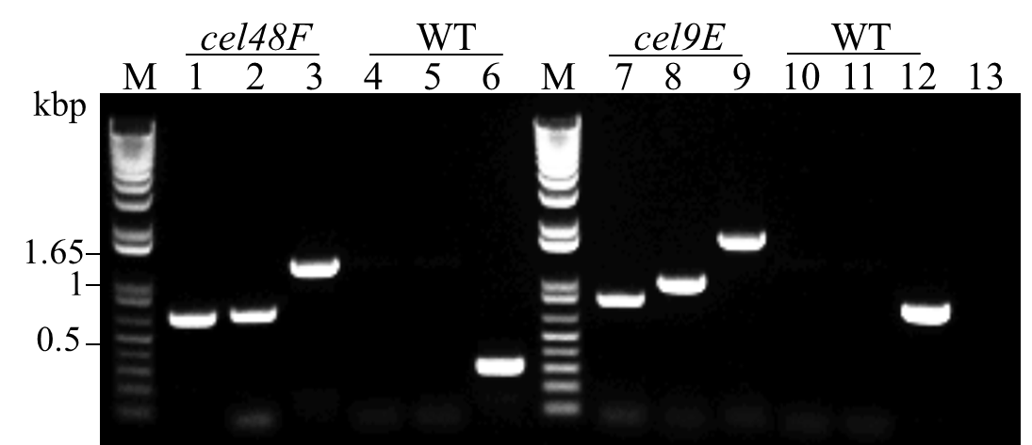
Fig. S2 Identification of cel48F and cel9E anti-sense mutants by PCR. Primers for each PCR reaction are as follows: 1, Cel48FF- intronF1; 2, intronR1-Cel48FR; 3, Cel48FF-Cel48FR; 4, Cel48FF-intronF1; 5, intronR1-Cel48FR; 6, Cel48FF-Cel48FR; 7, Cel9EF-intronF1; 8, intronR1-Cel9ER; 9, Cel9EF-Cel9ER; 10, Cel9EF-intronF1; 11, intronR1-Cel9ER; 12, Cel9EF-Cel9ER.

