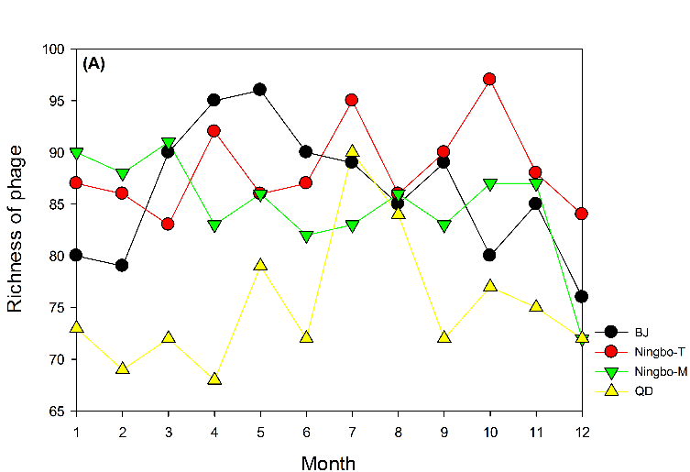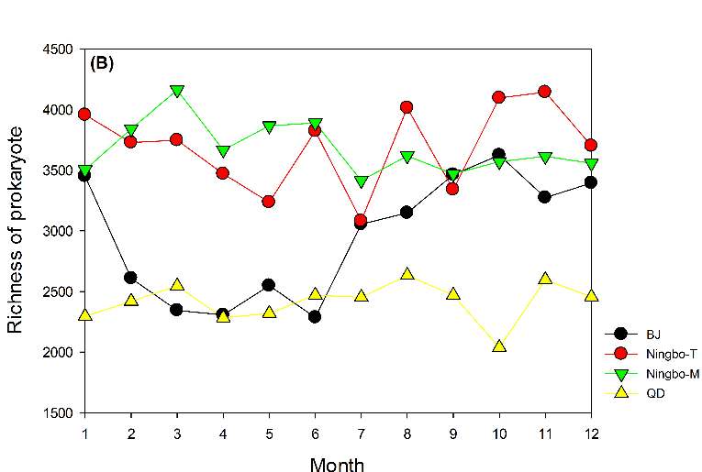
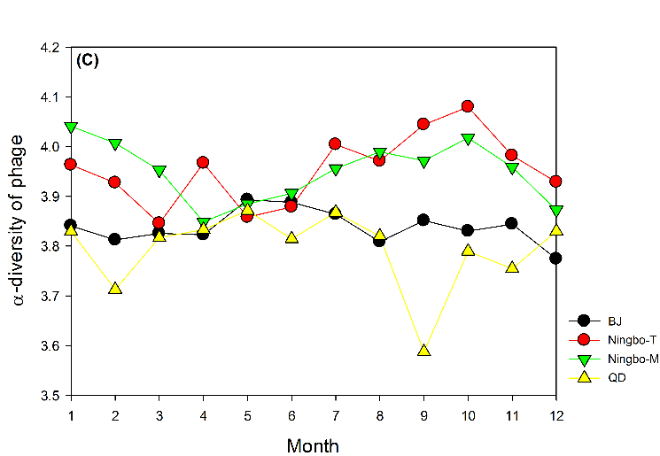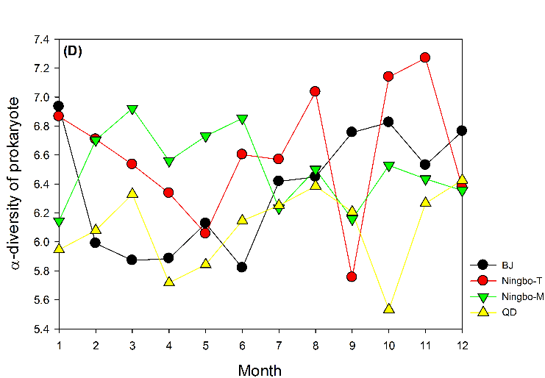
Fig. S1. Spatiotemporal changes in (A) richness of phages, (B) richness of prokaryotes, (C) the α-diversity of phages and (D) the α-diversity of prokaryotes. BJ: Beijing samples; QD: Qingdao samples; Ningbo-M: samples from Ningbo anaerobic digester maintained at mesophilic temperature, and Ningbo-T: samples from Ningbo anaerobic digester maintained at thermophilic temperature.

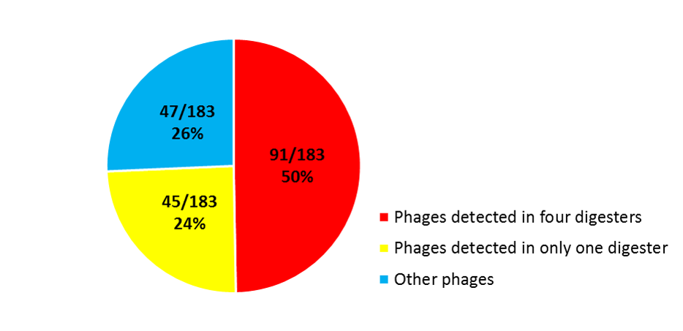
Fig. S2. Proportions of phages based on their detection frequencies in anaerobic digesters.

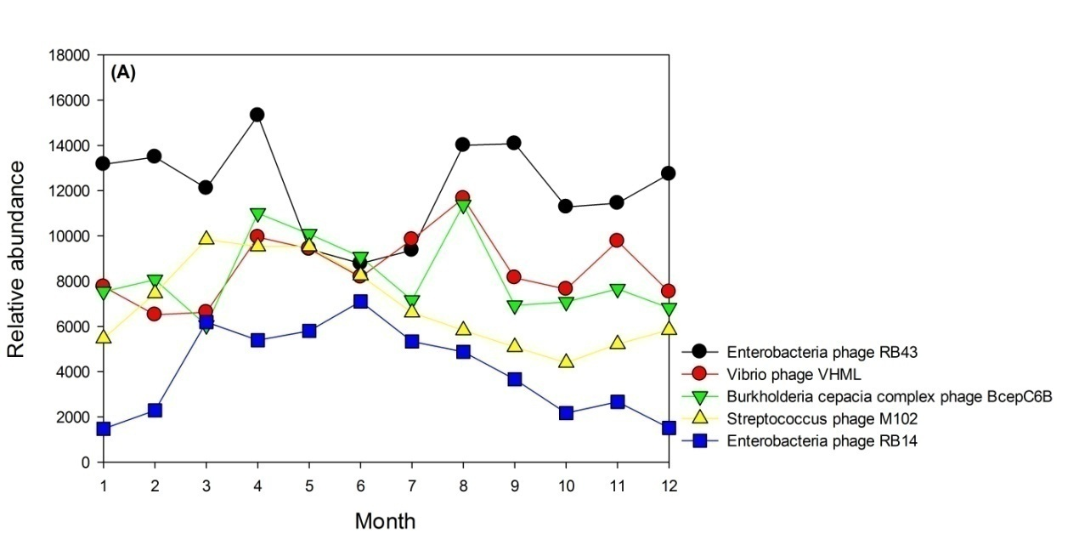
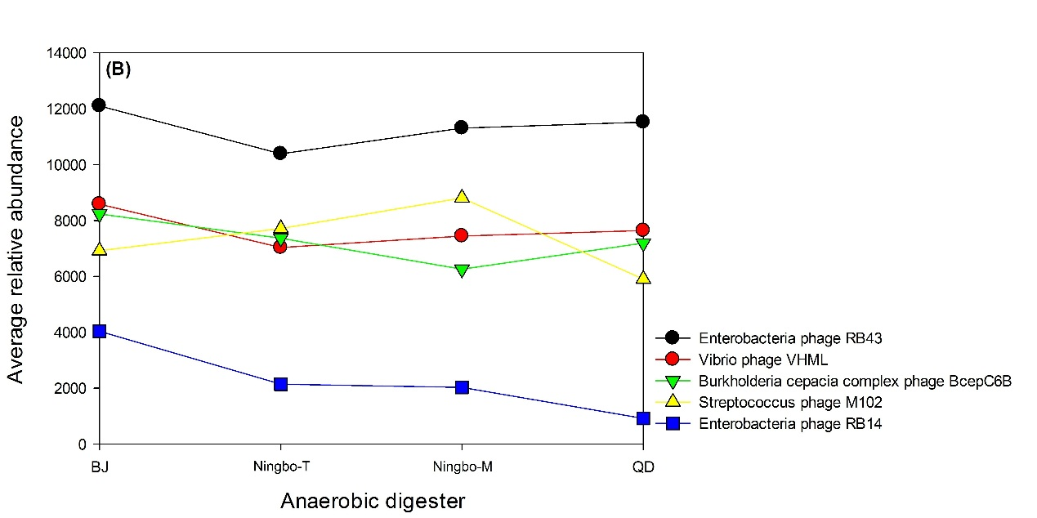
Fig. S3. The most abundant phages detected in Beijing samples as functions of (A) time and their average relative abundance in samples across (B) space.

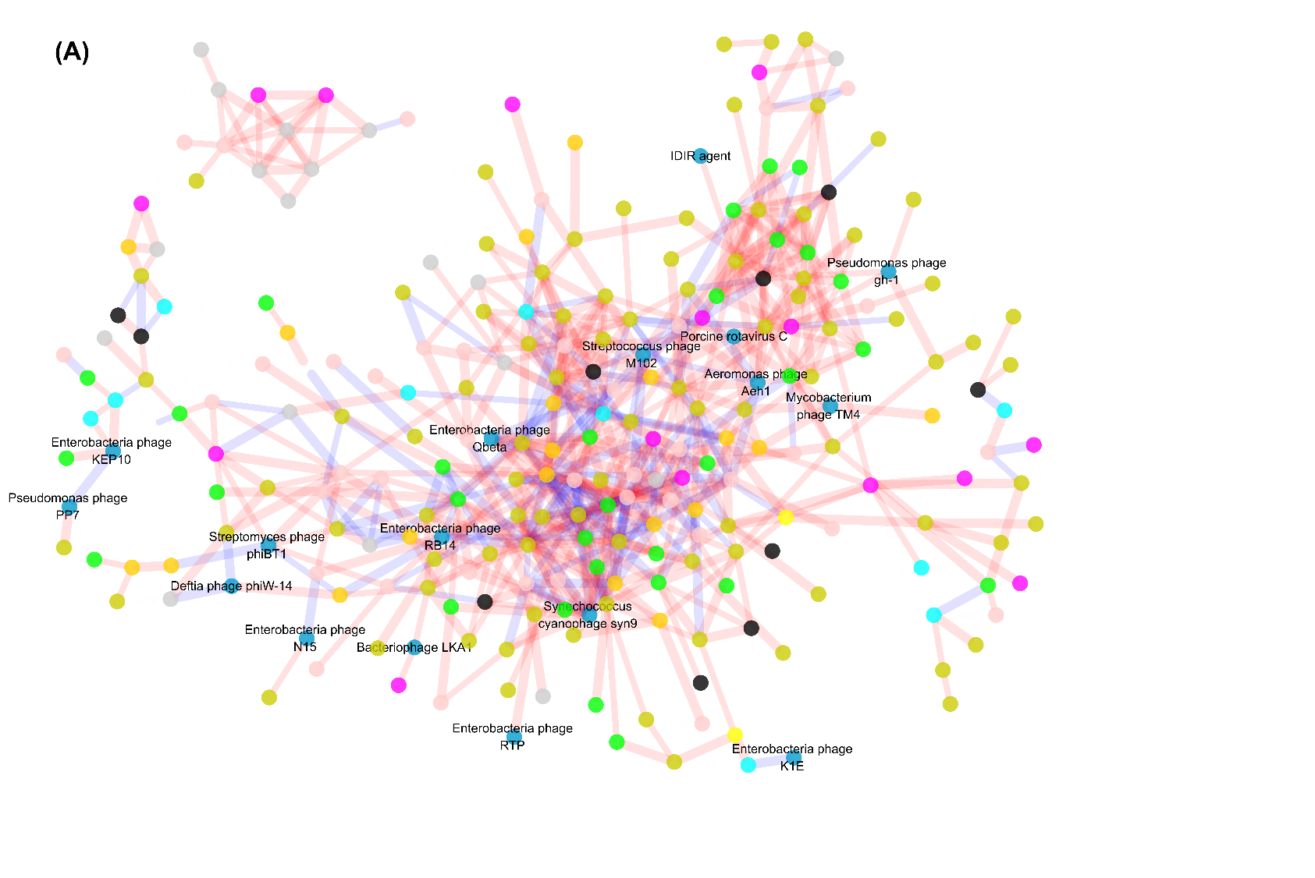
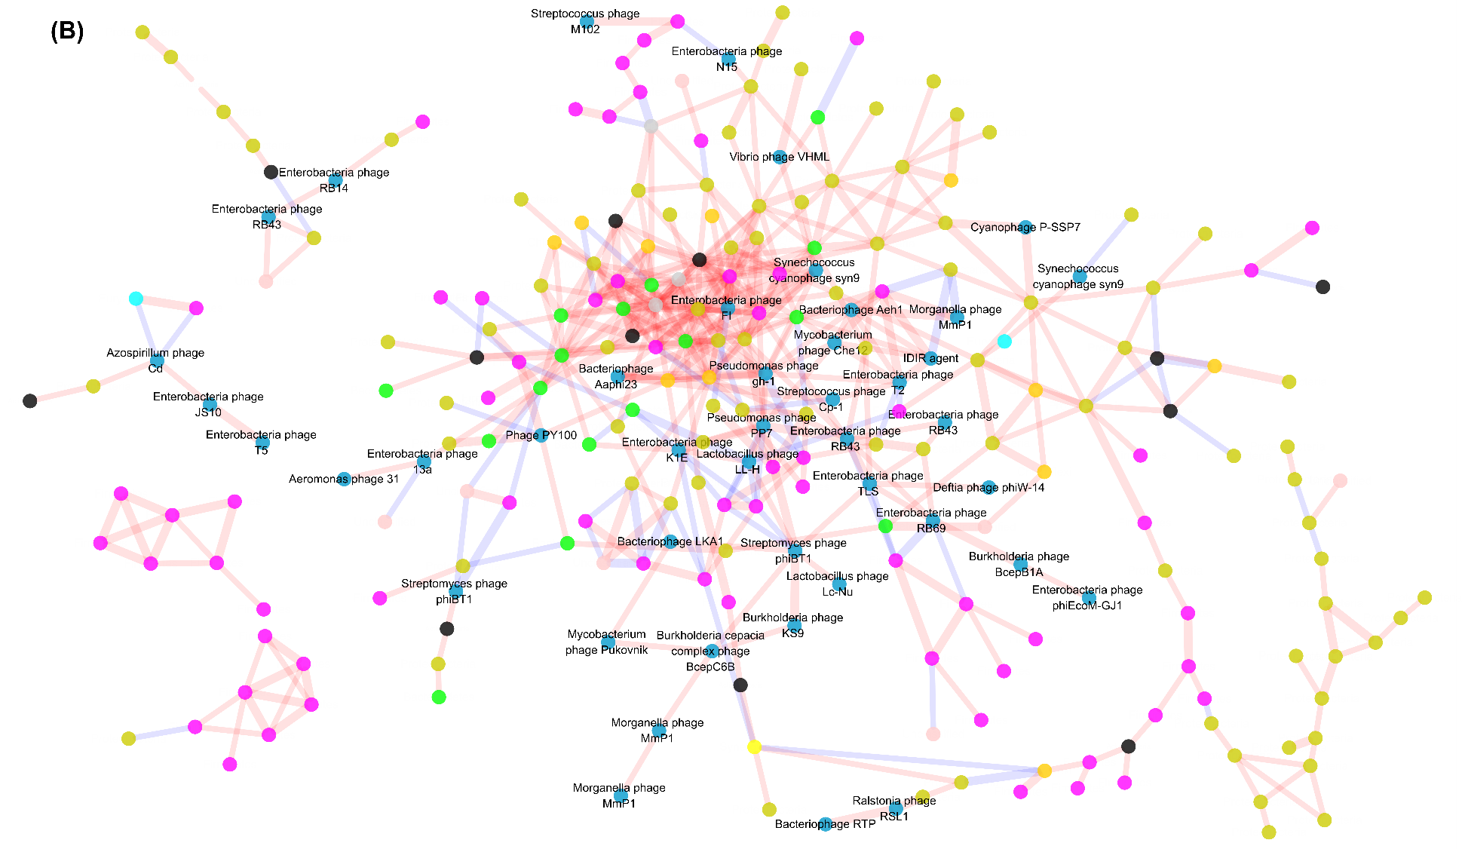

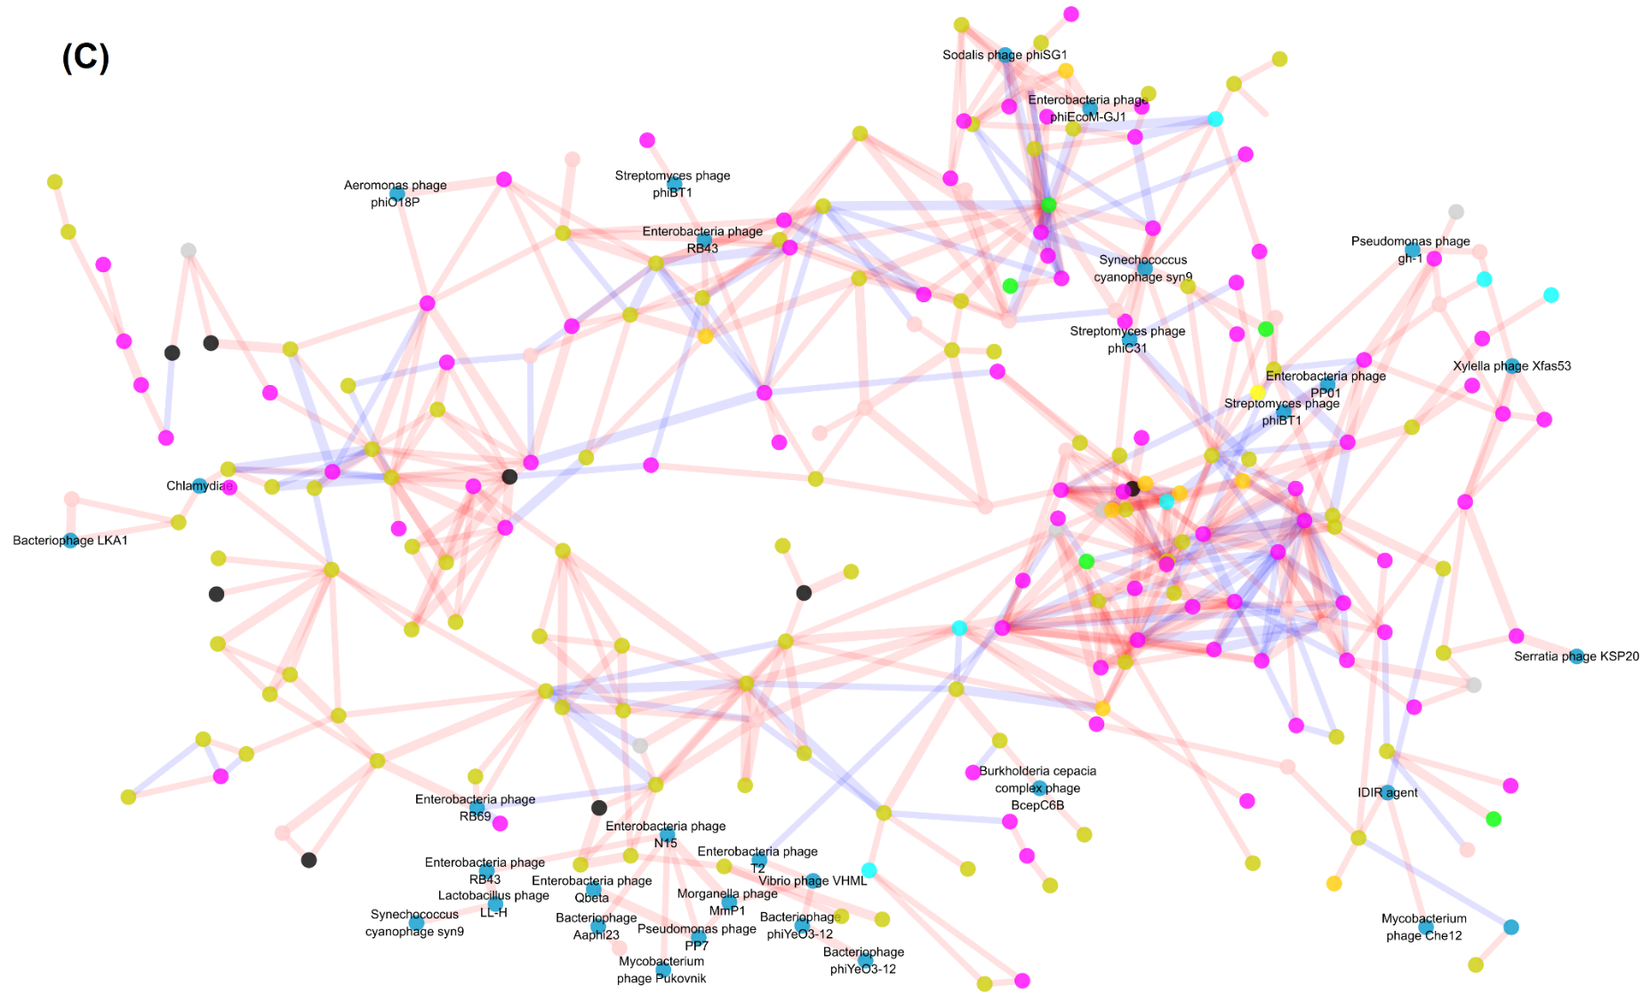
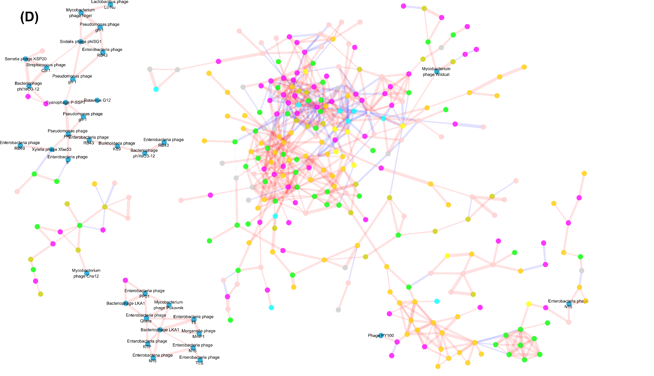
Fig. S4. Association networks generated from (A) Beijing, (B) Ningbo-T, (C) Ningbo-M and (D) Qingdao samples. Modules with equal or less than 5 nodes were omitted. Positive linkages are shown in red edges, while negative linkages are shown in blue edges. Spearman’s correlation coefficients are indicated by line width.
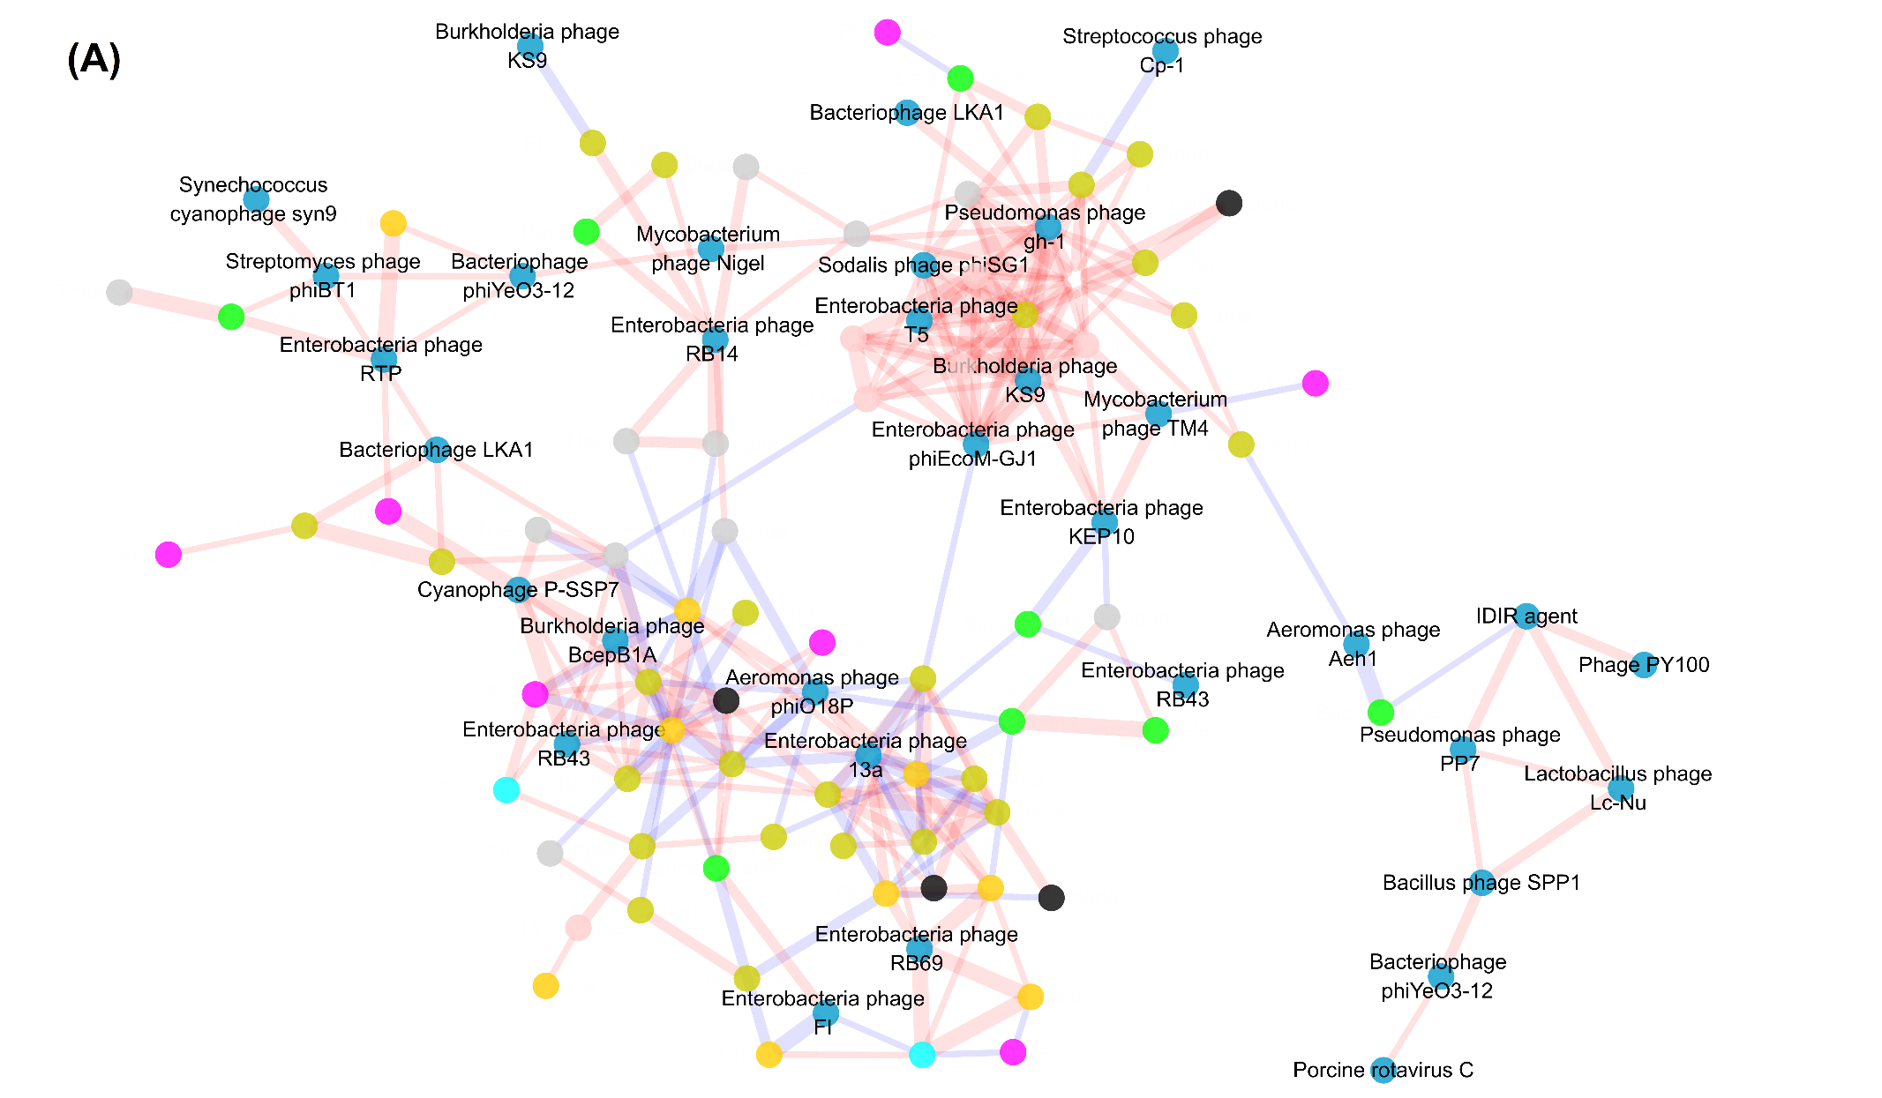
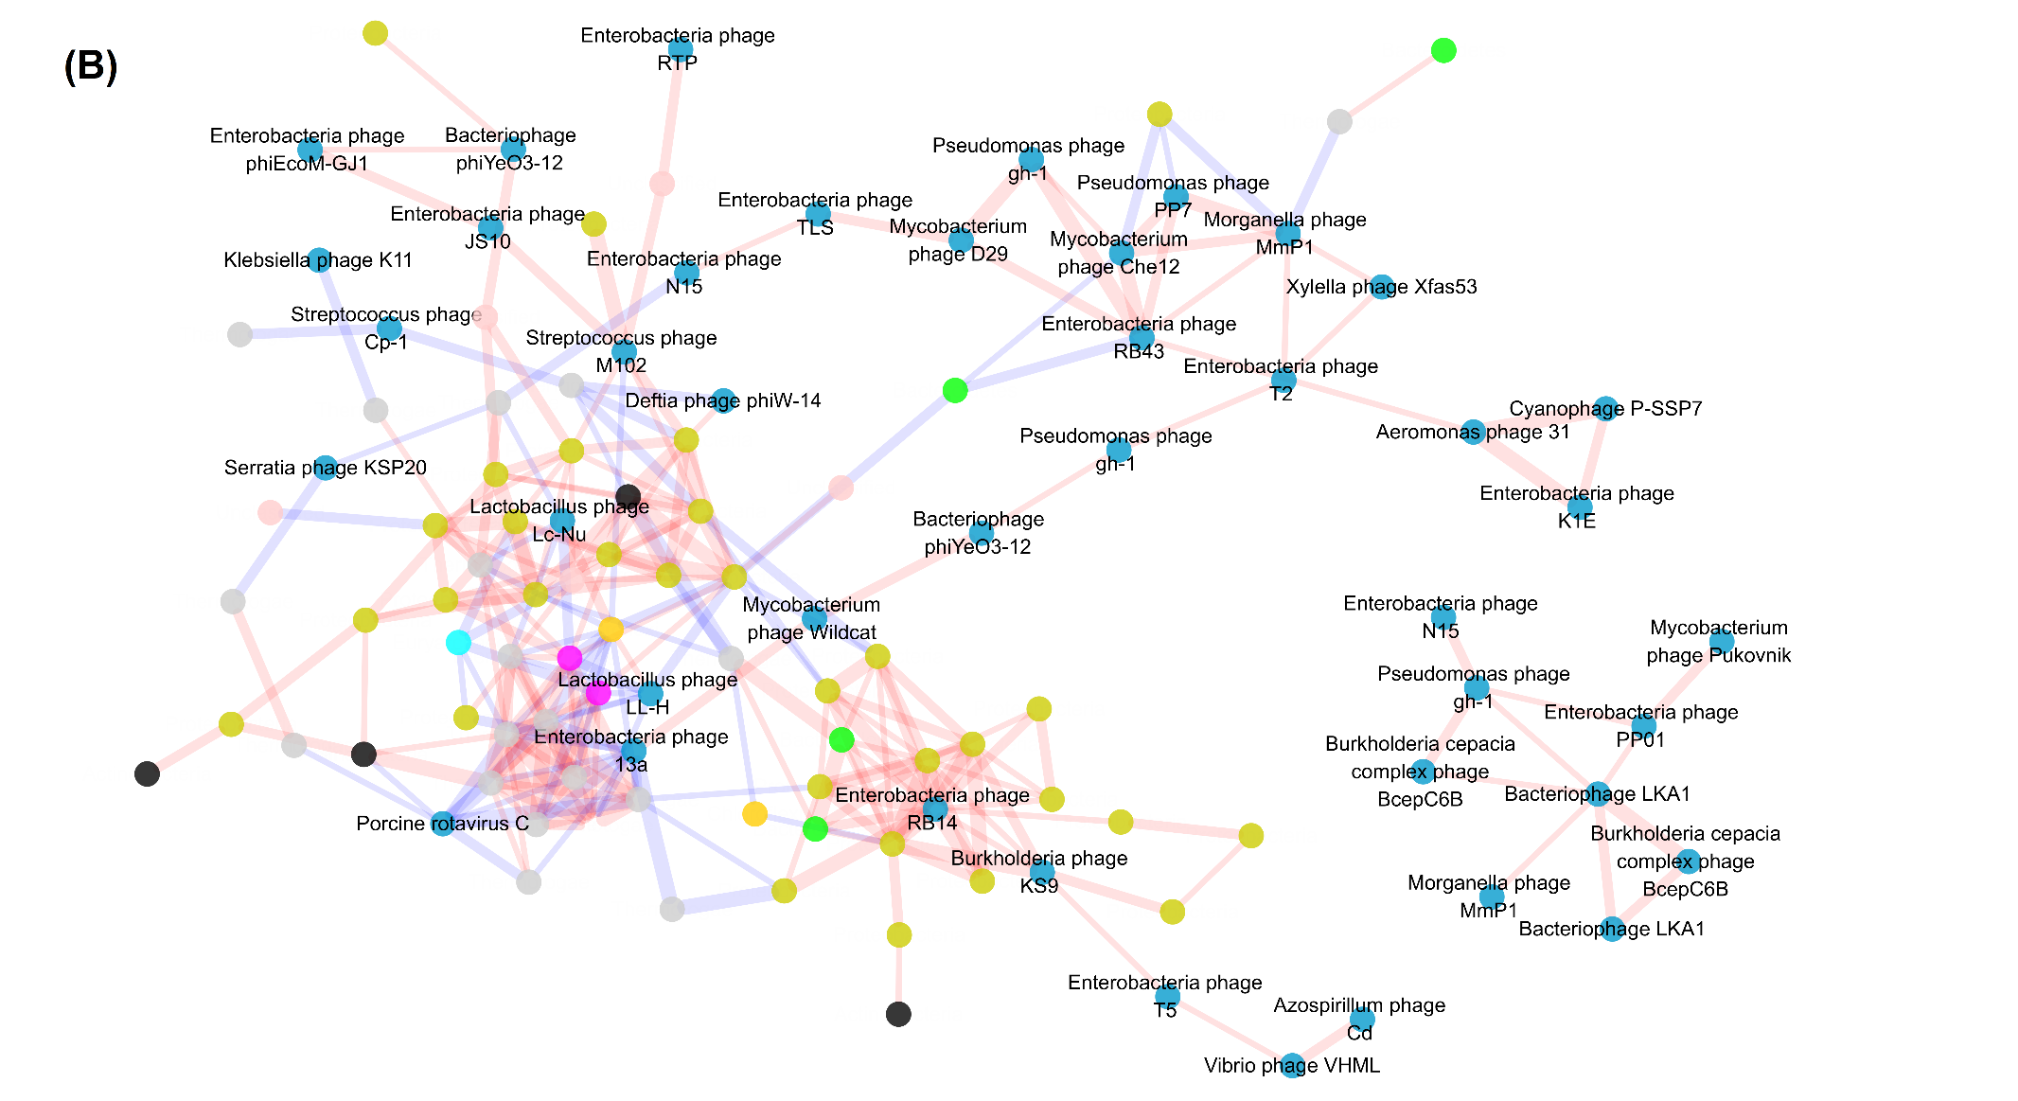
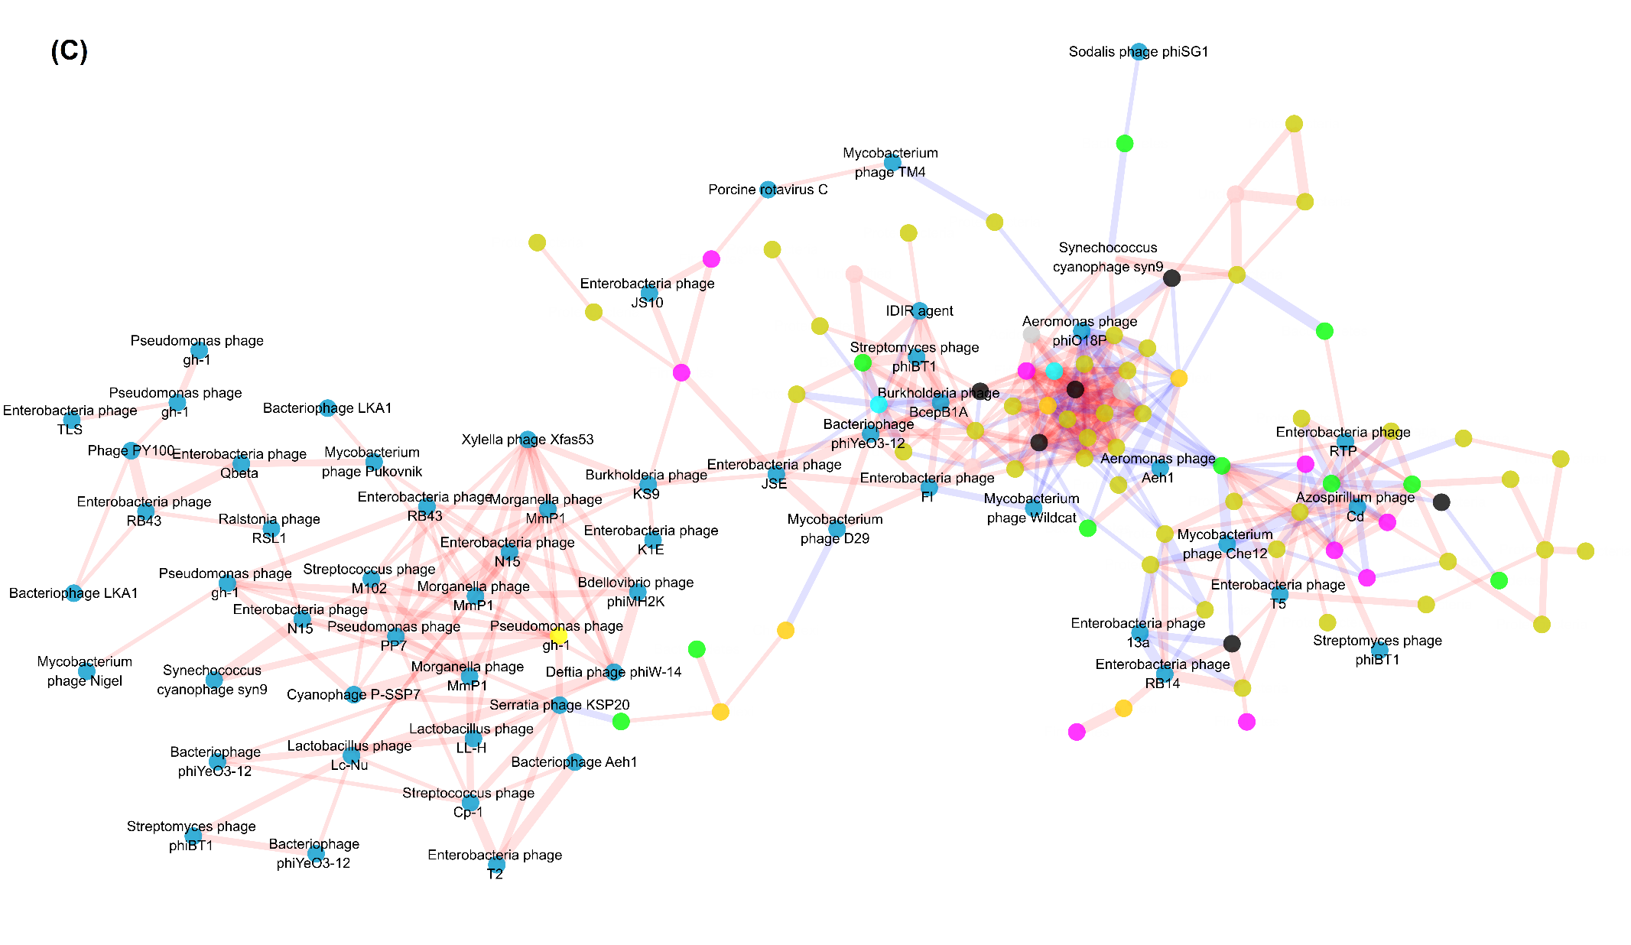
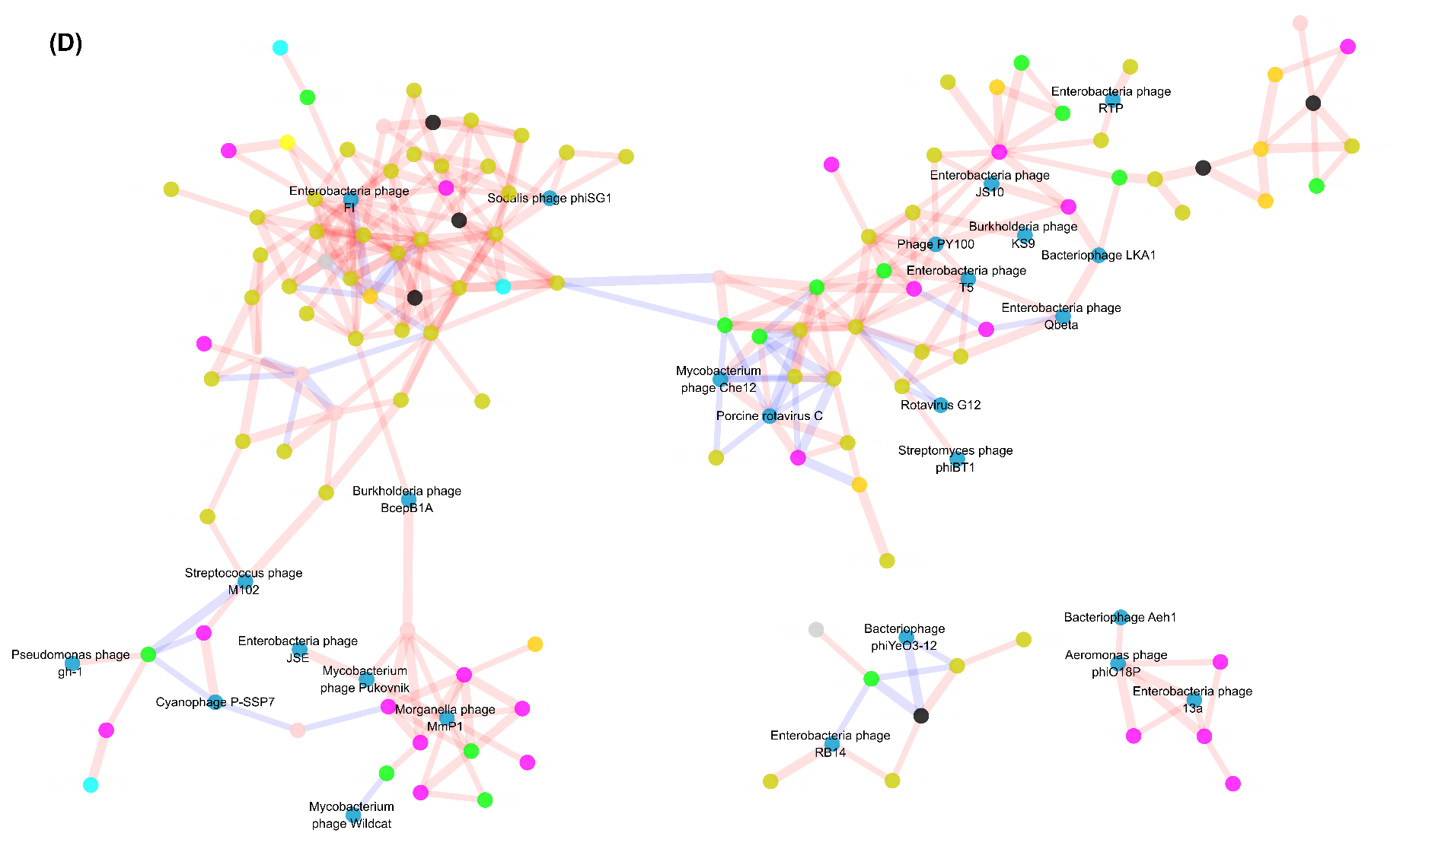
Fig. S5. Association networks generated according to seasons: (A) Winter, (B) Spring, (C) Summer and (D) Autumn. Modules with equal or less than 5 nodes were omitted. Positive linkages are shown in red edges, while negative linkages are shown in blue edges. Spearman’s correlation coefficients are indicated by line width.
Table S1. Dissimilarity tests of Mrpp, Anosim and Adonis on community structures.
Groups | Mrppª |  | Anosim |  | Adonis
 | δ | P-value | Statistic R | P-value | Statistic R² | P-value
BJ vs Ningbo-T | 0.183 | 0.002^{b} | 0.254 | 0.004 | 0.142 | 0.001
BJ vs Ningbo-M | 0.163 | <0.001 | 0.512 | 0.001 | 0.217 | 0.002
BJ vs QD | 0.207 | <0.001 | 0.417 | 0.001 | 0.236 | 0.001
Ningbo-T vs Ningbo-M | 0.167 | 0.024 | 0.19 | 0.005 | 0.075 | 0.060
Ningbo-T vs QD | 0.222 | 0.001 | 0.353 | 0.002 | 0.2 | 0.001
Ningbo-M vs QD | 0.2 | 0.001 | 0.423 | 0.001 | 0.225 | 0.001
ªAbbreviations: Mrpp, multi-response permutation procedure; Anosim, analysis of similarity; Adonis, non-parametric multivariate analysis of variance with the Adonis function.
^{b}Boldface values indicate significant differences (P<0.050).

Table S2. Measurements of physicochemical properties related to process performance.
Sample | TSª (mg/mL) | VS (mg/mL) | Gas (m³/d) | COD (mg/L)
BJ1 | 14.26 | 8.44 | - | 24.26
BJ2 | 17.83 | 9.67 | - | 62.18
BJ3 | 23.47 | 14.35 | - | 199.12
BJ4 | 14.04 | 8.60 | - | 28.41
BJ5 | 17.90 | 10.67 | - | 247.31
BJ6 | 5.94 | 2.80 | - | 52.63
BJ7 | 20.53 | 10.01 | - | 115.79
BJ8 | 29.52 | 12.65 | - | 9.43
BJ9 | 15.44 | 25.08 | - | 56.34
BJ10 | 15.19 | 8.86 | - | 18.00
BJ11 | 3.51 | 2.01 | - | 30.00
BJ12 | 12.25 | 7.73 | - | 36.00
Ningbo-M1 | 84.15 | 34.79 | - | 246.63
Ningbo-M2 | 65.43 | 26.15 | - | 99.15
Ningbo-M3 | 60.15 | 24.12 | - | 78.72
Ningbo-M4 | 84.16 | 34.80 | - | 107.49
Ningbo-M5 | 68.38 | 27.57 | - | 197.36
Ningbo-M6 | 58.44 | 26.56 | - | 62.50
Ningbo-M7 | 79.72 | 32.57 | - | 395.70
Ningbo-M8 | 61.72 | 24.15 | - | 84.21
Ningbo-M9 | 98.96 | 36.71 | - | 136.84
Ningbo-M10 | 94.27 | 31.31 | - | 89.62
Ningbo-M11 | 122.09 | 42.87 | - | 169.70
Ningbo-M12 | 26.07 | 22.45 | - | 81.00
QD1 | 12.51 | 4.84 | 8692.97 | 70.64
QD2 | 12.51 | 4.84 | 10116.07 | 82.13
QD3 | 14.47 | 5.38 | 13419.16 | 131.06
QD4 | 21.26 | 4.22 | 12573.21 | 101.42
QD5 | 21.50 | 7.39 | 15376.43 | 116.30
QD6 | 19.23 | 7.59 | 13698.46 | 103.41
QD7 | 13.02 | 4.34 | 10664.73 | 298.92
QD8 | 10.53 | 3.18 | 7818.60 | 84.21
QD9 | 17.18 | 5.27 | 7740.30 | 31.58
QD10 | 13.11 | 3.97 | 7238.42 | 42.45
QD11 | 14.04 | 5.63 | 7665.04 | 107.04
QD12 | 12.53 | 5.12 | 7577.07 | 66.00
ªAbbreviations: BJ: Beijing; QD: Qingdao; TS, total solid content; VS, volatile solid content; Gas, average daily biogas production; COD, chemical oxygen demand; NH₃-N, ammonia nitrogen.

Table S3. Taxonomic information of Euryarchaeota OTUs.

OTU | Kingdom | Phylum | Class | Order | Family | Genus
OTU_1019 | Archaea | Euryarchaeota | Methanobacteria | Methanobacteriales | Methanobacteriaceae | Methanobacterium
OTU_107 | Archaea | Euryarchaeota | Methanobacteria | Methanobacteriales | Methanobacteriaceae | Methanobacterium
OTU_1073 | Archaea | Euryarchaeota | Methanomicrobia | Methanomicrobiales | Methanomicrobiales-  _incertae_sedis | Methanolinea
OTU_1087 | Archaea | Euryarchaeota | Methanobacteria | Methanobacteriales | Methanobacteriaceae | Methanobacterium
OTU_1104 | Archaea | Euryarchaeota | Methanomicrobia | Methanomicrobiales | Methanomicrobiales-  _incertae_sedis | Methanolinea
OTU_1106 | Archaea | Euryarchaeota | Methanomicrobia | Methanomicrobiales | Methanomicrobiales-  _incertae_sedis | Methanolinea
OTU_1109 | Archaea | Euryarchaeota | Methanomicrobia | Methanosarcinales | Methanosaetaceae | Methanosaeta
OTU_1112 | Archaea | Euryarchaeota | Methanomicrobia | Methanomicrobiales | Methanomicrobiales-  _incertae_sedis | Methanoregula
OTU_1141 | Archaea | Euryarchaeota | Methanomicrobia | Methanosarcinales | Methanosaetaceae | Methanosaeta
OTU_115639 | Archaea | Euryarchaeota | Methanomicrobia | Methanomicrobiales | Methanomicrobiales-  _incertae_sedis | Methanolinea
OTU_1162 | Archaea | Euryarchaeota | Methanomicrobia | Methanomicrobiales | Methanomicrobiales-  _incertae_sedis | Methanolinea
OTU_1169 | Archaea | Euryarchaeota | Methanobacteria | Methanobacteriales | Methanobacteriaceae | Methanobacterium
OTU_1174 | Archaea | Euryarchaeota | Methanomicrobia | Methanomicrobiales | Methanomicrobiaceae | Methanosphaerula
OTU_1177 | Archaea | Euryarchaeota | Methanomicrobia | Methanomicrobiales | Methanomicrobiales-  _incertae_sedis | Methanolinea
OTU_1179 | Archaea | Euryarchaeota | Methanomicrobia | Methanomicrobiales | Methanomicrobiales-  _incertae_sedis | Methanolinea
OTU_118 | Archaea | Euryarchaeota | Methanobacteria | Methanobacteriales | Methanobacteriaceae | Methanobacterium
OTU_1185 | Archaea | Euryarchaeota | Methanomicrobia | Methanosarcinales | Methanosaetaceae | Methanosaeta
OTU_1205 | Archaea | Euryarchaeota | Methanomicrobia | Methanomicrobiales | Methanospirillaceae | Methanospirillum
OTU_1210 | Archaea | Euryarchaeota | Methanomicrobia | Methanomicrobiales | Methanomicrobiales-  _incertae_sedis | Methanolinea
OTU_1215 | Archaea | Euryarchaeota | Methanomicrobia | Methanomicrobiales | Methanospirillaceae | Methanospirillum
OTU_1274 | Archaea | Euryarchaeota | Methanomicrobia | Methanomicrobiales | Methanospirillaceae | Methanospirillum
OTU_1276 | Archaea | Euryarchaeota | Methanobacteria | Methanobacteriales | Methanobacteriaceae | Methanobacterium
OTU_12843 | Archaea | Euryarchaeota | Methanomicrobia | Methanomicrobiales | Methanomicrobiales-  _incertae_sedis | Methanolinea
OTU_1319 | Archaea | Euryarchaeota | Methanomicrobia | Methanosarcinales | Methanosaetaceae | Methanosaeta
OTU_1335 | Archaea | Euryarchaeota | Methanomicrobia | Methanomicrobiales | Methanomicrobiale-  s_incertae_sedis | Methanolinea
OTU_1351 | Archaea | Euryarchaeota | Methanomicrobia | Methanomicrobiales | Methanospirillaceae | Methanospirillum
OTU_1358 | Archaea | Euryarchaeota | Methanomicrobia | Methanomicrobiales | Methanospirillaceae | Methanospirillum
OTU_1359 | Archaea | Euryarchaeota | Methanomicrobia | Methanomicrobiales | Methanospirillaceae | Methanospirillum
OTU_1391 | Archaea | Euryarchaeota | Methanobacteria | Methanobacteriales | Methanobacteriaceae | Methanobacterium
OTU_1393 | Archaea | Euryarchaeota | Methanomicrobia | Methanomicrobiales | Methanomicrobiales-  _incertae_sedis | Methanolinea
OTU_1409 | Archaea | Euryarchaeota | Methanomicrobia | Methanomicrobiales | Methanospirillaceae | Methanospirillum
OTU_1443 | Archaea | Euryarchaeota | Methanomicrobia | Methanomicrobiales | Methanomicrobiaceae | Methanosphaerula
OTU_1456 | Archaea | Euryarchaeota | Methanobacteria | Methanobacteriales | Methanobacteriaceae | Methanothermobacter
OTU_146 | Archaea | Euryarchaeota | Methanobacteria | Methanobacteriales | Methanobacteriaceae | Methanobacterium
OTU_1482 | Archaea | Euryarchaeota | Methanomicrobia | Methanomicrobiales | Methanomicrobiales-  _incertae_sedis | Methanolinea
OTU_1492 | Archaea | Euryarchaeota | Methanomicrobia | Methanomicrobiales | Methanomicrobiales-  _incertae_sedis | Methanolinea
OTU_1504 | Archaea | Euryarchaeota | Methanomicrobia | Methanomicrobiales | Methanomicrobiales-  _incertae_sedis | Methanoregula
OTU_154 | Archaea | Euryarchaeota | Methanobacteria | Methanobacteriales | Methanobacteriaceae | Methanobacterium
OTU_1559 | Archaea | Euryarchaeota | Methanomicrobia | Methanomicrobiales | Methanospirillaceae | Methanospirillum
OTU_1566 | Archaea | Euryarchaeota | Methanomicrobia | Methanosarcinales | Methanosarcinaceae | Methanomethylovorans
OTU_1568 | Archaea | Euryarchaeota | Methanobacteria | Methanobacteriales | Methanobacteriaceae | Methanosphaera
OTU_1576 | Archaea | Euryarchaeota | Methanobacteria | Methanobacteriales | Methanobacteriaceae | Methanobacterium
OTU_1599 | Archaea | Euryarchaeota | Methanomicrobia | Methanomicrobiales | Methanomicrobiales-  _incertae_sedis | Methanoregula
OTU_1614 | Archaea | Euryarchaeota | Methanomicrobia | Methanomicrobiales | Methanomicrobiaceae | Methanosphaerula
OTU_1618 | Archaea | Euryarchaeota | Methanomicrobia | Methanomicrobiales | Methanomicrobiales-  _incertae_sedis | Methanolinea
OTU_1686 | Archaea | Euryarchaeota | Methanomicrobia | Methanomicrobiales | Methanomicrobiales-  _incertae_sedis | Methanolinea
OTU_1699 | Archaea | Euryarchaeota | Methanobacteria | Methanobacteriales | Methanobacteriaceae | Methanobacterium
OTU_1700 | Archaea | Euryarchaeota | Methanobacteria | Methanobacteriales | Methanobacteriaceae | Methanobrevibacter
OTU_1702 | Archaea | Euryarchaeota | Methanomicrobia | Methanosarcinales | Methanosaetaceae | Methanosaeta
OTU_1717 | Archaea | Euryarchaeota | Methanobacteria | Methanobacteriales | Methanobacteriaceae | Methanobacterium
OTU_1726 | Archaea | Euryarchaeota | Methanomicrobia | Methanosarcinales | Methanosaetaceae | Methanosaeta
OTU_1773 | Archaea | Euryarchaeota | Methanomicrobia | Methanomicrobiales | Methanomicrobiales-  _incertae_sedis | Methanolinea
OTU_1788 | Archaea | Euryarchaeota | Methanomicrobia | Methanomicrobiales | Methanomicrobiaceae | Methanosphaerula
OTU_1802 | Archaea | Euryarchaeota | Methanomicrobia | Methanomicrobiales | Methanospirillaceae | Methanospirillum
OTU_1812 | Archaea | Euryarchaeota | Methanomicrobia | Methanomicrobiales | Methanomicrobiales-  _incertae_sedis | Methanolinea
OTU_1828 | Archaea | Euryarchaeota | Methanomicrobia | Methanomicrobiales | Methanomicrobiales-  _incertae_sedis | Methanolinea
OTU_1855 | Archaea | Euryarchaeota | Methanomicrobia | Methanomicrobiales | Methanomicrobiales-  _incertae_sedis | Methanolinea
OTU_1896 | Archaea | Euryarchaeota | Methanomicrobia | Methanomicrobiales | Methanomicrobiales-  _incertae_sedis | Methanolinea
OTU_1898 | Archaea | Euryarchaeota | Methanomicrobia | Methanomicrobiales | Methanospirillaceae | Methanospirillum
OTU_1930 | Archaea | Euryarchaeota | Methanobacteria | Methanobacteriales | Methanobacteriaceae | Methanobacterium
OTU_195 | Archaea | Euryarchaeota | Methanobacteria | Methanobacteriales | Methanobacteriaceae | Methanobacterium
OTU_1965 | Archaea | Euryarchaeota | Methanomicrobia | Methanosarcinales | Methanosaetaceae | Methanosaeta
OTU_1979 | Archaea | Euryarchaeota | Methanomicrobia | Methanomicrobiales | Methanomicrobiales-  _incertae_sedis | Methanolinea
OTU_2007 | Archaea | Euryarchaeota | Methanobacteria | Methanobacteriales | Methanobacteriaceae | Methanobacterium
OTU_2036 | Archaea | Euryarchaeota | Methanobacteria | Methanobacteriales | Methanobacteriaceae | Methanobrevibacter
OTU_2046 | Archaea | Euryarchaeota | Methanobacteria | Methanobacteriales | Methanobacteriaceae | Methanobacterium
OTU_2122 | Archaea | Euryarchaeota | Methanomicrobia | Methanomicrobiales | Methanomicrobiales-  _incertae_sedis | Methanolinea
OTU_2132 | Archaea | Euryarchaeota | Methanomicrobia | Methanosarcinales | Methanosarcinaceae | Methanomethylovorans
OTU_2133 | Archaea | Euryarchaeota | Methanobacteria | Methanobacteriales | Methanobacteriaceae | Methanobacterium
OTU_2148 | Archaea | Euryarchaeota | Methanomicrobia | Methanomicrobiales | Methanospirillaceae | Methanospirillum
OTU_2191 | Archaea | Euryarchaeota | Methanomicrobia | Methanomicrobiales | Methanomicrobiales-  _incertae_sedis | Methanolinea
OTU_2218 | Archaea | Euryarchaeota | Methanomicrobia | Methanomicrobiales | Methanomicrobiaceae | Methanofollis
OTU_2248 | Archaea | Euryarchaeota | Methanomicrobia | Methanomicrobiales | Methanomicrobiales-  _incertae_sedis | Methanolinea
OTU_2278 | Archaea | Euryarchaeota | Methanomicrobia | Methanomicrobiales | Methanomicrobiales-  _incertae_sedis | Methanoregula
OTU_2303 | Archaea | Euryarchaeota | Methanomicrobia | Methanomicrobiales | Methanospirillaceae | Methanospirillum
OTU_233 | Archaea | Euryarchaeota | Methanobacteria | Methanobacteriales | Methanobacteriaceae | Methanobacterium
OTU_2368 | Archaea | Euryarchaeota | Methanobacteria | Methanobacteriales | Methanobacteriaceae | Methanobacterium
OTU_238 | Archaea | Euryarchaeota | Methanobacteria | Methanobacteriales | Methanobacteriaceae | Methanobacterium
OTU_2387 | Archaea | Euryarchaeota | Methanobacteria | Methanobacteriales | Methanobacteriaceae | Methanobrevibacter
OTU_2398 | Archaea | Euryarchaeota | Methanobacteria | Methanobacteriales | Methanobacteriaceae | Methanobacterium
OTU_2415 | Archaea | Euryarchaeota | Methanomicrobia | Methanomicrobiales | Methanomicrobiaceae | Methanosphaerula
OTU_2424 | Archaea | Euryarchaeota | Methanomicrobia | Methanomicrobiales | Methanomicrobiales-  _incertae_sedis | Methanolinea
OTU_2425 | Archaea | Euryarchaeota | Methanomicrobia | Methanomicrobiales | Methanomicrobiaceae | Methanosphaerula
OTU_2434 | Archaea | Euryarchaeota | Methanobacteria | Methanobacteriales | Methanobacteriaceae | Methanobacterium
OTU_2470 | Archaea | Euryarchaeota | Methanomicrobia | Methanomicrobiales | Methanomicrobiaceae | Methanosphaerula
OTU_2474 | Archaea | Euryarchaeota | Methanomicrobia | Methanosarcinales | Methanosaetaceae | Methanosaeta
OTU_2525 | Archaea | Euryarchaeota | Methanomicrobia | Methanosarcinales | Methanosarcinaceae | Methanosarcina
OTU_2528 | Archaea | Euryarchaeota | Methanomicrobia | Methanomicrobiales | Methanomicrobiales-  _incertae_sedis | Methanolinea
OTU_2562 | Archaea | Euryarchaeota | Methanomicrobia | Methanomicrobiales | Methanospirillaceae | Methanospirillum
OTU_2584 | Archaea | Euryarchaeota | Methanobacteria | Methanobacteriales | Methanobacteriaceae | Methanobacterium
OTU_2589 | Archaea | Euryarchaeota | Methanomicrobia | Methanosarcinales | Methanosaetaceae | Methanosaeta
OTU_2604 | Archaea | Euryarchaeota | Methanomicrobia | Methanomicrobiales | Methanospirillaceae | Methanospirillum
OTU_2667 | Archaea | Euryarchaeota | Methanomicrobia | Methanomicrobiales | Methanomicrobiaceae | Methanosphaerula
OTU_2679 | Archaea | Euryarchaeota | Methanomicrobia | Methanomicrobiales | Methanomicrobiales-  _incertae_sedis | Methanolinea
OTU_2683 | Archaea | Euryarchaeota | Methanomicrobia | Methanomicrobiales | Methanomicrobiales-  _incertae_sedis | Methanolinea
OTU_2695 | Archaea | Euryarchaeota | Methanomicrobia | Methanosarcinales | Methanosaetaceae | Methanosaeta
OTU_2704 | Archaea | Euryarchaeota | Methanomicrobia | Methanomicrobiales | Methanospirillaceae | Methanospirillum
OTU_2743 | Archaea | Euryarchaeota | Methanomicrobia | Methanomicrobiales | Methanomicrobiaceae | Methanosphaerula
OTU_2747 | Archaea | Euryarchaeota | Methanomicrobia | Methanomicrobiales | Methanomicrobiaceae | Methanosphaerula
OTU_279 | Archaea | Euryarchaeota | Methanobacteria | Methanobacteriales | Methanobacteriaceae | Methanobacterium
OTU_2814 | Archaea | Euryarchaeota | Methanomicrobia | Methanomicrobiales | Methanomicrobiales-  _incertae_sedis | Methanolinea
OTU_2846 | Archaea | Euryarchaeota | Methanomicrobia | Methanomicrobiales | Methanospirillaceae | Methanospirillum
OTU_2868 | Archaea | Euryarchaeota | Methanomicrobia | Methanomicrobiales | Methanospirillaceae | Methanospirillum
OTU_2872 | Archaea | Euryarchaeota | Methanomicrobia | Methanomicrobiales | Methanomicrobiales-  _incertae_sedis | Methanoregula
OTU_2878 | Archaea | Euryarchaeota | Methanomicrobia | Methanosarcinales | Methanosaetaceae | Methanosaeta
OTU_2901 | Archaea | Euryarchaeota | Methanomicrobia | Methanomicrobiales | Methanomicrobiales-  _incertae_sedis | Methanolinea
OTU_2906 | Archaea | Euryarchaeota | Methanomicrobia | Methanomicrobiales | Methanomicrobiales-  _incertae_sedis | Methanolinea
OTU_2937 | Archaea | Euryarchaeota | Methanobacteria | Methanobacteriales | Methanobacteriaceae | Methanobacterium
OTU_2944 | Archaea | Euryarchaeota | Methanomicrobia | Methanomicrobiales | Methanomicrobiaceae | Methanoculleus
OTU_2957 | Archaea | Euryarchaeota | Methanomicrobia | Methanomicrobiales | Methanomicrobiales-  _incertae_sedis | Methanolinea
OTU_302 | Archaea | Euryarchaeota | Methanomicrobia | Methanosarcinales | Methanosarcinaceae | Methanosarcina
OTU_3025 | Archaea | Euryarchaeota | Methanomicrobia | Methanomicrobiales | Methanospirillaceae | Methanospirillum
OTU_3057 | Archaea | Euryarchaeota | Methanobacteria | Methanobacteriales | Methanobacteriaceae | Methanobrevibacter
OTU_3066 | Archaea | Euryarchaeota | Methanomicrobia | Methanomicrobiales | Methanomicrobiales-  _incertae_sedis | Methanolinea
OTU_3088 | Archaea | Euryarchaeota | Methanobacteria | Methanobacteriales | Methanobacteriaceae | Methanobacterium
OTU_3094 | Archaea | Euryarchaeota | Methanobacteria | Methanobacteriales | Methanobacteriaceae | Methanobacterium
OTU_3120 | Archaea | Euryarchaeota | Methanomicrobia | Methanomicrobiales | Methanomicrobiales-  _incertae_sedis | Methanoregula
OTU_3123 | Archaea | Euryarchaeota | Methanomicrobia | Methanomicrobiales | Methanospirillaceae | Methanospirillum
OTU_3127 | Archaea | Euryarchaeota | Methanomicrobia | Methanomicrobiales | Methanocorpusculaceae | Methanocorpusculum
OTU_3130 | Archaea | Euryarchaeota | Methanobacteria | Methanobacteriales | Methanobacteriaceae | Methanobacterium
OTU_3131 | Archaea | Euryarchaeota | Methanobacteria | Methanobacteriales | Methanobacteriaceae | Methanobacterium
OTU_3160 | Archaea | Euryarchaeota | Methanomicrobia | Methanomicrobiales | Methanomicrobiales-  _incertae_sedis | Methanolinea
OTU_3208 | Archaea | Euryarchaeota | Methanomicrobia | Methanosarcinales | Methanosarcinaceae | Methanomethylovorans
OTU_3213 | Archaea | Euryarchaeota | Methanomicrobia | Methanomicrobiales | Methanospirillaceae | Methanospirillum
OTU_325 | Archaea | Euryarchaeota | Methanomicrobia | Methanomicrobiales | Methanospirillaceae | Methanospirillum
OTU_3289 | Archaea | Euryarchaeota | Methanomicrobia | Methanomicrobiales | Methanomicrobiales-  _incertae_sedis | Methanolinea
OTU_3304 | Archaea | Euryarchaeota | Methanomicrobia | Methanomicrobiales | Methanomicrobiaceae | Methanoculleus
OTU_337 | Archaea | Euryarchaeota | Methanomicrobia | Methanomicrobiales | Methanomicrobiales-  _incertae_sedis | Methanoregula
OTU_3375 | Archaea | Euryarchaeota | Methanomicrobia | Methanomicrobiales | Methanospirillaceae | Methanospirillum
OTU_343 | Archaea | Euryarchaeota | Methanobacteria | Methanobacteriales | Methanobacteriaceae | Methanobacterium
OTU_3434 | Archaea | Euryarchaeota | Methanomicrobia | Methanomicrobiales | Methanomicrobiales-  _incertae_sedis | Methanolinea
OTU_3464 | Archaea | Euryarchaeota | Methanomicrobia | Methanomicrobiales | Methanomicrobiaceae | Methanosphaerula
OTU_3470 | Archaea | Euryarchaeota | Methanomicrobia | Methanosarcinales | Methanosaetaceae | Methanosaeta
OTU_3500 | Archaea | Euryarchaeota | Methanomicrobia | Methanomicrobiales | Methanomicrobiales-  _incertae_sedis | Methanolinea
OTU_353 | Archaea | Euryarchaeota | Methanomicrobia | Methanomicrobiales | Methanomicrobiales-  _incertae_sedis | Methanolinea
OTU_3536 | Archaea | Euryarchaeota | Methanomicrobia | Methanomicrobiales | Methanospirillaceae | Methanospirillum
OTU_3580 | Archaea | Euryarchaeota | Methanomicrobia | Methanomicrobiales | Methanomicrobiales-  _incertae_sedis | Methanolinea
OTU_3650 | Archaea | Euryarchaeota | Methanomicrobia | Methanomicrobiales | Methanospirillaceae | Methanospirillum
OTU_3656 | Archaea | Euryarchaeota | Methanomicrobia | Methanomicrobiales | Methanomicrobiales-  _incertae_sedis | Methanolinea
OTU_367 | Archaea | Euryarchaeota | Methanomicrobia | Methanomicrobiales | Methanospirillaceae | Methanospirillum
OTU_3723 | Archaea | Euryarchaeota | Methanomicrobia | Methanomicrobiales | Methanomicrobiales-  _incertae_sedis | Methanolinea
OTU_3735 | Archaea | Euryarchaeota | Methanomicrobia | Methanosarcinales | Methanosaetaceae | Methanosaeta
OTU_3786 | Archaea | Euryarchaeota | Methanomicrobia | Methanomicrobiales | Methanomicrobiales-  _incertae_sedis | Methanolinea
OTU_3807 | Archaea | Euryarchaeota | Methanomicrobia | Methanosarcinales | Methanosaetaceae | Methanosaeta
OTU_3870 | Archaea | Euryarchaeota | Methanomicrobia | Methanomicrobiales | Methanospirillaceae | Methanospirillum
OTU_395 | Archaea | Euryarchaeota | Methanomicrobia | Methanomicrobiales | Methanomicrobiales-  _incertae_sedis | Methanolinea
OTU_396 | Archaea | Euryarchaeota | Methanobacteria | Methanobacteriales | Methanobacteriaceae | Methanobacterium
OTU_398 | Archaea | Euryarchaeota | Methanomicrobia | Methanomicrobiales | Methanospirillaceae | Methanospirillum
OTU_3985 | Archaea | Euryarchaeota | Methanomicrobia | Methanomicrobiales | Methanomicrobiaceae | Methanosphaerula
OTU_4126 | Archaea | Euryarchaeota | Methanomicrobia | Methanomicrobiales | Methanomicrobiales-  _incertae_sedis | Methanolinea
OTU_413 | Archaea | Euryarchaeota | Methanomicrobia | Methanomicrobiales | Methanomicrobiaceae | Methanoculleus
OTU_4130 | Archaea | Euryarchaeota | Methanomicrobia | Methanomicrobiales | Methanospirillaceae | Methanospirillum
OTU_41715 | Archaea | Euryarchaeota | Methanomicrobia | Methanomicrobiales | Methanomicrobiales-  _incertae_sedis | Methanolinea
OTU_418 | Archaea | Euryarchaeota | Methanomicrobia | Methanomicrobiales | Methanomicrobiales-  _incertae_sedis | Methanolinea
OTU_420 | Archaea | Euryarchaeota | Methanobacteria | Methanobacteriales | Methanobacteriaceae | Methanobacterium
OTU_422 | Archaea | Euryarchaeota | Methanomicrobia | Methanomicrobiales | Methanomicrobiaceae | Methanosphaerula
OTU_4221 | Archaea | Euryarchaeota | Methanobacteria | Methanobacteriales | Methanobacteriaceae | Methanobacterium
OTU_4316 | Archaea | Euryarchaeota | Methanomicrobia | Methanomicrobiales | Methanomicrobiales-  _incertae_sedis | Methanolinea
OTU_4332 | Archaea | Euryarchaeota | Methanomicrobia | Methanosarcinales | Methanosarcinaceae | Methanosarcina
OTU_439 | Archaea | Euryarchaeota | Methanomicrobia | Methanomicrobiales | Methanomicrobiaceae | Methanogenium
OTU_4402 | Archaea | Euryarchaeota | Methanomicrobia | Methanosarcinales | Methanosaetaceae | Methanosaeta
OTU_4422 | Archaea | Euryarchaeota | Methanomicrobia | Methanomicrobiales | Methanomicrobiaceae | Methanosphaerula
OTU_4439 | Archaea | Euryarchaeota | Methanobacteria | Methanobacteriales | Methanobacteriaceae | Methanobacterium
OTU_4533 | Archaea | Euryarchaeota | Methanobacteria | Methanobacteriales | Methanobacteriaceae | Methanobacterium
OTU_456 | Archaea | Euryarchaeota | Methanobacteria | Methanobacteriales | Methanobacteriaceae | Methanobrevibacter
OTU_4596 | Archaea | Euryarchaeota | Methanomicrobia | Methanomicrobiales | Methanomicrobiaceae | Methanosphaerula
OTU_4641 | Archaea | Euryarchaeota | Methanomicrobia | Methanosarcinales | Methanosaetaceae | Methanosaeta
OTU_4713 | Archaea | Euryarchaeota | Methanobacteria | Methanobacteriales | Methanobacteriaceae | Methanobacterium
OTU_4765 | Archaea | Euryarchaeota | Methanomicrobia | Methanomicrobiales | Methanomicrobiales-  _incertae_sedis | Methanolinea
OTU_4784 | Archaea | Euryarchaeota | Methanomicrobia | Methanosarcinales | Methanosarcinaceae | Methanosarcina
OTU_4789 | Archaea | Euryarchaeota | Methanomicrobia | Methanomicrobiales | Methanomicrobiales-  _incertae_sedis | Methanoregula
OTU_479 | Archaea | Euryarchaeota | Methanobacteria | Methanobacteriales | Methanobacteriaceae | Methanobacterium
OTU_4881 | Archaea | Euryarchaeota | Methanomicrobia | Methanosarcinales | Methanosarcinaceae | Methanosarcina
OTU_493 | Archaea | Euryarchaeota | Methanomicrobia | Methanomicrobiales | Methanospirillaceae | Methanospirillum
OTU_496 | Archaea | Euryarchaeota | Methanomicrobia | Methanomicrobiales | Methanospirillaceae | Methanospirillum
OTU_499 | Archaea | Euryarchaeota | Methanomicrobia | Methanomicrobiales | Methanomicrobiaceae | Methanosphaerula
OTU_508 | Archaea | Euryarchaeota | Methanomicrobia | Methanosarcinales | Methanosaetaceae | Methanosaeta
OTU_510 | Archaea | Euryarchaeota | Methanomicrobia | Methanomicrobiales | Methanomicrobiales-  _incertae_sedis | Methanoregula
OTU_515 | Archaea | Euryarchaeota | Methanomicrobia | Methanosarcinales | Methanosarcinaceae | Methanomethylovorans
OTU_518 | Archaea | Euryarchaeota | Methanomicrobia | Methanosarcinales | Methanosarcinaceae | Methanomethylovorans
OTU_520 | Archaea | Euryarchaeota | Methanomicrobia | Methanosarcinales | Methanosaetaceae | Methanosaeta
OTU_525 | Archaea | Euryarchaeota | Methanobacteria | Methanobacteriales | Methanobacteriaceae | Methanobacterium
OTU_533 | Archaea | Euryarchaeota | Methanomicrobia | Methanomicrobiales | Methanomicrobiales-  _incertae_sedis | Methanolinea
OTU_534 | Archaea | Euryarchaeota | Methanomicrobia | Methanomicrobiales | Methanomicrobiales-  _incertae_sedis | Methanolinea
OTU_549 | Archaea | Euryarchaeota | Methanobacteria | Methanobacteriales | Methanobacteriaceae | Methanobrevibacter
OTU_55 | Archaea | Euryarchaeota | Methanobacteria | Methanobacteriales | Methanobacteriaceae | Methanobacterium
OTU_562 | Archaea | Euryarchaeota | Methanomicrobia | Methanomicrobiales | Methanomicrobiales-  _incertae_sedis | Methanolinea
OTU_57 | Archaea | Euryarchaeota | Methanomicrobia | Methanosarcinales | Methanosaetaceae | Methanosaeta
OTU_590 | Archaea | Euryarchaeota | Methanobacteria | Methanobacteriales | Methanobacteriaceae | Methanobacterium
OTU_592 | Archaea | Euryarchaeota | Methanomicrobia | Methanomicrobiales | Methanomicrobiaceae | Methanoculleus
OTU_594 | Archaea | Euryarchaeota | Methanobacteria | Methanobacteriales | Methanobacteriaceae | Methanobacterium
OTU_612 | Archaea | Euryarchaeota | Methanomicrobia | Methanomicrobiales | Methanomicrobiales-  _incertae_sedis | Methanolinea
OTU_618 | Archaea | Euryarchaeota | Methanobacteria | Methanobacteriales | Methanobacteriaceae | Methanobacterium
OTU_638 | Archaea | Euryarchaeota | Methanomicrobia | Methanosarcinales | Methanosarcinaceae | Methanomethylovorans
OTU_64 | Archaea | Euryarchaeota | Methanobacteria | Methanobacteriales | Methanobacteriaceae | Methanobacterium
OTU_64176 | Archaea | Euryarchaeota | Methanomicrobia | Methanomicrobiales | Methanospirillaceae | Methanospirillum
OTU_65 | Archaea | Euryarchaeota | Methanomicrobia | Methanomicrobiales | Methanomicrobiales-  _incertae_sedis | Methanolinea
OTU_65920 | Archaea | Euryarchaeota | Methanobacteria | Methanobacteriales | Methanobacteriaceae | Methanosphaera
OTU_668 | Archaea | Euryarchaeota | Methanobacteria | Methanobacteriales | Methanobacteriaceae | Methanobacterium
OTU_702 | Archaea | Euryarchaeota | Methanomicrobia | Methanomicrobiales | Methanomicrobiales-  _incertae_sedis | Methanolinea
OTU_728 | Archaea | Euryarchaeota | Methanobacteria | Methanobacteriales | Methanobacteriaceae | Methanobacterium
OTU_731 | Archaea | Euryarchaeota | Methanomicrobia | Methanomicrobiales | Methanomicrobiaceae | Methanoculleus
OTU_745 | Archaea | Euryarchaeota | Methanomicrobia | Methanomicrobiales | Methanocorpusculaceae | Methanocorpusculum
OTU_746 | Archaea | Euryarchaeota | Methanomicrobia | Methanosarcinales | Methanosaetaceae | Methanosaeta
OTU_748 | Archaea | Euryarchaeota | Methanomicrobia | Methanosarcinales | Methanosaetaceae | Methanosaeta
OTU_777 | Archaea | Euryarchaeota | Methanomicrobia | Methanosarcinales | Methanosaetaceae | Methanosaeta
OTU_797 | Archaea | Euryarchaeota | Methanomicrobia | Methanosarcinales | Methanosarcinaceae | Methanosarcina
OTU_860 | Archaea | Euryarchaeota | Methanobacteria | Methanobacteriales | Methanobacteriaceae | Methanobrevibacter
OTU_861 | Archaea | Euryarchaeota | Methanomicrobia | Methanomicrobiales | Methanospirillaceae | Methanospirillum
OTU_870 | Archaea | Euryarchaeota | Methanomicrobia | Methanomicrobiales | Methanomicrobiales-  _incertae_sedis | Methanolinea
OTU_88 | Archaea | Euryarchaeota | Methanobacteria | Methanobacteriales | Methanobacteriaceae | Methanothermobacter
OTU_88466 | Archaea | Euryarchaeota | Methanomicrobia | Methanosarcinales | Methanosarcinaceae | Methanosalsum
OTU_90 | Archaea | Euryarchaeota | Methanobacteria | Methanobacteriales | Methanobacteriaceae | Methanobacterium
OTU_9042 | Archaea | Euryarchaeota | Methanobacteria | Methanobacteriales | Methanobacteriaceae | Methanosphaera
OTU_910 | Archaea | Euryarchaeota | Methanomicrobia | Methanomicrobiales | Methanomicrobiales-  _incertae_sedis | Methanoregula
OTU_915 | Archaea | Euryarchaeota | Methanomicrobia | Methanomicrobiales | Methanospirillaceae | Methanospirillum
OTU_916 | Archaea | Euryarchaeota | Methanomicrobia | Methanosarcinales | Methanosaetaceae | Methanosaeta
OTU_920 | Archaea | Euryarchaeota | Methanomicrobia | Methanomicrobiales | Methanospirillaceae | Methanospirillum
OTU_922 | Archaea | Euryarchaeota | Methanobacteria | Methanobacteriales | Methanobacteriaceae | Methanobacterium
OTU_924 | Archaea | Euryarchaeota | Methanomicrobia | Methanomicrobiales | Methanospirillaceae | Methanospirillum
OTU_931 | Archaea | Euryarchaeota | Methanomicrobia | Methanomicrobiales | Methanomicrobiales-  _incertae_sedis | Methanolinea
OTU_951 | Archaea | Euryarchaeota | Methanobacteria | Methanobacteriales | Methanobacteriaceae | Methanobrevibacter
OTU_96 | Archaea | Euryarchaeota | Methanobacteria | Methanobacteriales | Methanobacteriaceae | Methanobacterium
OTU_969 | Archaea | Euryarchaeota | Methanomicrobia | Methanomicrobiales | Methanospirillaceae | Methanospirillum
OTU_978 | Archaea | Euryarchaeota | Methanomicrobia | Methanomicrobiales | Methanomicrobiales-  _incertae_sedis | Methanolinea
OTU_986 | Archaea | Euryarchaeota | Methanobacteria | Methanobacteriales | Methanobacteriaceae | Methanobacterium

Table S4. Major properties of association networks.
Network properties | Whole | BJ | Ningbo-T | Ningbo-M | QD | Winter | Spring | Summer | Autumn
Threshold | 0.660 | 0.880 | 0.860 | 0.870 | 0.840 | 0.810 | 0.820 | 0.810 | 0.870
Network size (n)ª | 104 | 338 | 320 | 308 | 425 | 120 | 124 | 150 | 165
Total links | 231 | 725 | 564 | 591 | 815 | 293 | 290 | 461 | 333
R² of power-law^{b} | 0.753 | 0.853 | 0.932 | 0.839 | 0.897 | 0.787 | 0.832 | 0.796 | 0.852
Average degree (avgK) | 4.442 | 4.290 | 3.525 | 3.838 | 3.835 | 4.883 | 4.677 | 6.147 | 4.036
Average clustering coefficient (avgCC) | 0.294 | 0.224 | 0.221 | 0.267 | 0.249 | 0.410 | 0.312 | 0.371 | 0.341
Average path distance (GD)^{c} | 4.888 | 5.074 | 6.912 | 6.269 | 7.055 | 4.633 | 4.303 | 4.937 | 6.132
Modularity | 0.570 | 0.663 | 0.702 | 0.737 | 0.723 | 0.639 | 0.652 | 0.652 | 0.715
No. of modules | 9 | 41 | 45 | 34 | 47 | 10 | 12 | 10 | 16
No. of positive phage-prokaryote links | 48 | 72 | 73 | 41 | 17 | 88 | 29 | 71 | 69
No. of positive prokaryote-prokaryote links | 81 | 485 | 365 | 402 | 604 | 99 | 139 | 159 | 205
No. of positive phage-phage links | 42 | 5 | 50 | 19 | 44 | 37 | 43 | 111 | 13
No. of negative phage-prokaryote links | 23 | 27 | 33 | 11 | 4 | 32 | 47 | 43 | 21
No. of negative prokaryote-prokaryote links | 36 | 134 | 43 | 118 | 146 | 37 | 31 | 73 | 25
No. of negative phage-phage links | 1 | 2 | 0 | 0 | 0 | 0 | 1 | 4 | 0
ªThe number of phage genes and bacterial OTUs (i.e., nodes) in the network.
^{b}The square of correlation coefficient (R²) of the linear relationship log[P(k)] ~ -γlog(k), where P(k) is the number of nodes with k degrees (connectivity) and γ is a constant.
^{c}GD: geodesic distance.
Table S5. Dissimilarity of phage communities between months represented as β-diversity. Boldface values indicate dissimilarities between two consecutive months.
Nov | 14.4%
Dec | 18.4% | 16.1%
Jan | 18.8% | 17.5% | 15.7%
Feb | 21.4% | 20.8% | 19.2% | 16.6%
Mar | 19.9% | 18.9% | 17.0% | 13.8% | 18.8%
Apr | 21.1% | 21.5% | 20.2% | 19.5% | 19.1% | 18.8%
May | 17.7% | 17.5% | 20.3% | 16.3% | 20.4% | 16.1% | 15.9%
Jun | 18.6% | 18.0% | 20.7% | 18.8% | 24.7% | 16.2% | 18.0% | 13.7%
Jul | 17.7% | 18.5% | 20.4% | 19.1% | 22.9% | 19.4% | 17.5% | 15.1% | 16.0%
Aug | 18.9% | 19.4% | 19.4% | 18.8% | 20.1% | 19.0% | 18.0% | 17.1% | 18.3% | 14.2%
Sep | 16.6% | 18.4% | 18.4% | 19.1% | 21.5% | 19.2% | 20.3% | 17.8% | 18.4% | 17.5% | 16.2%
 | Oct | Nov | Dec | Jan | Feb | Mar | Apr | May | Jun | Jul | Aug

