Supporting Online Materials

Table S1. Summary of environmental parameters analyzed by two-tailed T-test.
Environmental parameters |  | Alpine meadow | Alpine steppe meadow | FDR
Vegetation properties | Plant biomass | 23.23±8.25 | 36.31±7.89 | 0.005
 | Plant diversity | 4.10±1.29 | 7.08±1.15 | 0.004
 | Plant species | 10.20±1.32 | 11.60±1.58 | 0.063
Soil properties | Moisture (%) | 0.20±0.03 | 0.18±0.03 | 0.100
 | pH | 7.54±0.10 | 7.70±0.05 | 0.000
 | Total nitrogen (g/100g) | 0.39±0.04 | 0.26±0.02 | 0.000
 | Total phosphorus (g/100g) | 0.058±0.004 | 0.045±0.002 | 0.000
 | Total Sulfur (g/100g) | 0.072±0.02 | 0.045±0.004 | 0.004
 | NH₄⁺-N (mg/kg) | 5.55±1.80 | 4.98±1.42 | 0.777
 | NO₃⁻-N (mg/kg) | 37.30±11.28 | 38.11±8.47 | 0.858
 | Soil organic carbon (g/100g) | 4.04±0.45 | 2.51±0.28 | 0.000
 | Available nitrogen (mg/kg) | 277.55±40.64 | 207.40±33.26 | 0.004
 | Rapidly available Phosphorus (mg/kg) | 28.25±5.38 | 8.65±2.69 | 0.000
Data present the mean value and standard deviation.

Table S2. The number of soil microbial OTUs and relative abundance in two meadow sites
Domain | Phylum | OTU number |  |  |  |  | Relative abundance
 |  | Total (%) | AM | ASM | FDR |  | AM | ASM | FDR
Archaea | Crenarchaeota | 109 (0.53) | 25.70±6.68 | 28.20±5.92 | 0.411 |  | 0.021±0.004 | 0.023±0.05 | 0.120
 | Euryarchaeota | 24 (0.12) | 1.00±1.15 | 2.00±1.41 | 0.164 |  | 0.001±0.000 | 0.001±0.000 | 0.357
Bacteria | Proteobacteria | 6257 (30.14) | 980.00±159.79 | 1157.80±94.34 | 0.014 |  | 0.286±0.024 | 0.262±0.027 | 0.088
 | α- | 2719 (13.10) | 498.60±80.20 | 541.20±47.13 | 0.212 |  | 0.181±0.017 | 0.153±0.021 | 0.009
 | β- | 592 (2.85) | 108.30±24.99 | 121.10±15.48 | 0.222 |  | 0.029±0.003 | 0.024±0.002 | 0.003
 | δ- | 1571 (7.57) | 194.70±37.91 | 265.70±28.76 | 0.000 |  | 0.029±0.003 | 0.037±0.005 | 0.000
 | γ- | 1293 (6.23) | 172.60±25.59 | 222.00±23.56 | 0.000 |  | 0.045±0.007 | 0.048±0.010 | 0.577
 | Acidobacteria | 3135 (15.10) | 650.20±117.67 | 781.00±79.06 | 0.016 |  | 0.251±0.024 | 0.267±0.012 | 0.119
 | Actinobacteria | 2757 (13.28) | 607.60±90.63 | 669.20±71.95 | 0.165 |  | 0.207±0.045 | 0.170±0.027 | 0.077
 | Planctomycetes | 2429 (11.70) | 389.60±63.68 | 487.30±40.03 | 0.003 |  | 0.050±0.006 | 0.063±0.004 | 0.000
 | Bacteroidetes | 1600 (7.71) | 303.10±59.87 | 332.90±40.57 | 0.235 |  | 0.057±0.012 | 0.056±0.007 | 0.841
 | Verrucomicrobia | 1146 (5.52) | 199.50±41.12 | 227.20±35.29 | 0.170 |  | 0.046±0.008 | 0.050±0.011 | 0.412
 | Chloroflexi | 1033 (4.98) | 166.00±23.07 | 238.40±20.46 | 0.000 |  | 0.025±0.003 | 0.035±0.003 | 0.000
 | Firmicutes | 1011 (4.87) | 159.50±23.47 | 203.90±20.70 | 0.000 |  | 0.023±0.002 | 0.031±0.004 | 0.000
 | Gemmatimonadetes | 401 (1.93) | 85.70±16.74 | 84.50±9.81 | 0.847 |  | 0.019±0.003 | 0.018±0.003 | 0.420
 | Armatimonadetes | 227 (1.09) | 25.80±6.18 | 51.00±6.43 | 0.000 |  | 0.002±0.001 | 0.005±0.001 | 0.000
 | others | 634 (3.05) | 87.00±11.25 | 111.00±11.44 | 0.000 |  | 0.114±0.002 | 0.020±0.004 | 0.005
 | total | 20763 (100) | 3680.70±559.64 | 4374.40±301.34 | 0.007
Data present the mean value and standard deviation.

Table S3. The number of OTUs and relative abundance of phylum Acidobacteria in two meadow sites
Subgroups | OTU number |  |  |  |  |  |  | Relative abundance (%)
 | AM | ASM | P=value |  |  | AM |  |  | ASM | P-value
Subgroup 3 | 16±.29 | 24.70±1.37 | 0.000 |  |  | 0.20±0.05 |  |  | 0.36±0.09 | 0.000
Subgroup 4 | 218.90±12.66 | 247.30±10.03 | 0.096 |  |  | 9.21±2.43 |  |  | 10.47±0.74 | 0.135
Subgroup 6 | 238.90±17.60 | 288.80±10.42 | 0.025 |  |  | 9.44±1.53 |  |  | 10.13±0.81 | 0.224
Subgroup 7 | 28.50±2.41 | 37.90±2.11 | 0.009 |  |  | 0.80±0.19 |  |  | 1.05±0.15 | 0.004
Subgroup 10 | 28.60±2.34 | 38.80±1.95 | 0.004 |  |  | 0.60±0.19 |  |  | 0.88±0.27 | 0.016
Subgroup 16 | 68.10±3.25 | 88.80±3.06 | 0.000 |  |  | 2.77±0.64 |  |  | 2.82±0.24 | 0.829
Subgroup 17 | 23.80±1.27 | 25.10±0.97 | 0.427 |  |  | 0.76±0.17 |  |  | 0.54±0.13 | 0.004
Data present the mean value and standard deviation.

Table S4. Dissimilarity report of the overall microbial community structure with three different statistical approaches between Alpine meadow and Alpine steppe meadow .

 | MRPP |  | Anosim |  | Adonis
 | δ | P | R | P | R² | P
OTUs | 0.558 | 0.001 | 0.535 | 0.001 | 0.187 | 0.002

Table S5. Topological properties of OTUs network analysis in the two alpine meadow sites.
Network indexes |  | ASM | AM
Empirical networks | Threshold | 0.890 | 0.890
 | Total nodes (n) | 828 | 613
 | Total links | 1588 | 945
 | Modularity (no. of modules) | 0.744(129) | 0.741(128)
 | R square of power-law | 0.959 | 0.909
 | Average degree (avgK) | 3.836 | 3.083
 | Average clustering coefficient(avgCC)) | 0.190 | 0.162
 | Average path distance(GD) | 2.559 | 0.782
 | Geodesic efficiency(E) | 0.070 | 0.028
 | Harmonic geodesic distance(HD) | 14.346 | 35.097
 | Density (D) | 0.005 | 0.005
 | Transitivity (Trans) | 0.499 | 0.495
Random networks | Avg clustering coefficient ±SD | 0.017±0.004 | 0.018±0.003
 | Avg path length±SD | 3.285±0.150 | 3.651±0.098
 | Avg modularity±SD | 0.593±0.006 | 0.515±0.004

Fig. S1. The difference of using carbon sources based on Biolog micro- plate analysis between alpine steppe meadow and alpine meadow were tested by two-tailed unpaired t-test. *: P < 0.05; **: P < 0.01.
a
b
Fig. S2. Canonical correspondence analysis (CCA) of (a) high-throughput sequencing data and (b) functional genes involved in C and N cycling with environmental factors. Ts, total sulfur, Tp, total phosphorus, Soc, soil organic carbon, Available N, available nitrogen, Mo, soil moisture.
a
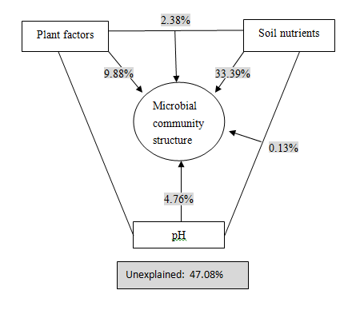
b
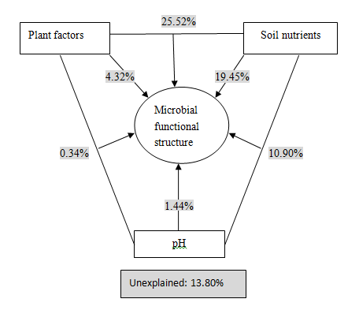
Fig. S3. Variation partitioning analysis (VPA) of (a) high-throughput sequencing data and (b) functional genes involved in C and N cycling with environmental factors. Plant factors included plant diversity and plant biomass. Soil nutrients included total nitrogen, total phosphorus, NH₄⁺-N, NO₃⁻-N, soil organic carbon, alkaline hydrolysis nitrogen, and rapidly available phosphorus.

