Supplementary Information

Table S1
Description of soil samples from the two soil profiles at the Luojiajiao site

Profiles | Description | depth | Replicates | Label
P01 | Long-term cultivated paddy soil | 0-18 cm | 6 |  | P01A
 | Long-term cultivated paddy soil | 18-33 cm | 6 |  | P01B
 | ashpit (cultural layer) | 33-40 cm | 6 |  | P01C
P04 | ashpit (cultural layer) | 3.2-3.3 m | 3 |  | P04A
 | buried ancient paddy soil | 3.3-3.4 m | 6 |  | P04B
 | buried ancient paddy soil | 3.4-3.6 m | 6 |  | P04C

Table S2
The radiocarbon dates for soil samples from the Luojiajiao site

Samples | Lab code | 14C age  (yr BP±1σ) | Calibrated age  (yr BP, 1σ) | Calibrated age  (yr BP, 2σ)
P01A3 | BA111279 | 545±20 | 1330 - 1340 (9.7%)  1395 - 1425 (58.5%) | 1320 - 1350 (25.1%)  1390 - 1430 (70.3%)
P01B5 | BA111280 | 420±80 | 1420 - 1530 (49.5%)  1570 - 1630 (18.7%) | 1320 - 1350 (1.5%)  1390 - 1650 (93.9%)
P01C5 | BA111281 | 5740±60 | 6531- 6701 (68.2%) | 6461 - 6731 (95.4%)
P04A5 | BA111282 | 5635±25 | 6456 - 6511 (62.8%)  6411 - 6426 (5.4%) | 6451 - 6551 (77.0%)  6381 - 6441 (18.4%)
P04B6 | BA111283 | 5790±25 | 6616 - 6706 (68.2%) | 6561 - 6721 (95.4%)
P04C6 | BA111284 | 5680±30 | 6496 - 6556 (59.7%)  6471 - 6486 (8.5%) | 6461 - 6611 (95.4%)

Table S3
Geochemical parameters of soil samples in this study
 | P01A | P01B | P01C | P04A | P04B | P04C
pH | 6.44±0.07 | 6.74±0.06 | 6.76±0.06 | 6.26±0.06 | 6.34±0.05 | 6.24±0.06
Moisture % | 39.05±2.47 | 30.856±3.43 | 37.98±3.74 | 34.97±1.70 | 33.06±2.98 | 38.43±4.26
TOC (g Kg⁻¹) | 26.37±1.64 | 23.43±2.84 | 24.44±1.46 | 24.44±3.52 | 22.14±1.21 | 39.21±4.00
TN (g Kg⁻¹) | 2.89±0.15 | 2.44±0.15 | 2.04±0.28 | 1.91±0.15 | 1.59±0.11 | 2.76±0.28
TC (g Kg⁻¹) | 27.43±1.34 | 24.58±1.00 | 32.60±2.17 | 29.11±1.99 | 22.83±0.88 | 42.84±4.18
TS (g Kg⁻¹) | 0.41±0.03 | 0.30±0.03 | 0.13±0.02 | 0.24±0.01 | 0.13±0.01 | 0.57±0.07
DOC (mg Kg⁻¹) | 163.55±12.20 | 137.41±25.20 | 156.00±15.34 | 93.28±15.43 | 31.56±5.14 | 56.78±16.92
CEC (Cmol Kg⁻¹) | 6.72±0.18 | 7.55±0.50 | 9.91±0.26 | 13.65±1.06 | 5.41±0.32 | 5.47±0.76
NH₄⁺ (mg Kg⁻¹) | 7.86±0.43 | 7.74±0.75 | 5.71±0.60 | 5.46±0.49 | 9.36±0.30 | 9.27±0.98
AK (mg Kg⁻¹) | 102.59±3.14 | 100.08±4.08 | 166.25±12.34 | 204.57±10.17 | 185.53±9.85 | 178.91±14.16
TP (g Kg⁻¹) | 4.27±0.28 | 7.54±0.79 | 11.93±0.56 | 63.32±4.43 | 2.46±0.37 | 4.86±0.57
AP (mg Kg⁻¹) | 1.19±0.08 | 1.19±0.12 | 2.27±0.16 | 4.84±0.57 | 1.00±0.09 | 0.90±0.06
d 13C/12C | -27.08±0.68 | -26.24±0.21 | -24.08±0.11 | -23.49±0.28 | -24.04±0.14 | -24.18±0.25
d 15N/14N | 3.66±0.45 | 2.27±1.16 | 9.70±1.24 | 8.81±0.35 | 7.61±0.16 | 6.97±0.46
total PLFA (mg Kg⁻¹) | 8.91±0.47 | 5.61±0.96 | 0.65±0.11 | 0.89±0.06 | 0.94±0.20 | 0.88±0.17
Phytolith (grains g⁻¹) | 17546 | 10680 | 12063 | 13680 | 14117 | 9878
TRS (cmol kg⁻¹) | 0.98±0.12 | 0.83±0.11 | 1.01±0.19 | 1.08±0.39 | 0.91±0.19 | 0.81±0.19
ARS (cmol kg⁻¹) | 0.23±0.05 | 0.21±0.03 | 0.28±0.06 | 0.23±0.06 | 0.22±0.07 | 0.29±0.12
S/G | 0.40 | 0.40 | ND | ND | 0.12 | 0.15
TOC, total organic carbon; TC, total carbon; DOC, dissolved organic carbon; TN, total nitrogen; TS, total sulfur; CEC, cation exchange capacity; TP, total phosphorus; AP, available phosphorous; TRS, total reducing substances; ARS, active reducing substances; S/G, syringyl to guaiacyl ratio of organic matter. ND: data were not detected

Table S4
Significance tests based on the dissimilarities of overall functional gene diversity among samples with three statistical approaches

 | MRPP |  | ANOSIM |  | Adonis
 | δ | P | R | P | F | P
Long-term cultivated soil vs ancient buried soil
GeoChip | 0.202 | <0.001 | 0.901 | 0.001 | 0.484 | 0.001
16S rDNA | 0.6649 | 0.001 | 0.9647 | 0.001 | 9.6894 | 0.001
PLFA | 0.1528 | 0.002 | 0.47 | 0.001 | 0.2404 | 0.01
Paddy soil vs mulberry soil (GeoChip)
P01 - P05 | 0.142 | <0.001 | 0.519 | 0.003 | 0.23 | 0.001
P04 - P05 | 0.1 | <0.001 | 0.976 | 0.001 | 0.3 | 0.001
MRPP, multi-response permutation procedure; ANOSIM, analysis of similarity; Adonis, non-parametric multivariate analysis of variance.

Table S5
Blast results of 16 most abundant unclassifiable OTUs

OTU ID | Length (bp) | The most closest sequence  in GenBank | Accession No. | Coverage % | Identity %
00005 | 329 | Uncultured bacterium clone 1020B13 16S ribosomal RNA gene | HM641676.1 | 100 | 98
00084 | 329 | Uncultured bacterium clone GA21498d09 16S ribosomal RNA gene | JN607009.1 | 100 | 94
00003 | 330 | Uncultured bacterium clone: B0610D002_E05 gene for 16S rRNA | AB660631.1 | 100 | 99
00154 | 331 | Uncultured bacterium clone Out22 16S ribosomal RNA gene | HQ677574.1 | 100 | 99
00015 | 331 | Uncultured bacterium clone HDB_SIOH1020 16S ribosomal RNA gene | HM185832.1 | 100 | 99
07170 | 332 | Uncultured bacterium clone GB4XUSJ08JD6VI 16S ribosomal RNA gene | JQ504537.1 | 99 | 99
00180 | 332 | Uncultured bacterium clone GB4XUSJ08JOCML 16S ribosomal RNA gene | JQ505595.1 | 100 | 97
00018 | 332 | Uncultured bacterium clone GB4XUSJ08JPSD7 16S ribosomal RNA gene | JQ493420.1 | 100 | 99
00019 | 332 | Uncultured bacterium clone 16S-T6-1-F11 16S ribosomal RNA gene | KC664071.1 | 100 | 99
00002 | 333 | Uncultured bacterium clone B1_58 16S ribosomal RNA gene | HM228610.1 | 100 | 99
00111 | 333 | Uncultured bacterium clone HDB_SIPI600 16S ribosomal RNA gene | HM187031.1 | 100 | 95
00190 | 333 | Uncultured bacterium clone 4040RB13 16S ribosomal RNA gene | JQ976562.1 | 100 | 100
00132 | 333 | Uncultured bacterium clone 1020B13 16S ribosomal RNA gene | HM641676.1 | 100 | 99
00009 | 333 | Uncultured bacterium clone HDB_SIOI1125 16S ribosomal RNA gene | HM185962.1 | 100 | 99
00119 | 333 | Uncultured bacterium clone PH1-25 16S ribosomal RNA gene | DQ444026.1 | 100 | 100
00282 | 335 | Uncultured bacterium clone T10.165 16S ribosomal RNA gene | GQ124291.1 | 99 | 98
Representative sequences for the 16 most abundant unclassifiable OTUs (at least 500 sequences per OTU) were blasted against NCBI nr database. The results showed thirteen matched uncultured bacteria with 99% or better coverage with at least 98% identity.

Table S6
Summary of key parameters of network topology

Ancient: Buried paddy soils; Modern: Currently cultivated paddy soils;
avgK, Average connectivity; GD, Average path; avgCC, Average clustering coefficient.

Classification | Samples | Size (n) | Links | avgK | GD | avgCC
Carbon cycling | Ancient | 3066 | 57787 | 37.695 | 3.613 | 0.612
 | Modern | 2890 | 68622 | 47.489 | 2.967 | 0.715
Nitrogen cycling | Ancient | 2172 | 25699 | 23.664 | 3.362 | 0.571
 | Modern | 2058 | 33042 | 32.111 | 3.854 | 0.693

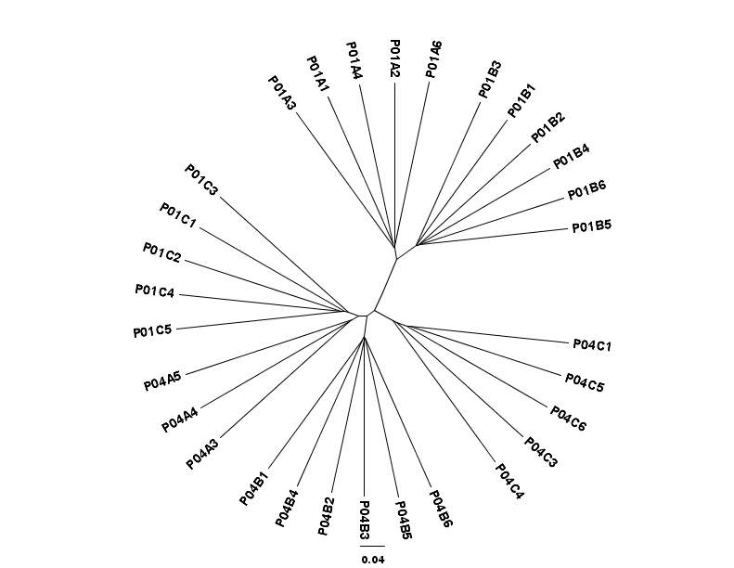
Buried ancient
samples
Long-term cultivated samples
Ash pit

Fig. S1
Jackknifing Support unweighted unifrac UPGMA clustering of 16S rRNA gene 454 pyrosequencing data.

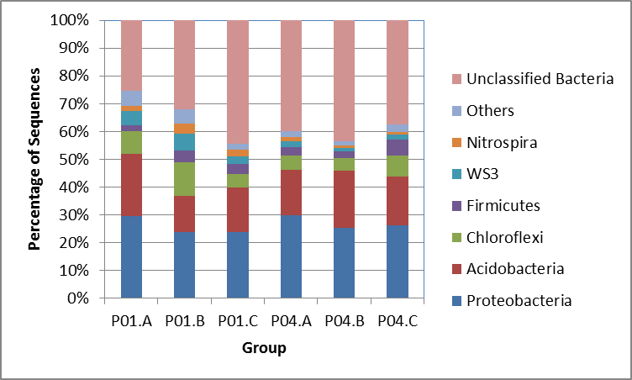

Fig. S2
Phylum distribution of bacterial communities of all the samples as revealed by 16S rRNA gene based pyrosequencing. “Others” includes Actinobacteria, Cyanobacteria, Armatimonadetes, Spirochaetes, Chlamydiae, Deferribacteres, Chlorobi, Bacteroidetes, BRC1, Aquificae, Verrucomicrobia, TM7, OD1, OP11, Deinococcus-Thermus, Gemmatimonadetes, and Planctomycetes, each less than 1 % of the total sequences per group.

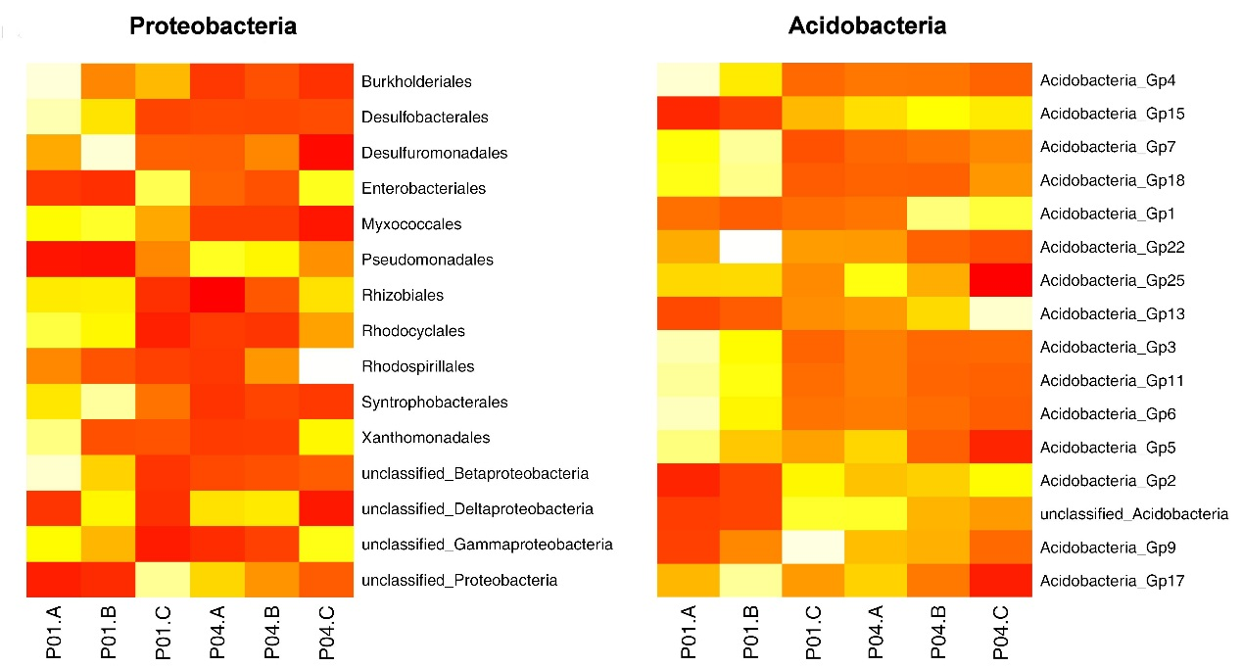

Fig. S3
Differential distribution of Proteobacteria and Acidobacteria among treatments. OTUs that contained at least 1% of the total sequences in at least one treatment were selected and agglomerated to order. The orders depicted here are significantly different (p<= 0.05) among treatments.

Fig. S4
Canonical correspondence analysis (CCA) compares the 16S rRNA gene pyrosequencing data (symbols) and environmental variables (arrows). Environmental variables were chosen based on significance calculated from individual CCA results and variance inflation factors (VIFs) calculated during CCA. The percentage of variation explained by each axis is shown, and the relationship is significant (P < 0.005)

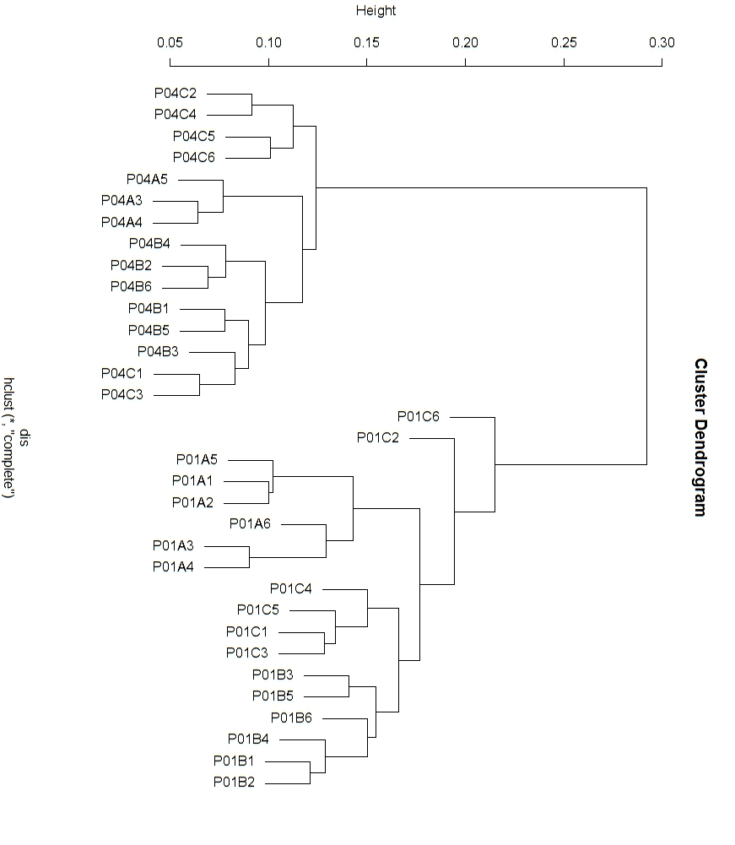

Ancientt
Modern

Fig. S5
UPGMA clustering of samples based on normalized signal intensity data for detected functional genes.

Fig. S6
Canonical correspondence analysis (CCA) compares the GeoChip hybridization signal intensities (symbols) and environmental variables (arrows). Environmental variables were chosen based on significance calculated from individual CCA results and variance inflation factors (VIFs) calculated during CCA. The percentage of variation explained by each axis is shown, and the relationship is significant (p < 0.005).

Fig. S7
The normalized average signal intensity of the detected functional genes involved in carbon cycling. The complexity of carbon is presented in order from labile to recalcitrant. All data are presented as the mean ± SE. **p < 0.01, *p < 0.05.

Fig. S8
The normalized average signal intensity of the detected functional genes involved in methane metabolism. mcrA encoding alpha subunit of methyl coenzyme M reductase; mmoX encoding particulate methane monooxygenase; pmoA encoding methane monooxygenase. All data are presented as the mean ± SE. **p < 0.01.

